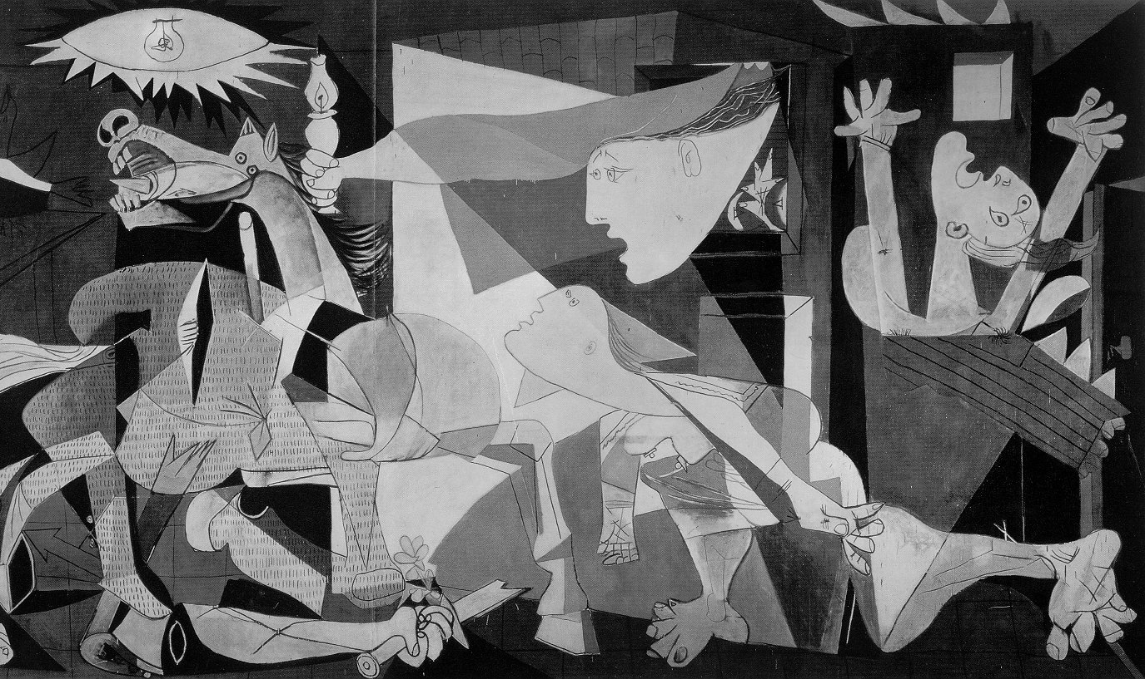

Pablo Picasso. Guernica; 1937. Oil on Canvas,
350 x 782 cm

Museo Nacional Centro de Arte Reina Sofia, Madrid

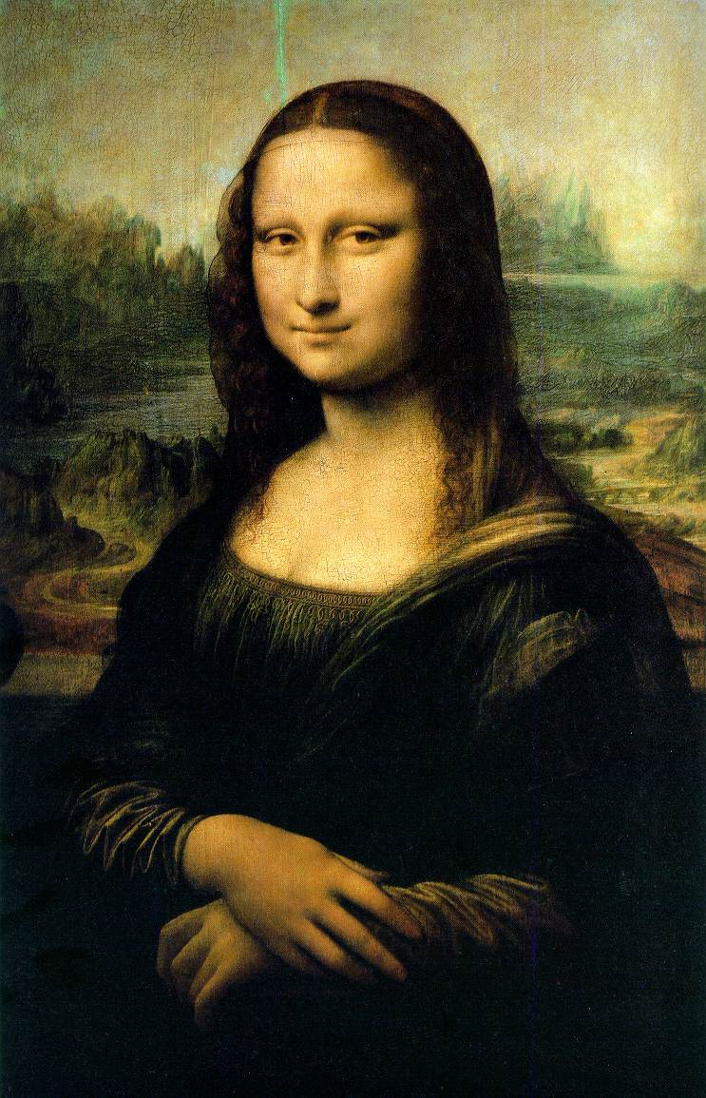

Leonardo da Vinci; Mona Lisa; c. 1505.
Oil on panel, 77x 55 cm.
Musée de Lovre, Paris
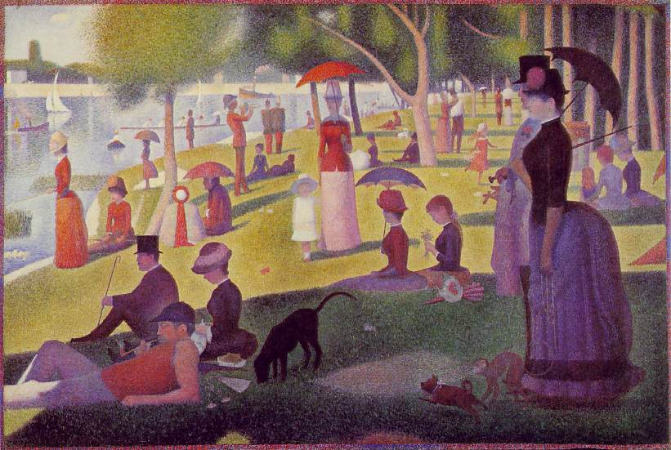

Georges Seurat, Sunday afternoon in Big Jatte Island,
1884-1886, Oil on Canvas
The Art Institute of Chicago


Tomas Gainsborough, Mr. and Mrs. Andrews, 1748-1749,
Oil on canvas, 70x 119 cm.
National Galery, London
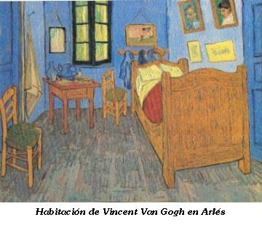

Vincent van Gogh, The painter’s bedroom in Arles, 1889.
Oil on canvas, 57,5x74 cm.
Musée d’Orsay, Paris

