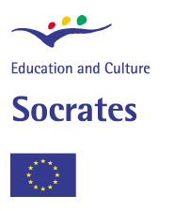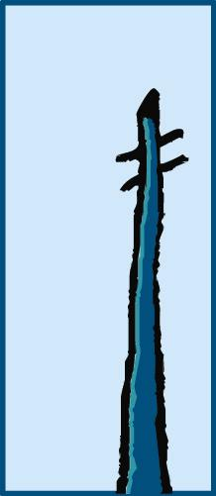
Cea Francesc de Borja Moll
C/ Llorenç M. Duran, 37
07300 Inca.
Tel. 0034 971 88 05 35
Fax. 0034 971 501598
ceafrancescdeborjamoll@
caib.es

EL PI DE FORMENTOR.

ARTISTS BIOGRAPHIES.

1. Read the text.

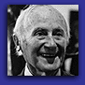

Joan Miró.
Birth 1893, Barcelona; death 1983, Palma de Mallorca.

Joan Miró Ferrà was born in April 20th, 1893, in Barcelona. At the age of 14, he went to a business school in Barcelona and also attended La Lonja’s Escuela Superior de Artes Industriales y Bellas Artes in the same city. Upon completing three years of art studies, he took a position as a clerk. After suffering a nervous breakdown, he abandoned business and resumed his art studies, attending Francesc Gali’s Escola d’Art in Barcelona from 1912 to 1915. Miró received early encouragement from the dealer José Dalmau, who gave him his first solo show at his gallery in Barcelona in 1918. In 1917, he met Francis Picabia.

In 1920, Miró made his first trip to Paris, where he met Pablo Picasso. From this time, Miró divided his time between Paris and Montroig, Spain. In Paris, he associated with the poets Max Jacob, Pierre Reverdy, and Tristan Tzara and participated in Dada activities. Dalmau organized Miro’s first solo show in Paris, at Galerie la Licorne in 1921. His work was included in the first Surrealist exhibition at the Galerie Pierre that same year. He visited Netherlands in 1928 and began series of paintings inspired by Dutch masters. This year he also executed his first papiers collés and collages. In 1929, he started his experiments in lithography, and his first etchings date form 1933. During the early 1930s, he made Surrealist sculptures incorporating painted stones and found objects. In 1936, Miró left Spain because of the civil war; he returned in 1941. Also in 1936, Miró was included in the exhibitions Cubism and Abstract Art and Fantastic Art, Dada, Surrealism at the Museum of Modern Art, New York. The following year, he was commissioned to create a monumental work for the Paris World’s Fair.

Miro’s first major museum retrospective was held at the Museum of Modern Art , New York, in 1941. That year, Miró began working ceramics with Josep Llorens i Artigas and started to concentrate on prints, from 1954 to 1958, he worked almost exclusively in these two mediums. He received the Grand Prize for Graphic work at the Venice Biennale in 1954, and his work was included in the first Ducumenta exhibition in Kassel the following year. In 1958, Miró was given a Guggenheim International Award for murals for the UNESCO building in Paris. The following year, he resumed painting, initiating a series of mural-sized canvases. During the 1960s, he began to work intensively in sculpture. Miró retrospectives took place at the Musée National d’Art Moderne, Paris, in 1962, and the Gran Palais, Paris, 1974. In 1978. the Musée National d’Art Moderne exhibited over 500 works in major retrospective of his drawings. Miró died December 25th, 1983, in Palma de Mallorca, Spain.

2. Find words or phrases in the biography that mean the same as the expressions below.

- to become depressed and anxious, and cannot cope with everyday life. (breakdown)
- someone who buys or sells goods of a particular king. ( dealer)
- short journey to a place and back again. (trip)
- collection of objects on public display, eg in a museum. (exhibition)
- art of carving or modelling solid objects using clay, wood, stone, plaster or other materials.(sculpture)
- piece of heavy coarse cloth prepared for painting a picture on, or the picture painted on it. (canvas)

3.Read the biography and fill in the gaps with the words below.

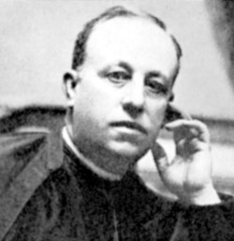

Miquel Costa i Llobera.
Birth 1854, Pollença, Mallorca; Death 1922, Mallorca.

Catalan poet,.................. in Pollença, Mallorca, Spain, in 1854. he was ordained a...................in 1888 and became a doctor of theology the following year. One of the neo-classicists, he joined formal richness to linguistic clarity, becoming a “mestre en Gay Saber” for his poetic gifts. He combined Christian and Pagan................... in his best book, Horaciones (1906), and he relied on classical metres. ..................in Italy and elsewhere enriched his thematic material. Among his ....................are Poesies (1885-1907), Del Aire i de la terra (1897), Liricas (1899) and Visiones de Palestina (1908).
- books.
- traditions.
- travels.
- born.
- priest.

4. Write a biography with the given information (100 words).

Hermenegildo Anglada Camarasa.

Birth: 1871 Barcelona, Spain.
Death: 1959 Pollença, Mallorca, Spain.
Job: Artist.
Education: La Lonja Escuela Superior de Artes Industriales y Bellas Artes.
Fist important exhibition: Paris, 1898.
Other exhibitions: Sala Pares, Venice Biennale in 1903,1905,1907, Paris, Rome.
Awards: Gold medal in Venice Biennale in 1907.
Residence: Moved to Pollença where his paintigs change.
Style and subjects: Colourful paintings, nearly abstract and landscapes.
Museums: pictures in Museu Nacional de Catalunya, Gran Hotel de Palma and Ermitage, Sant Petersburg.

Cea Francesc de Borja Moll
C/ Llorenç M. Duran, 37
07300 Inca.
Tel. 0034 971 88 05 35
Fax. 0034 971 501598
ceafrancescdeborjamoll@
caib.es

EL PI DE FORMENTOR PAINTINGS.

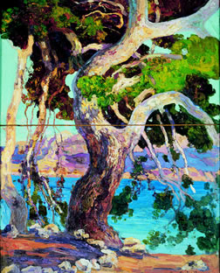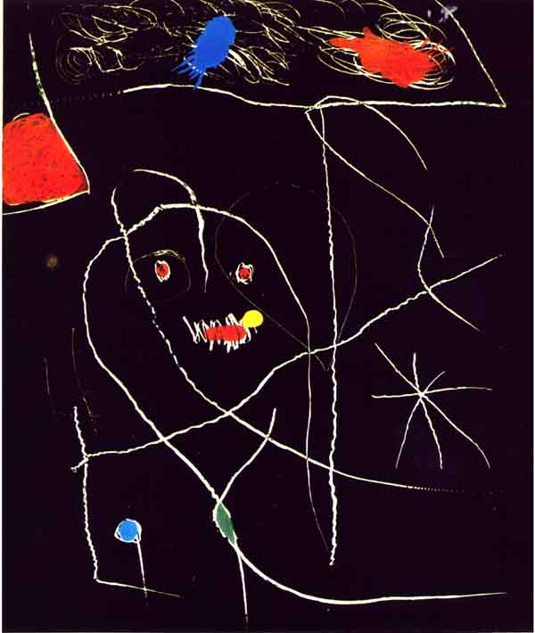

El Pi de Formentor, C.1922 El Pi de Formentor, 1976
Hermenegildo Anglada Camarasa Joan Miró Ferrà
Oil on canvas. Aquatint. Engraving.
Size: 63 x 49 cm. Size: 39 x 35 cm.
Es Baluard Museo d’Art Modern I HW Galery. Florida.
Contemporani de Palma

1.Look at the pictures and compare them. Emphasize the differences between them.
Write a list of differences between the two pictures.
Differences.
Picture 1. Picture 2.

Author: H.Anglada Camarasa Author: Joan Miró
Technic: Oil on canvas Technic: Aquatint. Engraving
By daylight At night.

Write sentences comparing the two pictures.
Example.

The picture on the left was painted by Hermenegildo Anglada Camarasa and the picture on the right was painted by Joan Miró.

DESCRIPTION OF A LANDSCAPE.

a. Structures we will use:

There is a/ there are some…
It is/ they are…

There is a lake ( singular). It is very big.
There are some trees ( plural). They are beautiful.

b. Prepositions of place we will use:

on
in
opposite
in front of
next to
north/south/ east/ west
at the centre/ at the top/ at the bottom of the picture
on the right hand side/ on the left hand side

c. Landscape vocabulary.

Tree
River/sea/lake
Mountain
Grass
Bush
Leaf/leaves
Branch
Plants
Flowers
Trunk
Sky
Forest

d. useful adjectives
big, huge, small
nice, beautiful, magnificent, horrible, ugly
thin/thick
tall, short
colours: green, (dark) brown, (light) blue, etc.
e. Personal impression.
It makes me feel…
Sad
Happy
Calm
Excited
Angry.

