LANDSCAPE IN MALLORCA

(19th and 20th centuries)

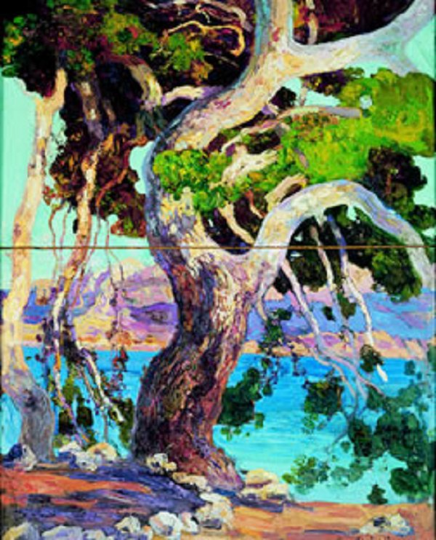

Hermenegild Anglada Camarassa, (c.1922) The pine of Formentor, Oil on canvas, 63 x 49 cm.

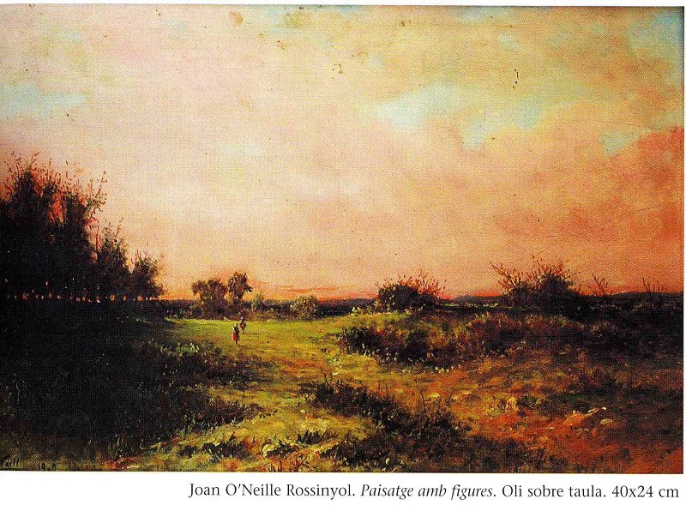

Joan O’Neille Rossinyol(1828-1907)Landscape with figures. Oil on canvas. 40x24 cm

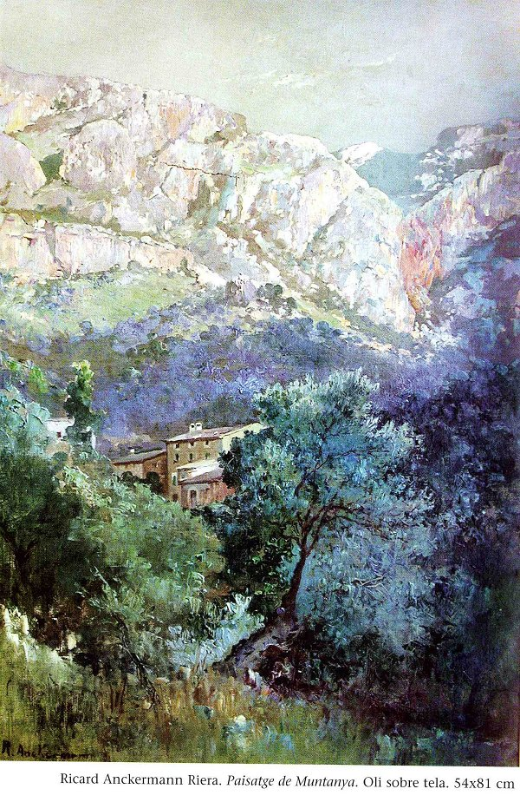

Ricard Ankerman Riera(1842-1907) Mountain Landscape.
Oil on canvas.54x81 cm

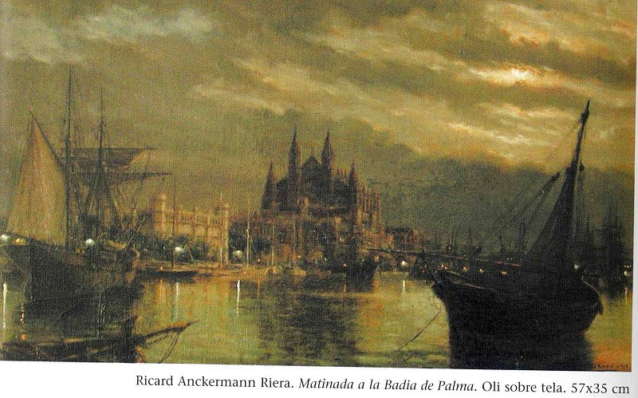

Ricard Ankerman Riera(1842-1907).
Daybreak in Palma Bay.
Oil on canvas. 57x35cm

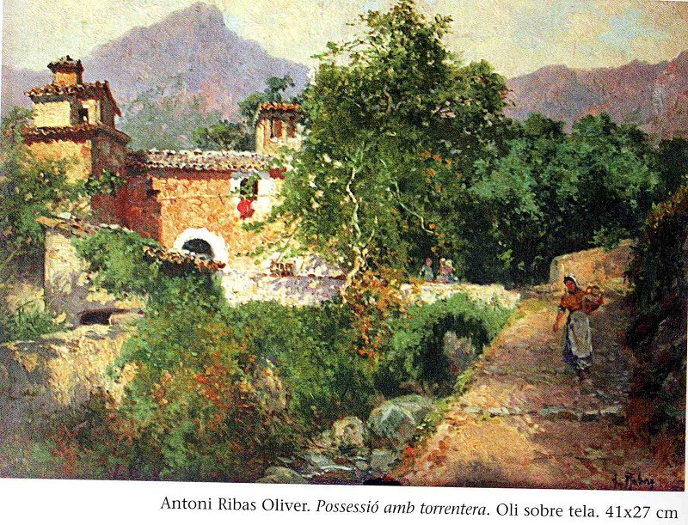

Antoni Ribas Oliver(1845-1911). House with torrent.
Oil on canvas. 41x27cm.

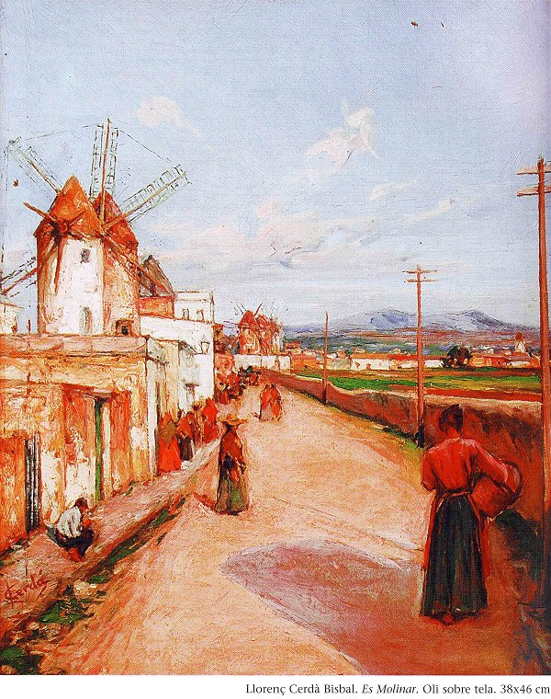
Llorenç Cerdà Bisbal(1862-1955), Es Molinar.
Oil on Canvas. 38x46cm

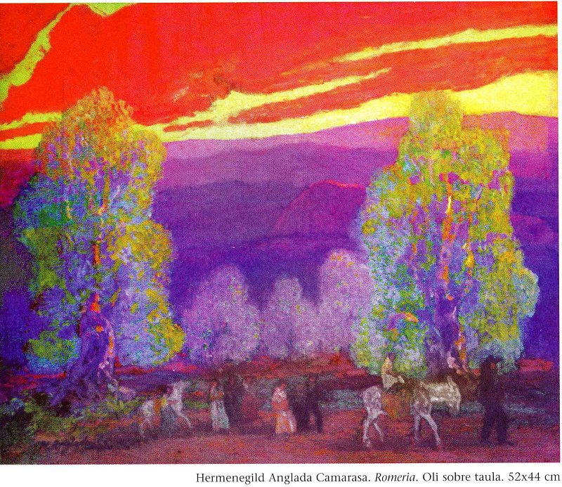

Hermenegild Anglada Camarasa(1873-1959). Pilgrimage. Oil on canvas.52x44cm

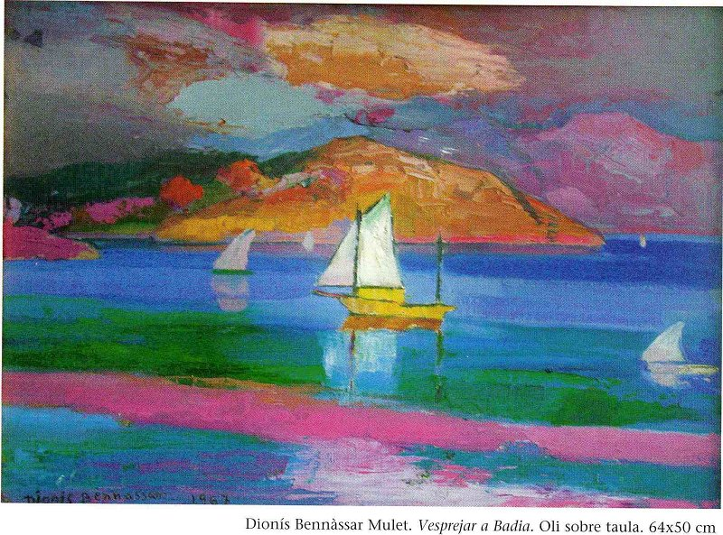

Dionís Bennàssar Mulet (1905-1967).Sunset in Bay.
Oil on canvas.64x50 cm.

