What a wonderful World?

To get you thinking

- What different forms of art can you think of?
- Would you say that a song is art?
- How can you relate art to nature?
- Can you think of any songs in which nature is mentioned?

Let’s get started

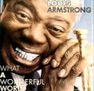
You are going to listen to Louis Armstrong singing What a Wonderful World.

- Do you know anything about the singer?
- Can you guess what the song will be about?

Step 1

Look at the pictures the teacher has just handed out. Place them in the correct order according to what you hear in the song.

Step 2

Listen to the song again and in small groups, answer the following questions.
- How many colours are mentioned in the song?
- Which nouns refer to the physical world? Make a list.
- Which actions are people performing in the song?

 After you listen
Now discuss the following question in groups.

- What is the message of the song? Do you agree with it?
- Is life really wonderful?
- What can we do to improve our lives?
- Is nature important in our world?
- What can we do to improve the place where we live?
 Vocabulary

In English there are many idioms and expressions related to nature. Each of the pictures is related to an idiom. Match the idiom to its corresponding picture.
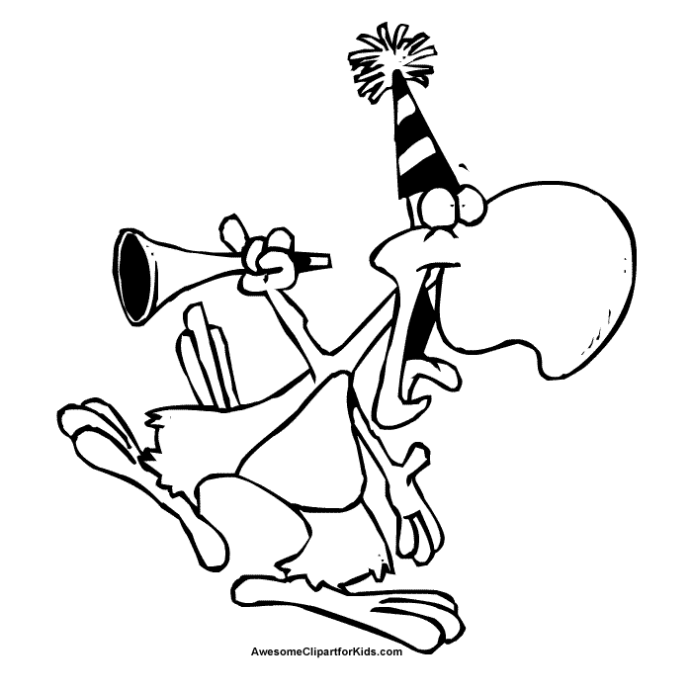

__________ __________ __________

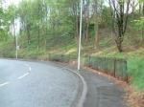

__________ __________ __________

to be over the moon
to live on another planet
to drive someone round the bend
to be a dark horse
to be a party animal
to go to the ends of the earth

 In pairs, try to guess what the idioms mean and match them to their possible meanings.
to be practical
do everything you can
to be ignored
to be extremely happy
to love parties and socialising
to be clever and skilful in a way that no one knew or expected
to have no awareness of the real world
to make someone very angry and frustrated
to be over the moon
to live on another planet
to drive someone round the bend
to be a dark horse
to be a party animal
to go to the ends of the earth

 Use the idioms above to fill the gaps in the following sentences

a. She very absentminded, it as if she ______________________.
b. When he found out he had passed the exam he started laughing and he couldn’t stop. He was _______________________.
c. The computer won’t do what I tell it to. It’s __________________.
d. He had been ____________________ for many years when someone unexpectedly discovered his drawings in a drawer.
e. I don’t understand how she does it. She studies, she works, and she doesn’t miss a party. She’s a ______________________ if ever I saw one.

Oviedo and its Landscape

 In groups discuss the following questions.

- Are there any green areas or parks in your city?
- Do you ever visit them?
- Are they an important social or cultural part of Oviedo?
- What would you change if you were in charge of the open spaces?
- What sorts of activities take place in these areas?
- When do people practice outdoor sports?
- Are these sports frequent in Asturias/Oviedo?

 Going for a walk

Look at the following pictures and comment on the differences.

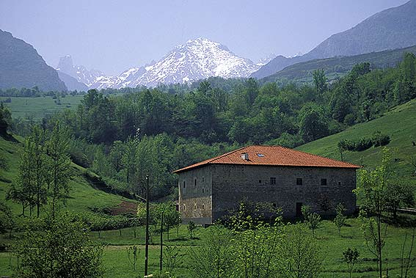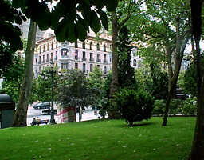

- What are some of the differences between these pictures?
- What time of the year do you think they were taken in?
- Why do you think so?
- What colours do you tend to associate with this time of the year in the city/country?

- In pairs, now write a short story ending with the following line:

And after a long day in the cold and dangerous Picos de Europa, we realised that we had been very lucky. We drove off with the same thought, “What a wonderful World!”

