Lover's portrait in poetry: its construction and deconstruction from the Middle Ages to Baroque
(Universal Literature class; Preparation for University Entrance Examination)

In the first three poems we can see the construccion of the portrait of the lover in the western poetry.
Text 1: The troubadours idealize the dame and receive the platonic theories on love. We underline a brief description (which will become a common place) and the hyperbolic definition of the lady.
Text 2: Petrarca gathers the tradition of troubadours and emphasizes it. His Laura, the donna angelicata (angelic woman), is the culmination of physical and moral beauty. In this sonnet she is described as a superhuman: her beauty and her soul are higher than the other creatures'. In earth it is almost impossible to find gold like her hair, pearls like her teeth...; her voice is like an angels’ singing...
Text 3: Ausiàs March (15th cent.) inherits the double tradition of troubadours (very close to catalan poetry) and the petrarchism. He has idealistic and realistic love poems. This is an idealistic one. The poet uses the praeteritio: he says that he will break with the exaggerated style of troubadours and he want to say the truth about his lover. Nevertheless, he makes a more exaggerated portrait than his predecessors.

In the poems of 16th and 17th centuries the petrarchist model is strengthened or deconstructed. Compare all them with Petrarca's sonnet.
a) Strengthening:
text 4 (Michelangelo): according to the platonic thinking, lover's beauty is a way to the world of ideas and to God.
text 5 (Gaspara Stampa): Nature is not enough to form the most beautiful creature; Art can do it.
text 7 (W. Shakespeare): Lover's beauty owes nothing to Nature; however, Nature (the flowers) owes her own beauty to the Fair Youth.

d) Deconstruction:
text 6 (Louise Labé): his lover used the petrarchist common places with her and now she is in love and suffers.
text 8 (W. Shakespeare): His lover (the Dark Lady) has none of the petrarchist characteristics (which are destroyed one by one by Shakespeare). However, he loves her and he declares that she is more beautiful than all the ladies who are described by the lying poets.
text 9 (Luis de Camões): The poet undresses his lover. She does not love him. Therefore, she does not need her beauty. All gifts can be returned to Nature and the Goddesses, and she will keep the only thing which belongs to her: the inhumanity.
text 10 (Francesc Vicent Garcia): A satirical and scatological baroque destruction of petrarchist portrait. The poet shows Beauty as revolting: the golden hair has louses and scabies, the crystal eyes are full of sleep, the lips of carnation sometimes have bad breath... The conclusion is extreme (the baroque language is always extreme: for sublimity and for vulgarity): Is this the dunghill which charms you? / I might shit on Love and Beauty.

TEXT 1
Guilhem de Peitieu (William of Poitiers)

Farai chansoneta nueva,  Ans que vent ni gel ni plueva:  Ma dona m'assai' e·m prueva,  Quossi de qual guiza l'am;  E ja per plag que m'en mueva  No·m solvera de son liam. | I shall write a new little song  before it turns windy, cold and rainy:  let my mistress assay and test me  so she'll learn in which fashion I love her;  and certainly, come hell and high water,  she won't free me from her snares.
Qu'ans mi rent a lieis e·m liure,  Qu'en sa carta·m pot escriure.  E no m'en tenguatz per iure,  S'ieu ma bona dompna am!  Quar senes lieis non puesc viure,  Tant ai pres de s'amor gran fam. | Instead, I surrender and deliver myself to her,  so that she can write my name in her charter.  And don't think I am drunk,  if I love my good mistress,  because I can't live without her,  so much I starve for her love.
Que plus es blanca qu'evori,  Per qu'ieu autra non azori:  Si·m breu non ai aiutori,  Cum ma bona dompna m'am,  Morrai, pel cap sanh Gregori,  Si no·m baiza en cambr'o sotz ram. | Because she is whiter than ivory,  and for this I can't adore anyone else:  if I am not ressured shortly,  that my good mistress loves me,  I shall die, by the head of St. Gregory,  unless she kisses me in her room or under a tree.
Qual pro i auretz, dompna conja,  Si vostr'amors mi deslonja  Par que us vulhatz metre monja!  E sapchatz, quar tan vos am,  Tem que la dolors me ponja,  Si no·m faitz dreg dels tortz q'ie us clam. | What good will it be to you, beautiful dame,  if your love parts me from you?  You seem to intend to become a nun!  And know, since I love you so much,  that I fear that the pain will harm me,  if you don't redress the wrongs I blame on you.
Qual pro i auretz s'ieu m'enclostre  E no·m retenetz per vostre  Totz lo jois del mon es nostre,  Dompna, s'amdui nos amam.  Lai al mieu amic Daurostre,  Dic e man que chan e bram.  Per aquesta fri e tremble,  Quar de tam bon'amor l'am,  Qu'anc no cug qu'en nasques semble  En semblan del gran linh n'Adam. | What good will it be to you if I become a monk  and you don't keep me as your own?  All the joy in the world is ours,  Lady, if we love each other.  Down there, I tell and command my friend Daurostre  to sing and cry.  I shiver adn shake for this woman  because I love her of such a good love:  I don't think one alike to her was born  in the great lineage of the noble Adam.

(English translation from http://www.trobar.org/troubadours)

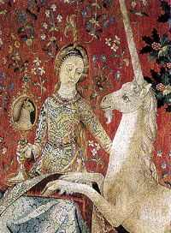

Tapestry of La Dame à la Licorne (Musée de Cluny, Paris)

TEXT 2
Francesco Petrarca

Sonnet CCXX
Onde tolse Amor l'oro, e di qual vena,
Per far due treccie bionde? e 'n quali spine
Colse le ròse, e 'n qual piaggia le brine
Tenere e fresche, e die' lor polso e lena?
Onde le perle, in ch'ei frange et affrena
Dolci parole, oneste e pellegrine?
Onde tante bellezze, e si divine
Di quella fronte, piú che 'l ciei serena?
Da quali angeli mosse, e di qual spera,
Quel celeste cantar che mi disface
Si che m'avanza omai da disfar poco?
Di qual sol nacque l'alma luce altèra
Di que' belli occhi ond'io ho guerra e pace,
Che m cuocono il cor in ghiaccio e 'n foco?

Whence did Love get the gold, and from what ore,
To make two yellow braids? And in what bower
Of thorns did he pluck roses, in what shore
The fresh and fragile hoar, and give it power?
Whence come the pearls in which he breaks and ties
Sweet honest words, incomparably fine?
Whence all the beauties that are so divine
Of that forehead serener than the skies?
From what angels derives and from what sphere,
The holy singing by which I am slain,
So that little is left to give me pain?
From what sun qame the lofty light and clear
That declares peace and war to my desire,
And scalds my heart with ice as well as fire?

(English translation from http://www.darsie.net/library/petrarch.html)

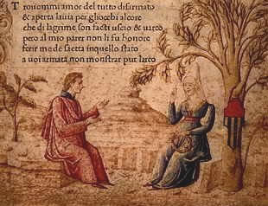
Petrarca and Laura; Canzionere, 15th cent. (Biblioteca Marziana, Venice)

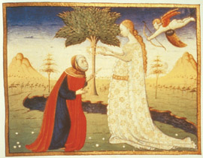
Petrarca and Laura; miniature of Giovan Pietro Birago for Triunfo della Morte (Bristish Library, London)

TEXT 3
Ausiàs March

[23]
Lleixant a part l'estil dels trobadors
qui, per escalf, trespassen veritat
e sostraent mon voler afectat
perquè no em torb, diré el que trop en vós.
Tot mon parlar als qui no us hauran vista
res no valrà, car fe no hi donaran,
e los veents que dins vós no veuran
en creure a mi llur arma serà trista.

L'ull de l'hom pec no ha tan fosca vista
que vostre cos no jutge per gentil;
no el coneix tal com lo qui és subtil:
hoc, la color, mas no sap de la llista.
Quant és del cos menys de participar
ab l'esperit, coneix bé lo grosser:
vostra color i el tall pot bé saber,
mas ja del gest no porà bé parlar.

Tots som grossers en poder explicar
ço que mereix un bell cos e honest:
jóvens gentils, bons sabents, l'han request
e, famejants, los cové endurar.
Lo vostre seny fa ço que altre no basta,
que sap regir la molta subtilea.
En fer tot bé s'adorm vostra perea.
Verge no sou perquè Déu ne volc casta.

Sol per a vós basta la bona pasta
que Déu retenc per fer singulars dones.
Fetes n'ha assats molt sàvies e bones,
mas compliment dona Teresa el tasta,
havent en si tan gran coneiximent
que res no el fall que tota no es conega:
a l'hom devot sa bellesa encega,
past d'entenents és son enteniment.

Venecians no han lo regiment
tan pacific com vostre seny regeix
subtilitats que l'entendre us nodreix
e del cos bell sens colpa el moviment.
Tan gran delit tot hom entenent ha
e ocupat se troba en vós entendre
que lo desig del cos no es pot estendre
a lleig voler, ans com a mort està.

Llir entre cards, lo meu poder no fa
tant que pogués fer corona invisible.
Meriu-la vós. Car la qui és visible
no es deu posar lla on miracle està.
English translation avaliable in:
Ausiàs MARCH, A Key Anthology, Translated by Robert Archer. Sheffield: The Anglo-Catalan Society, 1992. Ausiàs MARCH, Selected Poems. Translated by Arthur Terry. Austin: University of Texas Press, 1976 .

TEXT 4

Michelangelo

83
Veggio nel tuo bel viso, signor mio,
quel che narrar mal puossi in questa vita:
l'anima, della carne ancor vestita,
con esso è già più volte ascesa a Dio.
E se 'l vulgo malvagio, isciocco e rio,
di quel che sente, altrui segna e addita,
non è l'intensa voglia men gradita,
l'amor, la fede e l'onesto desio.
A quel pietoso fonte, onde siàn tutti,
s'assembra ogni beltà che qua si vede
più c'altra cosa alle persone accorte;
né altro saggio abbiàn né altri frutti
del cielo in terra; e chi v'ama con fede
trascende a Dio e fa dolce la morte.

From thy fair face I learn, O my loved lord,
That which no mortal tongue can rightly say;
The soul imprisoned in her house of clay,
Holpen by thee to God hath often soared:
And tho' the vulgar, vain, malignant horde
Attribute what their grosser wills obey,
Yet shall this fervent homage that I pay,
This love, this faith, pure joys for us afford.
Lo, all the lovely things we find on earth,
Resemble for the soul that rightly sees,
That source of bliss divine which gave us birth:
Nor have we first fruits or remembrances
Of heaven elsewhere. Thus, loving loyally,
I rise to God and make death sweet by thee.

Translated by John Addington Symonds

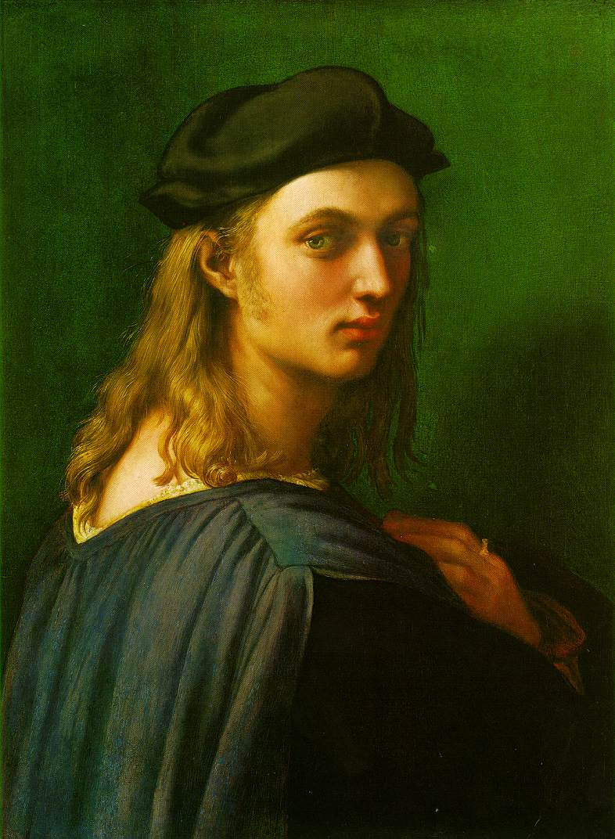

Portrait of Bindo Altoviti (c. 1515), by Raphael (National Gallery of Art, Washington)

TEXT 5

Gaspara Stampa

LV
Voi, che' n marmi, in colori, in bronzo, in cera
imitate e vincete la natura,
formando questa e quell' altra figura,
che poi somigli a la sua forma vera,
venite tutti in graziosa schiera
a formar la più bella creatura,
che facesse giamai la prima cura,
poi che con le sue man fe' la primiera.
Ritraggete il mio conte, e siavi a mente
qual è dentro ritrarlo, e qual è fore;
sì che a tanta opra non manchi niente.
Fategli solamente doppio il core,
come vedrete ch' egli ha veramente
il suo e 'l mio, che gli ha donato Amore.

TEXT 6

Louise Labé

23
Las ! que me sert que si parfaitement
Louas jadis et ma tresse dorée,
Et de mes yeux la beauté comparée
A deux Soleils, dont Amour finement
Tira les traits causes de ton tourment ?
Où êtes-vous, pleurs de peu de durée ?
Et mort par qui devait être honorée
Ta ferme amour et itéré serment ?
Doncques c'était le but de ta malice
De m'asservir sous ombre de service ?
Pardonne-moi, Ami, à cette fois,
Etant outrée et de dépit et d'ire ;
Mais je m'assur', quelque part que tu sois,
Qu'autant que moi tu souffres de martyre.

What good is it to me that once you praised
The silk peffection of my golden hair,
Or that to two bright Suns you would compare
The beauty of my eyes, from which Love gazed

And shot the burning darts so expertly?
Where are you now, tears that so quickly dried?
Or death, which was to prove you would abide
By oath of love and solemn fealty?

Or did you seek from malice to delude,
Enslaving by pretending servitude?
Forgive the thought, my dearest love, this once

When grief and anger piercingly combine:
I tell myself, wherever you may chance
To be, your martyrdom's as harsh as mine.

(English translation from http://www.coulmont.com/labe/sonnet23.html)

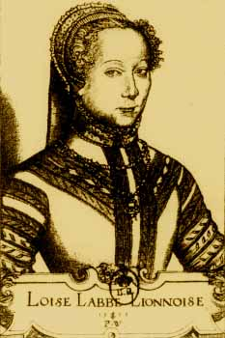

Portrait of Louise Labé (1555), by Pierre Waeiriot
(engraving in the edition of the poems of L. Labé)

TEXT 7

William Shakespeare

XCIX

The forward violet thus did I chide:
«Sweet thief, whence didst thou steal thy sweet that smells,
If not from my love's breath? The purple pride
Which on thy soft cheek for complexion dwells
In my love's veins thou hast too grossly dy'd.»

The lily I condemned for thy hand,
And buds of marjoram had stol'n thy hair;
The roses fearfully on thorns did stand,
One blushing shame, another white despair;

A third, nor red nor white, had stol'n of both,
And to his robbery had annex'd thy breath;
But, for his theft, in pride of all his growth
A vengeful canker eat him up to death.

More flowers I noted, yet I none could see,
But sweet, or colour it had stol'n from thee.

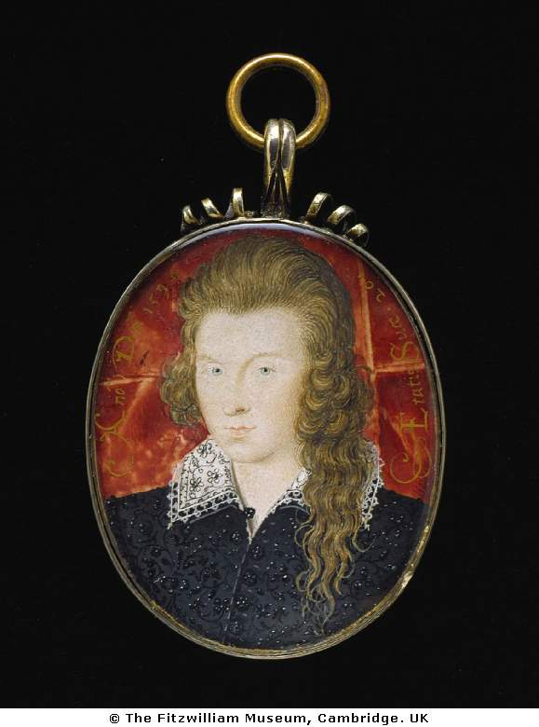

Miniature portrait (1594) of Henry Wriothesley, 3rd Earl of Southampton (the Fair Youth?), by Nicholas Hilliard.

TEXT 8

William Shakespeare

CXXX

My mistress' eyes are nothing like the sun;
Coral is far more red than her lips' red;
If snow be white, why then her breasts are dun;
If hairs be wires, black wires grow on her head.
I have seen roses damasked, red and white,
But no such roses see I in her cheeks;
And in some perfumes is there more delight
Than in the breath that from my mistress reeks.

I love to hear her speak, yet well I know
That music hath a far more pleasing sound;
I grant I never saw a goddess go;
My mistress when she walks treads on the ground.

And yet, by heaven, I think my love as rare
As any she belied with false compare.

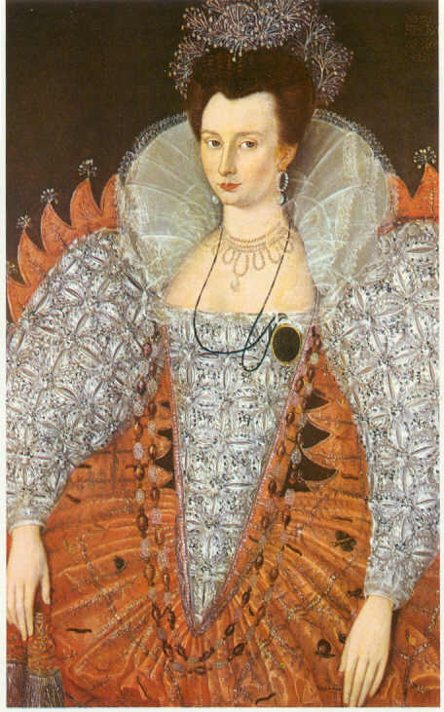

Portrait of Mary Fitton (the Dark Lady?), anonymous (1596)
(Royal Academy of Art)

TEXT 9

Luís de Camões

Tornai essa brancura à alva açucena,
E essa purpúrea cor às puras rosas;
Tornai ao Sol as chamas luminosas
Dessa vista que a roubos vos condena.
Tornai à suavíssima Sirena
Dessa voz as cadências deleitosas;
Tornai a graça às Graças, que queixosas
Estão de a ter por vós menos serena;
Tornai à bela Vénus a beleza;
A Minerva o saber, o engenho e arte;
E a pureza à castíssima Diana.
Despojai-vos de toda essa grandeza
De dons; e ficareis em toda a parte
Convosco mesma, que é ser inumana.

English translation avaliable in: Luís de CAMÕES, Selected Sonnets: A Bilingual Edition.
Edited and translated by William Baer.The University of Chicago Press, 2005.

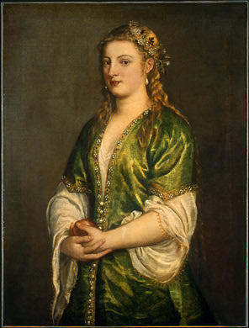

Portrait of a Lady (c.1555), by Titian (National Gallery of Art, Washington)

TEXT 10

Francesc Vicent Garcia

En apreci d'estar enamorat

Sarna i polls cria lo cabell dorat,
lleganyes cria l’ull que és més cristós
i, en lo nas del rostre més hermós,
lo moc, que és verd i negre, està encollat;
lo llavi del clavell més colorat
és pudent a vegades i asquerós
i la mà hermosa i blanca és molt fereós
que al cul de sa senyora haja arribat;
d’aquest món lo cony millor se’l veu pixar,
està a dos dits del cul, habita i mora,
del trassero polit ix merda pura
que, a la bellesa, fea sol deixar.
Est és lo muladar que us enamora?
Jo me cago en l’amor i en sa hermosura!

