IDEA

Portraits and faces

Plan of the lesson

TITEL: Hidden Clues
Exercices/duration | Preparation/Media/Material | Student’s activities
1) 25’  2) 25´ | • cards /sheets with multiple choice exercise  - pictures and artists  (see example 1)  - when was the picture made? (see example 2)  - cards with pictures (paintings / photos…) (see example 3) | - the cards are distributed to the students/learners. They have the choice between five artist´ s names or five information and have to find the right answer in relation to the picture on the card.  - The learners are asked to give a title to the picture and to explain why they have chosen this title. (e.g. I chose the title “Eternity” because this roll of wood looks endless. It brings me a sort of symbolic message: a never ending world.)

Example 1

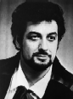
Who ist his man?

- Tom Cruise
- René Kollo
- Placido Domingo
- Luciano Pavarotti
- Dean Martin

His profession is

- a painter
- a writer
- a politician
- a singer
- a dancer

Example 2
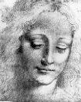
When was this painting made?

- 11th century
- 18th century
- 15th century
- 19th century
- 14th century

Examples for titles:

Rolling wood
Eternity
Incarnation

Give an explanation for the title you have given

Example 3
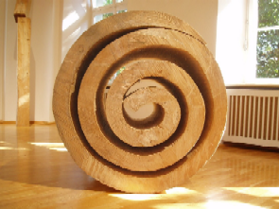
Foto: H. Sajons
When was this painting made?
- 12th century
- 15th century
- 18th century
- 20th century
- 14th century

