“Girl with a Pearl Earring”, by Vermeer, Le Hague

February 2006

Plan of the lesson

TITLE: Portraits and faces
Exercices/duration | Preparation/Media/Material | Student’s activities
1) 5’  2) 15’  3) 20/30’  4) 10’  5) 30’  6) 5’/10’  7) 5’  8) 30’ | - A reproduction of the portrait “Girl with a Pearl Earring” by Vermeer (can be virtual through internet or computer file)  - the book “Girl with a Pearl Earring” by Chevalier  - the film poster “Girl with a Pearl Earring”  Teachers will find the pictures under :  - http://www.tchevalier.com/gwape/  - Fotocopies of some pages the first chapter of the book (or of the whole chapter depending on the level of the class)  - Dictionaries  - List of questions  (see Appendix 1)  Teacher shows the pictures of the paintings mentioned in the book (numbered). (see Appendix 2)  And a sheet with the titles of the paintings in a random order. (see Appendix 3)  A sheet with the descriptions of the paintings from the book  - Teachers will find the pictures under :  - http://www.tchevalier.com/gwape/  - http://www.ibiblio.org/wm/paint/auth/vermeer/  - http://it.wikipedia.org/wiki/Dipinti_celebri | - each learner says if he/she has already seen the painting, or read the book, or seen the film and adds his/her own opinion about that/those. (warming up)  - Each learner reads the first 5/6 pages individually or in pairs and underlines the parts with descriptions of people. Students can use their dictionaries. (reading comprehension)  - Teacher asks learners (in turns) to read the single bits of description and explains the meaning of words if needed. (reading aloud/pronounciation)  - Teacher draws the learners’ attention to the painting “Girl with a Pearl Earring” and asks them to write in pairs a description of the girl’s face (possibly using the vocabulary they have found in the chapter read before. (writing)  - Learners in groups make up their own story about the girl in the painting. Teacher provides a list of few questions to guide the writing.  Learners look at the paintings and read the titles and try to match them. (reading comprehension, conversation)  Students receive a sheet with short descriptions of the paintings taken from the book. Each student (or pair of Sts) reads only one description and tries to match it with the right painting. (reading comprehension)  Students read each description aloud and the matching title, taking turns. (reading aloud, pronunciation)

Appendix 1

One of the best-loved paintings in the world is a mystery.

Who is the model and why has she been painted?

What is she thinking as she stares out at us?

Are her wide eyes and enigmatic half-smile innocent or seductive?

And why is she wearing a pearl earring?

Appendix 2
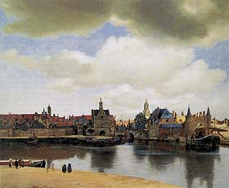1 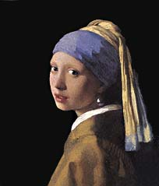8
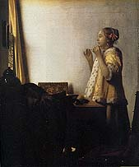 2 7 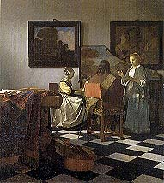 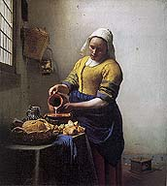 3 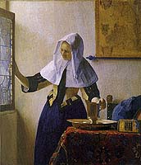6
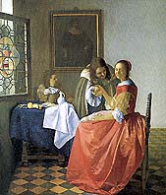4 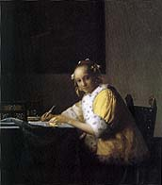5

Appendix 3
Girl With a Pearl Earring, Mauritshuis, The Hague
Woman With a Water Jug, Metropolitan Museum of Art, New York
The Concert, Isabella Gardner Museum, Boston [stolen]
A Lady Writing, National Gallery of Art, Washington, D.C.
The Girl With the Wineglass, herzog Anton Ulrich Museum,, Brunswick
The Milkmaid, Rijksmuseum, Amsterdam
Woman With a Pearl Necklace, Staatliche Museen Preussischer Kulturbesitz,
Gemaldegalerie, Berlin-Dahlem
View of Delft, Mauritshuis, The Hague

Appendix 4
"Lick your lips, Griet."
I licked my lips.
"Leave your mouth open."
I was so surprised by this request that my mouth remained open of its own will. I blinked back tears. Virtuous women did not open their mouths in paintings.

"When you look at her cap long enough, you see that he has not really painted it white, but blue, and violet, and yellow."
"But it's a white cap, you said."
"Yes, that's what is so strange. It's painted many colors, but when you look at it, you think it's white

"In between the women is a man sitting with his back to us–"
"Van Ruijven," my father interrupted.
"Yes, van Ruijven. All that can be seen of him is his back, his hair, and one hand on the neck of a lute."
"He plays the lute badly," my father added eagerly.
"Very badly. That's why his back is to us – so we won't see that he can't even hold his lute properly."
My father chuckled. He was always pleased to hear that a rich man could be a poor musician.

"Look at me," he said.
She looked at him. Her eyes were large and dark, almost black.
He gave her a quill and paper. She sat in the chair, leaning forward, and wrote, an inkwell at her right. He opened a pair of the upper shutters and closed the bottom pair. The room became darker but the light shone on her high round forehead, on her arm resting on the table, on the sleeve of the yellow mantle.
"Move your left hand forward slightly," he said. "There."
She wrote.
"Look at me," he said.
She looked at him.

"Do you remember the painting we saw in the Town Hall a few years ago? It was a view of Delft, from the Rotterdam and Schiedam Gates. With the sky that took up so much of the painting, and the sunlight on some of the buildings."
"And the paint had sand in it to make the brickwork and the roofs look rough. And there were long shadows in the water, and tiny people on the shore nearest us."
"That's the one."
I remembered it well, remembered thinking that I had stood at that very spot many times and never seen Delft the way the painter had.

"You remember the last one," Maria Thins reminded Catharina. "The maid. Remember van Ruijven and the maid in the red dress!"
Catharina snorted with muffled laughter.
"That was the last time anyone looked out from one of his paintings," Maria Thins continued, "and what a scandal that was!"

"When he painted Tanneke she stood there happily pouring milk for months without a thought passing through that head, God love her."

Entranced with herself in the mirror, she did not seem to be aware that anyone was looking at her.
I wanted to wear the mantle and the pearls. I wanted to know the man who painted her like that.

