Plan of the lesson

TITEL: Symbols and Publicity Level : B1-B2

Activity Language: English - any language □ L1 XX L2

Author : European Team of EU Project “IDEA”
Timing /skills | Preparation/ Material | Procedure
1) 15´ /  Speaking fluency | - Art pictures related to allegories or including symbols (see pictures below) | - Students/learners (small groups) are asked to look for symbols in 2 pictures and to make a list of these symbols describing also their meaning in short sentences. They report to the class. (e.g.: I found a pigeon which could be the symbol for freedom or peace)  - They decide of two symbols which they consider to be relevant for themselves. (e.g.: For me the cross is important as it is the symbol of my religion… )
2) 20 ´/  Writing – text composition | - Collection of easy , daily symbols (see suggestions box below with example) | - Mix the cards with all the symbols and let each student/learner chose 3 of them. They are then asked to write a story involving them.
3) 15 ´/  Speaking and writing | - Collection of words which suggests a situation / a country…. to be matched with pictures  - Exercise for 3rd age people (review of previous experiences) | - When thinking of countries some pictures automatically come in mind (e.g.: the windmills for Holland,…). Students/learners collect ideas that are written on the board.  - 3rd age people are asked if they were symbols that they knew as they were 20 or 25 that do not exist anymore or that have changed in meaning or importance. (e.g. a television was an unusual piece of furniture in the 50th, now a television is not even a symbol for being financially well-off, …)

input.doc

Symbols
What are they for?

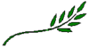 Peace Symbol  Seal of Solomon

 Symbol for women  Symbol for men

♫ Music Water / sea

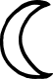 Symbol for Turkey / Islam  Love / affection

€ euro £ Pfund

¥ Yen % Percent

+ plus © Copyright

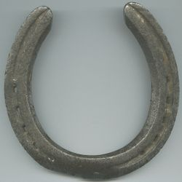 Horseshoe = symbol for luck

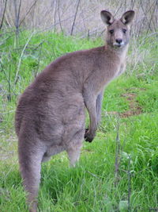 Kangoroo for Australia 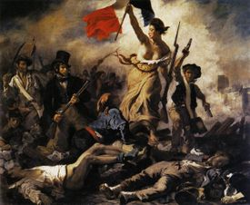 Marianne for France

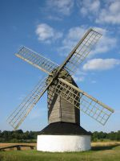 Windmill for the Netherlands 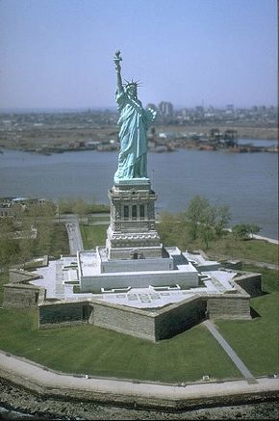 Statue of Liberty = USA

Allegories

Examples:

Allegorien vor dem Zeughaus in Berlin /
Allegories in Front of the Arsenal in Berlin
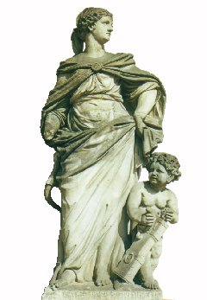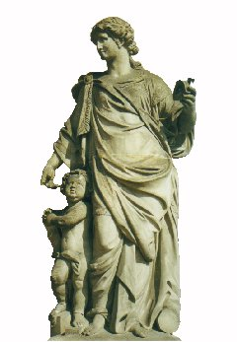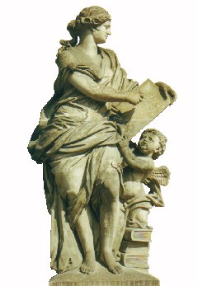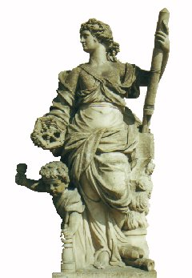

Vor dem Zeughaus in der Straße "Unter den Linden" stehen die oben abgebildeten Statuen, von links nach rechts die Wissenschaften Mechanik, Geometrie, Arithmetik und Ballistik symbolisierend (vgl. Knobloch, E.: 100 Jahre Mathematik in Berlin, DMV-Mitteilungen 2001 (4), 32-38).
Aus der Sicht der Mathematik offenbaren diese Statuen interessante Details (s. u.).
In front of the arsenal located in the street "Unter den Linden" the statues, which are presented above, are placed. They symbolize the sciences mechanics, geometry, arithmetic, and ballistics (from left to right) (cf. Knobloch, E.: 100 Jahre Mathematik in Berlin, DMV-Mitteilungen 2001 (4), 32-38). From the view of mathematics these statues provide interesting details (see below).
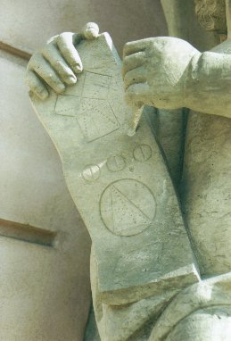
Die zur Allegorie Geometrie gehörende Putte hat ein "Pergament" entrollt, auf dem eine Skizze des Beweises des Satzes von Pythagoras zu erkennen ist. Genauer wird der Beweis des Kathetensatzes, der Euklid zugeschrieben wird, skizziert. Den Kathetensatz zweimal angewendet, ergibt eben den Satz des Pythagoras. Darunter ist zu erkennen, dass der Umkreismittelpunkt ein (spitzwinkliges) Dreieck in drei gleichschenklige Dreiecke teilt. Weiter unten ist nachzuvollziehen, dass eine Diagonale ein Rhomboid in zwei kongruente Dreiecke zerlegt. Um allerdings den Bezug zur obersten Zeichnung herzustellen, hätte besser die andere Diagonale eingezeichnet werden sollen.
The allegory geometry contains a detail (some kind of unrolled parchment), which contains a sketch of the proof of the theorem of Pythagoras. The drawing below shows that the center of the circle passing all vertices of the given (acute-angled) triangle decomposes itself into three triangles, where for each the lengths of two edges coincide. The last drawing shows that a rhomboid may be divided into two congruent triangles. But it would have been better to include the other diagonal to relate it to the most upper drawing.
Created by W. Volk in October 2002
Last formal changes on December 31st, 2005
http://www.w-volk.de/museum/allego01.htm

