Plan of the lesson

TITEL: Symbols and Publicity Level : A1/A2

Activity Language: □ L1 □ L2

Author : European Team of EU Project “IDEA”
Timing /Skills | Preparation/ Material | Procedure
1. 5’ introduction | A brief summary of the national flags  See google : Historia de las banderas nacionales | Teacher gives an introduction to the topic: “meaning of symbols” and give the students some information about the origins of the flags, students listen…
2. 15’ warm up | A map of Europe and the cards with some flags of European nations  See annex 1 | Teacher puts the cards on the table and hangs the map of Europe (you can also use a world map) on the wall.  Teacher encourages the students to identify the different flags and to look for similarities and to compare them making comments and exchanging opinions.  On plenary  Example see annex 2
3. 10’ speaking | A list of European nations | Pin the national flags on the respective country on the map. The students stand in a half circle with their teacher and he/she starts asking the first questions: e.g.: which are the bordering countries of Germany, the student next to him answers, e.g.:“The neighbouring countries are …”; the next student asks his/her neighbour and so on.  Students work with a list of nations and have to look for its adjectives.  Pairwork.  See annex 3
4. 30’ association | The flags pinned on the map and the teacher puts cards on the table with informations about nations (authors, literature, arts, food).  See annex 4 | Teacher writes on the blackboard, brainstorming see example annex 5  The students associate this information with each country using the simple present and the past tense depending on the requirement.  Students choose one card and then they stand in an halfcircle in front of the blackboard and map.  On plenary

Annex 1
Cards with flags

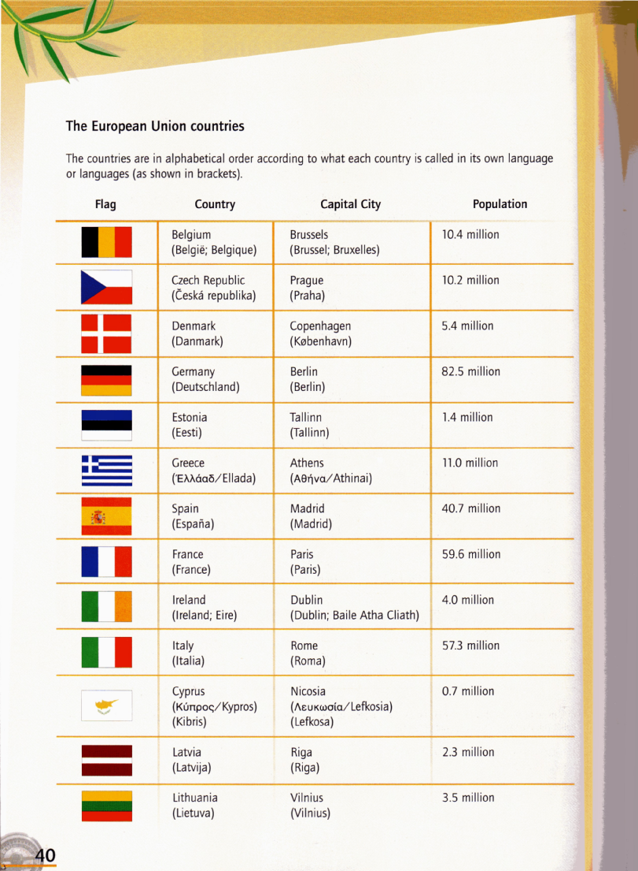

Annex 2
Teacher: Look at the flags of Germany and Belgium. Compare the flags….
Students: They have the same colours but they are ordered in different ways.

Annex 3

Country | Nationality
Germany | German
Austria
Belgium
Spain
France
Greece
Finland
Sweden
Switzerland
etc.

Annex 4
CULTURE

History | Food | Literature | Arts | Festivities | Buildings
Fernando Magallanes | Paella  Camembert | Shakespeare | Frédéric Chopin | Oktoberfest | Big Ben

The objective of this activity is to improve simple present and past tense in an easy and funny way.

Teacher: “Please take a card with the information that you can manage.”

Each student takes a card and the teacher asks: “Tell us, what is written on your card!” He/she says: Fernando Magallanes.
Teacher or students ask: “Who was Fernando Magallanes?”
Answer: “He was a seaman and discovered the Magallanes Strait. He came from Portugal.”
Teacher: “Pin your card in the right column.”

Teacher asks: “Tell us, what is written on your card!”
He/she says: “Paella.”
The students ask: “What is Paella?”
Answer: “Paella is a typical spanish dish. It is made with rice.”

Teacher asks: “Tell us, what is written on your card!”
He/she says: “Akropolis.”
The students ask: “What is Akropolis?”
Answer: “That is a building in Athens, Greece. That is a symbol of the Greek ancient culture.”

Annex 5

Each card has one information!

Charles Chaplin, Big Ben, Shakespeare, Leonardo da Vinci, Coliseum, Alhambra, Federico Fellini, Antoni Gaudi, Gustave Eiffel, Notre Dame, Astrid Lindgren, Ingrid Bergmann, Vasco de Gama, Fernando Pessoa, “the rooster” (symbol of Portugal), Santa Claus, Homero, Manneken-Pis, Hergé (Tintin), Brandenburger Tor, Atomium, Tivoli, Anne Frank, Johann G. Gutenberg, Sigmund Freud, Martin Luther, Gustav Klimt, Windmill, Lorelei, Volvo, Seawoman-statue, Waterloo, Akropolis, Oscar Wilde, Frédéric Chopin, El Toro, Mikka Häkkinen, Grundtvig, Asterix, Henrik Ibsen, Camembert, Pizza, Gyros, La Gioconda (Mona Lisa), Hans Christian Andersen, Rembrand, Van Gogh, René Descartes, Venice Carneval, Luis Pasteur, Abba, Vikings, Alfred Nobel, Oktoberfest, Wolfgang Amadeus Mozart, Prater, James Joyce, Simone de Beauvoir, Agatha Christie, Virginia Woolf, Maria Callas, Edith Piaf, Neuschwanstein, Versailles,…..

