Plan of the lesson

TITLE: Symbols and Publicity: “Mona Lisa’s secret” Level : B1

Activity Language: English □ L1 □ L2

Author : European Team of EU Project “IDEA”, Italy
Timing /skills | Preparation/ Material | Procedure
1) 10’  warming up  2) 15’ reading com-prehension  3)15’  writing/speaking  4) 35´  reading com-prehension  5)5’  speaking  6) 10’ | - Mona Lisa’s puzzle: cut out pieces of a photocopied Mona Lisa’s picture Appendix 1  - Text about Mona Lisa’s exploitation by artists and advertising. Appendix 2  - Cut outs of Mona Lisa’s portrait (her eyes, her mouth, her hands) Appendix 3  - 26th chapter of “The da Vinci Code” (App. 4)  Extra Activities  - Photocopies with Mona Lisa by Leonardo da Vinci and by Andy Warhol  - A photocopy with short biographies of the two artists mixed up (App.6) | - Teacher gives each Student a piece of the puzzle, asks him/her to guess what picture it belongs to. Students are then asked to put the pieces together to compose the original picture. Warming up prompts and describing Mona Lisa’s features. (see Appendix 1)  - In groups Students read the text. Teacher checks the comprehension with the class as a whole. (Appendix 2)  - In groups Students make up a slogan for an advert using Mona Lisa’s image/features and explain it to the class. Exercise: creating an advertisement. (Appendix 3)  - Teacher draws attention to Mona Lisa’s fame used by other artists: is it only a coincidence or is it a marketing strategy? Two examples: Dan Brown and Andy Warhol.  - Students read the26th chapter of the Da Vinci Code. Teacher checks the comprehension with the class as a whole. (App.4)  - Review of Comparatives and superlatives with examples from the text.  - Extra activities: Teacher shows the two photocopies and asks Students to compare them and express their opinions. (App. 1 and 5)  - Students Andy read Warhol’s biography and Leonardo da Vinci’s one mixed up. In pairs they put the two biographies in order. Appendix 6)

Appendix 1 What’s the most beautiful painting you have seen? What’s the most famous painting in the world? In your opinion, is the most famous one the most beautiful one as well? Why is it so famous? Is it a symbol? What is it the symbol of?
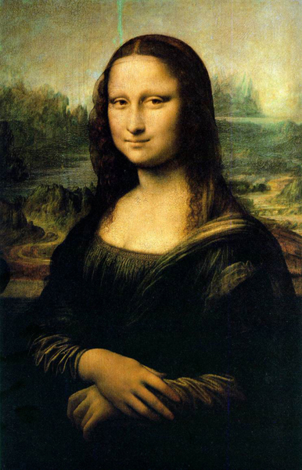

1. Describe Mona Lisa’s eyes, nose, mouth, lips, cheeks, neck, hair, hands: is she beautiful? 2. Match the words on the left with appropriate adjectives on the right (according to your personal choice)

Mona Lisa’s SMILE is  Mona Lisa’s HANDS are  Mona Lisa’s POSE is  Mona Lisa’s EYES are | Politely crossed  Enigmatic  Deep  Self-confident  Classical  Calm  Serene  Satisfied  Beautiful  Popular

Appendix 2

Can you compare Mona Lisa to the women you can usually see in advertisements? Did you know Mona Lisa has often been a testimonial in advertising campaigns?

THE QUEEN OF PUBLICITY: WHAT’S HER SECRET?
(Freely adapted from “The fine art of advertising”, Barry Hoffman, Stewart Tabori & Chang, 2002)
No one has her reputation but she wasn’t always popular.
It was just another well-respected painting even if already famous as a symbol of enigmatic beauty.
Her rise to the top began when “she” was stolen from the wall of the Louvre in 1911. Brought to the attention of the public (through tabloid headlines) she became the symbol of high art but also an object to make fun of.
When Marcel Duchamp drew a moustache and a goatee on her face, this previously sacrosanct image became the number one image to use when you wanted to make fun of high art.
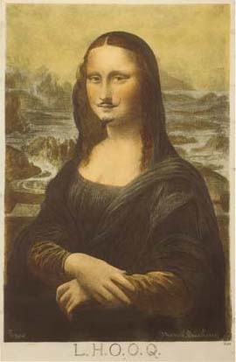

With the pop art movement Mona Lisa became the perfect example to show how the world of high culture and consumer (“low”) culture could meld.
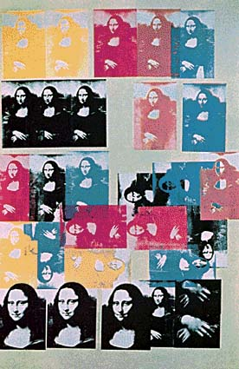
Mona Lisa is the female image advertiser
choose to have fun with when they want you to buy their product.
A little irreverence can turn high art to meet commercial needs.

Why do they choose Mona again and again
whenever they need an image
from “High culture”?
Because of her much discussed “enigmatic” smile: letting the enigmatic reputation of Mona’s smile speak for your product is among the most popular tactics.
Because her smile conveys satisfaction, and advertisers love a satisfied user.
Because it is mysterious, Mona Lisa’s smile can be turned to any number of ends.
Because she is open to interpretation.
This may be because she has the patient smile of someone being made fun of but willing to be the butt of the joke.
The symbol of high art has thus become the queen of advertising, reigning not only from the pages of magazines, but also from towels, mugs, and T-shirts.
Is that such a bad thing after all?
Appendix 3

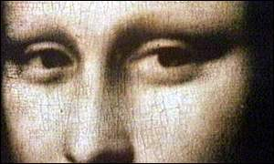

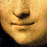

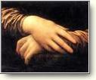
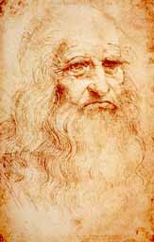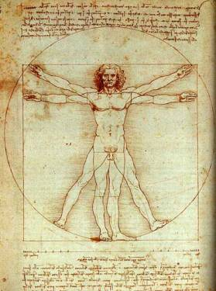

EXERCISE
If you had to use the pictures below to advertise products, what product would you use these pictures for?
  - Electronics/software/technology
  - Products that have to do with women/beauty/sex/perfume
  - Companies that make commodities that help make living pleasant and profitable
  - Modern art galleries
  - Food
  - Tourism
  - A book
  - Italy

What slogan would you suggest? (Ex. We can manipulate her image/We can replicate that image again and again with no loss of fidelity/We can reproduce a masterpiece/ the smile of appetite/the smile of an Italian mother)

APPENDIX 4:

Do you think Mona Lisa’s image and the reference to Da Vinci in its title helped Dan Brown’s Book “The Da Vinci Code” to become a best seller? Why?

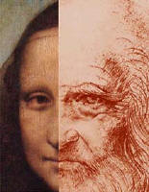
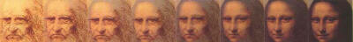

The Da Vinci Code
(Adapted from Chapter 26)

MONA LISA’S SECRET

The Mona Lisa’s status as the most famous piece of art in the world, Langdon knew, had nothing to do with her enigmatic smile. Quite simply, the Mona Lisa was famous because Leonardo da Vinci claimed she was his finest accomplishment. He carried the painting with him whenever he travelled and, if asked why, would reply that he found it hard to part with his most sublime expression of female beauty.

Even so, many historians suspected Da Vinci’s reverence for Mona Lisa had nothing to do with its artistic mastery. In actuality, the painting was a surprisingly ordinary sfumato portrait. Da Vinci’s veneration for this work, many claimed, stemmed from something far deeper: a hidden message in the layers of the paint. The public at large still considered her smile a great mystery.

No mystery at all, Langdon thought. No mystery at all.

Most recently Langdon had shared the Mona Lisa’s secret with a rather unlikely group – a dozen of inmates at the Essex Penitentiary. Langdon’s jail seminar was part of Harvard programme attempting to bring education into the prison system.

Standing at an overhead projector in a darkened penitentiary library, Langdon had shared the Mona Lisa’s secret with the prisoners attending class, men whom he found surprisingly engaged – rough, but sharp. ‘ You may notice’ Langdon told them,’ that the background behind her face is uneven. Da Vinci painted the horizon line on the left significantly lower than the right.’

‘He screwed it up?’ one of the inmates asked.
Langdon chuckled. ‘ No . Da Vinci didn’t do that too often. Actually this is a trick Da Vinci played. By lowering the countryside on the left, Da Vinci made Mona Lisa look much larger from the left side than from the right side. A little Da Vinci inside joke. Historically, the concepts of male and female have assigned sides – left is female, and right is male. Because Da Vinci was a big fan of feminine principles, he made Mona Lisa look more majestic from the left that the right.’

‘I heard he was a homosexual’ said a small man with a goatee. ‘Is that why he was into the feminine thing?’

‘Actually’ Langdon said ‘Da Vinci was in tune with the balance between male and female. He believed that a human soul could not be enlightened unless it had both male and female elements’.

‘Hey, Mr Langford’, a muscle-bound man said. ’Is it true that the Mona Lisa is a picture of Da Vinci in drag?’

‘It’s quite possible’, Langdon said. ‘Computerized analysis of the Mona Lisa and Da Vinci’s self-portraits confirm some points of congruency in their faces. Da Vinci’s Mona Lisa is neither male nor female. It carries a subtle message of androgyny. It’s a fusing of both.’

‘Actually Da Vinci left a big clue that the printing was supposed to be androgynous. Has anyone here ever heard of an Egyptian god named Amon?’

‘Yes!’ the big guy said. ‘God of masculine fertility!’

And do you know who Amon’s counterpart was? The Egyptian goddess of fertility?’
The question met with several seconds of silence. ‘It was Isis’ Langdon told them, grabbing a grease pen. ‘So we have the male god, Amon. ‘he wrote it down. ‘And the female goddess, Isis, whose ancient pictogram was once called L’ISA.’

Langdon finished writing.
AMON L’ISA

‘Ring any bells?’ he asked.
‘Mona Lisa….’ Somebody gasped.
Langdon nodded. ‘Gentlemen, not only does the face of Mona Lisa look androgynous, but her name is an anagram of the divine union of male and female. And that, my friends is Da Vinci’s little secret, and the reason for Mona Lisa’s knowing smile.’

1. Look at the underlined sentences: ask your teacher and/or classmates if you have any doubt about comparatives and superlatives.
2.Write some sentences about the Mona Lisa and/or Leonardo da Vinci using comparatives and superlatives to explain why you would use their images for an advertising campaign.

Appendix 5
Andy Warhol was one of the most important artists of pop art, which became extremely popular in the
second half of the twentieth century. Though he is best remembered for his paintings of Campbell's soup cans, he also created hundreds of other works including commercial advertisements and films.
Dates: August 6, 1928 -- February 22, 1987
He said: ’A masterpiece can be endlessly replicated: repetition of images distinguished pop art from the unique original.’

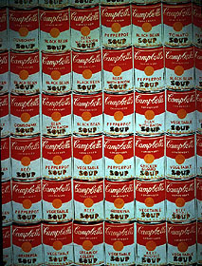 Andy Warhol Pop Art

and Mona Lisa

APPENDIX 6 : Scrambled Biographies

 | 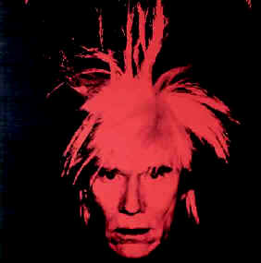 And
Leonardo da Vinci  1  2  3  4  5  6  7  8  9  10  11 | Andy Warhol  1  2  3  4  5  6  7  8  9  10  11
He was born in the small Tuscan town of Vinci in 1452.
He was born in Pittsburgh, Pennsylvania in 1930.
His parents were Czech immigrants.
After his education at an Institute of Technology, he moved to New York.
He was an artist, a scientist, and a scholar.
In New York he worked for Vogue and Harper’s Bazaar and designed window displays.
His artwork, as wells as his inventions, are still admired today.
When he was a teenager his family moved to Florence, where he studied with the artist Andrea del Verrocchio.
His unusual hairstyle became nearly as famous as his artwork.
He worked as a court painter, an architect and an engineer for the Duke of Milan.
In Milan he worked on his famous mural “The last supper”.
In 1502 he returned to Florence where he lived for 12 years.
In Florence he produced perhaps his most famous painting, “Mona Lisa” or “La Gioconda”.
He used everyday objects and images of famous people as subjects for his work.
He often repeated the same image many times on one painting or print.
From 1514 to 1516 he lived in Rome under the patronage of Pope Leo X.
His interest in things that were contemporary and popular defined his work as Pop Art.
In 1516 he travelled to France and entered the service of King Francis I.
He redefined the barrier between art and commerce.
He died on May 2nd, 1519 in the king’s summer palace on the Loire.
He is best remembered for his paintings of Campbell's soup cans.
He died in 1987.

HOMEWORK

Read the following text about Leonardo da Vinci and then decide if the sentences below are true (T) or false (F).

Leonardo da Vinci was born in the small Tuscan town of Vinci in 1452. He was an artist, a scientist, and a scholar. His artwork, as wells as his inventions, are still admired today.

When he was a teenager his family moved to Florence, where he studied as an apprentice under the artist Andrea del Verrocchio.

He quickly developed his own artistic style and in about 1482 he entered the service of the Duke of Milan. He worked as a court painter, an architect and an engineer. From 1495 to 1497 he worked on his famous mural “The last supper”.

In 1502 he returned to Florence where he lived for 12 years. It was during this time that he produced perhaps his most famous painting, “Mona Lisa” or “La Gioconda”.
Leonardo’s Mona Lisa may be the most famous painting of time, perhaps for the model’s enigmatic smile.

From 1514 to 1516 he lived in Rome under the patronage of Pope Leo X.

In 1516 he travelled to France and entered the service of King Francis I. He died on May 2nd, 1519 in the king’s summer palace on the Loire.

TRUE OR FALSE ?

1. Leonardo was born in 1452 T F

2. When Andrea del Verrocchio was a young man he instructed Leonardo T F

3. We know that Leonardo moved to Milan in 1482 T F

4. Leonardo worked in different kinds of jobs for the Duke of Milan. T F

5. He worked on the mural “The Last Supper” for two years. T F

6. Leonardo worked for 12 years painting “La Gioconda”, or the “Mona Lisa”. T F

7. “The Last Supper” is Leonardo’s most famous artwork T F

HOMEWORK
Read the following text about Andy Warhol and then decide if the sentences below are true (T) or false (F).

Andy Warhol was born in Pittsburgh, Pennsylvania, on August 8, 1930. His parents were Czech immigrants, and his last name was originally Warhola. After his education at an Institute of Technology, Warhol moved to New York, where he worked for Vogue and Harper’s Bazaar and designed window displays.

When he moved to New York Andy Warhol’s personal style began to emerge, and his unusual hairstyle and mannerism became nearly as famous as his artwork.

By the 1969s Warhol’s art was quite different than that of most other artists. He used everyday objects and images of famous people as subjects for his work, often repeating them many times on one painting or print. His interest in things that were contemporary and popular defined his work as Pop Art.

He grasped the function of celebrity and mass media in modern society and redefined the barrier between art and commerce. Some critics consider him as the most significant artist of the second half of the 20th century.

He died in 1987.

TRUE OR FALSE ?

1. Andy Warhol was born in New York in 1930 T F

2. His parents were German immigrants T F

3. He worked for two famous fashion magazines T F

4. Warhol was famous for his conservative style T F

5. He represented the same person in one single painting many times T F

6. He was interested in contemporary and popular objects T F

7. He is still alive T F

The enigmatic smile (it speaks for your product, approval, patient, calm inner assurance, deep self-confidence, serene)
Politely crossed hands
Her pose (classical beauty)
Eyes looking slightly right

1. Electronics/software/technology

(We can manipulate her image
We can replicate that image again and again with no loss of fidelity
We can reproduce a masterpiece)
A masterpiece can be endlessly replicated: repetition of images distinguished pop art from the unique original

2. Products that have to do with women/beauty/sex/perfume

3. Companies that make commodities that help make living pleasant and profitable

(Leonardo’s fame as an engineer, inventor, and a scientist)

4. (modern Art galleries

5. Food
(the smile of appetite
the smile of an Italian mother

She knows but isn’t telling What????

Overused

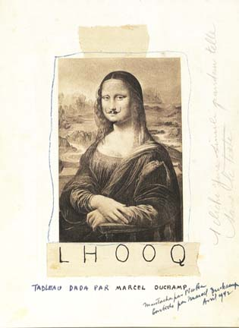

The quintessence of Andy Warhol art was to remove the difference between fine arts and the commercial arts used for magazine illustrations, comic books, record albums or advertising campaigns.

EXERCISE 3
If you had to use the pictures below to advertise a product, what product would you use this picture for?
  - Electronics/software/technology
  - Products that have to do with women/beauty/sex/perfume
  - Companies that make commodities that help make living pleasant and profitable
  - Modern art galleries
  - Food

Appendix 5

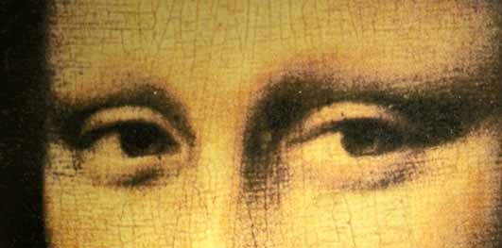

The enigmatic smile (it speaks for your product, approval, patient, calm inner assurance, deep self-confidence, serene)
Politely crossed hands
Her pose (classical beauty)
Eyes looking slightly right

1. Electronics/software/technology

(We can manipulate her image
We can replicate that image again and again with no loss of fidelity
We can reproduce a masterpiece)
A masterpiece can be endlessly replicated: repetition of images distinguished pop art from the unique original

2. Products that have to do with women/beauty/sex/perfume

3. Companies that make commodities that help make living pleasant and profitable

(Leonardo’s fame as an engineer, inventor, and a scientist)

4. (modern Art galleries

5. Food
(the smile of appetite
the smile of an Italian mother

She knows but isn’t telling What????

Overused
much identified with Pop Art as Andy Warhol. The media called him the Prince of Pop. Warhol made his way from a Pittsburgh working class family to an American legend.

Born in Pittsburgh
Andy was born in 1928 in Pittsburgh as the son of Slovak immigrants. His original name was Andrew Warhola. His father was as a construction worker and died in an accident when Andy was 13 years old.
Andy showed an early talent in drawing and painting. After high school he studied commercial art at the Carnegie Institute of Technology in Pittsburgh. Warhol graduated in 1949 and went to New York where he worked as an illustrator for magazines like Vogue and Harpar's Bazaar and for commercial advertising. He soon became one of New York's most sought of and successful commercial illustrators.

The Pop Icon
In 1952 Andy Warhol had his first one-man show exhibition at the Hugo Gallery in New York. In 1956 he had an important group exhibition at the renowned Museum of Modern Art.
In the sixties Warhol started painting daily objects of mass production like Campbell Soup cans and Coke bottles. Soon he became a famous figure in the New York art scene. From 1962 on he started making silkscreen prints of famous personalities like Marilyn Monroe or Elizabeth Taylor.
The quintessence of Andy Warhol art was to remove the difference between fine arts and the commercial arts used for magazine illustrations, comic books, record albums or advertising campaigns. Warhol once expressed his philosophy in one poignant sentence:
"When you think about it, department stores are kind of like museums".

The Factory
The pop artist not only depicted mass products but he also wanted to mass produce his own works of pop art. Consequently he founded The Factory in 1962. It was an art studio where he employed in a rather chaotic way "art workers" to mass produce mainly prints and posters but also other items like shoes designed by the artist. The first location of the Factory was in 231 E. 47th Street, 5th Floor (between 1st & 2nd Ave).
Warhol's favorite printmaking technique was silkscreen. It came closest to his idea of proliferation of art. Apart from being an Art Producing Machine, the Factory served as a filmmaking studio. Warhol made over 300 experimental underground films - most rather bizarre and some rather pornographic. His first one was called Sleep and showed nothing else but a man sleeping over six hours.

Nearly Murdered
In July of 1968 the pop artist was shot two to three times into his chest by a woman named Valerie Solanis. Andy was seriously wounded and only narrowly escaped death. Valerie Solanis had worked occasionally for the artist in the Factory. Solanis had founded a group named SCUM (Society for Cutting Up Men) and she was its sole member. When Valerie Solanis was arrested the day after, her words were "He had too much control over my life".
Warhol never recovered completely from his wounds and had to wear a bandage around his waist for the rest of his life.

Andy Warhol Art in the Seventies
After this assassination attempt the pop artist made a radical turn in his process of producing art. The philosopher of art mass production now spent most of his time making individual portraits of the rich and affluent of his time like Mick Jagger, Michael Jackson or Brigitte Bardot.
Warhol's activities became more and more entrepreneurial. He started the magazine Interview and even a night-club. In 1974 the Factory was moved to 860 Broadway. In 1975 Warhol published THE philosophy of Andy Warhol. In this book he describes what art is:
"Making money is art, and working is art and good business is the best art."

A Bizarre Personality
Warhol was a homosexual with a slightly bizarre personality. In the fifties he dyed his hair straw-blond. Later he replaced his real hair by blond and silver-grey wigs.
The pop artist loved cats, and images of them can be found on quite a few of his art works. One of Andy's friends described him as a true workaholic. Warhol was obsessed by the ambition to become famous and wealthy. And he knew he could achieve the American dream only by hard work.
In his last years Warhol promoted other artists like Keith Haring or Robert Mapplethorpe.
Andy Warhol died February 22, 1987 from complications after a gall bladder operation. More than 2000 people attended the memorial mass at St.Patrick's Cathedral. The pop art icon Warhol was also a religious man - a little known fact.
Two years later, in May 1994 the Andy Warhol Museum opened in his home town Pittsburgh in Pennsylvania.

Andy Warhol Pop Art

Andy Warhol was one of the most important artists of pop art, which became extremely popular in the second half of the twentieth century. Though he is best remembered for his paintings of Campbell's soup cans, he also created hundreds of other works including commercial advertisements and films.
Dates: August 6, 1928 -- February 22, 1987

