Plan of the lesson

TITLE: Symbols and Publicity Level : A2

Activity Language: Italian o L1 o L2

Author : European Team of EU Project “IDEA” ITALY
Timing /skills | Preparation/ Material | Procedure
1) 15’ listening  speaking  (writing)  2) 15´  speaking  3) 20’  writing  4) 20’  reading  speaking  5)10’  Reading  speaking | - A4 paper sheets with peaces of a coloured piece of paper glued in the centre of them  - Computer, screen, overhead projector  - Advertisements from magazines  - Paragraphs written by students and corresponding advertisements  - Short Text about the symbolic meaning of colours in Italia tradition | - Teacher gives each student a sheet with a different colour in the middle and in turns each student says what the colour usually represents in his country (ex. In Italy: white = marriage, black = mourning, red = passion). Teacher writes a chart on the blackboard to summarize the inputs. Extra activity: Students might eventually write words, short sentences (brainstorming) that come to their mind linked to the colour they have got (in the white part of sheet all around the colour).  - Teacher shows some paintings projecting them on the big screen and asks students why the painters have chosen those particular colours as dominant. (Appendix 1) and suggest possible “titles” before the teacher gives the right ones.  - Teacher divides the class into groups and gives each group a picture with an advertisement from a magazine in which one particular colour is dominant. Students write a paragraph saying why, according to them that colour has been chosen to advertise that product.(Appendix 2)  - Each team show their advertisement and read their paragraph aloud, if necessary describing the picture as well, and other students say their opinion.…………….  - In turns students read and comment. (Appendix 3)

Appendix 1

‘Mangiatori di patate’ di Van Gogh
‘Innamorati e fiori’ di Chagall
‘Il Carro del Sole’ di Previati
‘Senza titolo’ di Minetti
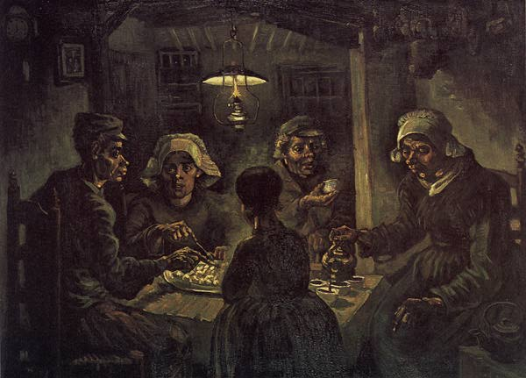

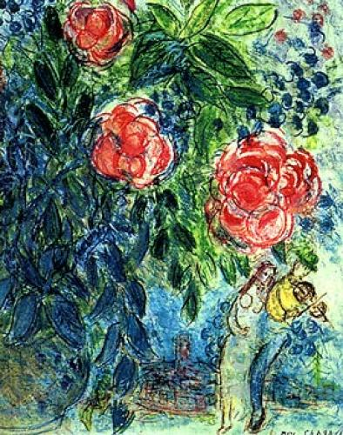


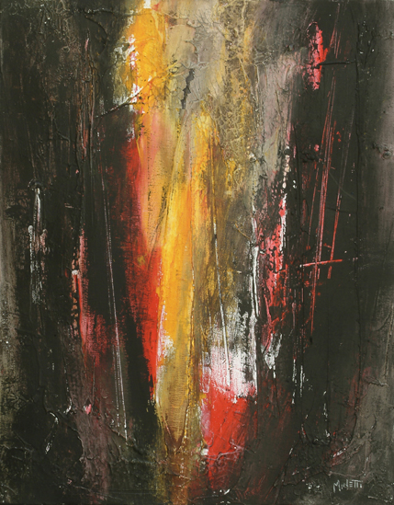

Appendix 3
Azzurro = effetto espressivo calmante, vita affettiva e istintiva = fedeltà
Rosso = capacità di recepire direttamente e scaricare gli stimoli esterni.
Marrone = approccio positivo con la madre (=Terra).
Verde = speranza /libertà / salute
Giallo = gelosia / oro / Sole /intelligenza
Rosso =amore
Bianco = innocenza / argento / Luna
Nero = morte

