

Sample sheet for exercises – IDEA

Plan of the lesson

TITEL: Fairy tales: Peter and the Wolf Level A2/B1

Activity Language: English □ L1; X□ L2

Author : European Team of EU Project “IDEA”
Timing /skills | Preparation/ Material | Procedure
5`  Indication of the content of lesson  Comprehension |  | - Teacher explains the objectives of her/his lesson: “Today we will reproduce – with our own words – the story of Peter and the Wolf in Spanish (= language of subject). Therewith we will exercise the application of the different tenses of verbs (present tense, simple past,...)”
About 15`  Introduction to the musical  Comprehension | - CD with the musical in the students’ mother language (in this case german)  - CD-player  - Poster with the instruments contributing to the musical  (to be pinned on the blackboard,  s. Annex 2).  - Illustrations of the episodes of the musical (complete set is handed out to each group,  s. Annex 3). | - Teacher gives a summary of the musical: “You may know Peter and the Wolf as one of the most beloved childrens’ musicals. The composer is Serge Prokofiev...” (s. Annex 1“notes for the teacher”)  - Teacher points to the poster: “Each instrument plays a very specific character in this musical – you will notice this while listening”  - Teacher forms groups (3-4 students) and hands out the illustrations: “The illustrations will guide you through the story”.  - Teacher: “Note the important and necessary words you will need for reconstructing the story”
26`Presentation  Comprehension | - CD play on | - Students/learners listen and take notes.
45`  Application  Use of (new) vocabulary and grammar  Teamwork | - List of new vocabulary and idioms  (s. Annex 4) | - Students/learners compare the list with their own notes; remaining unknown words are clarified in plenary.  - Teacher indicates the activity: “Each group shall reconstruct the story based on the illustrations. Please don’t use a dictionary.  - The version, interpretation and perspective of the story shall be decided within the group.  - Afterwards, each group will select a narrator and a number of actors (everyone should have a role to play).”
60` |  | - Each group presents the story to the plenary.
Feedback 15` |  | - After the presentations, the class gets together with the teacher in a circle, and comments about the experience with this novel kind of activity.

Background
Sergei Prokofiev (1891-1953) was born in the village of Sontsovka in the Donets region of the Ukraine. He was a child prodigy on the order of Mozart, composing for piano at age five and writing an opera at nine. His first teacher was his mother, a talented pianist. He attended the St. Petersburg Conservatory from 1904 to 1914, winning the Anton Rubinstein prize for best student pianist when he graduated. He travelled widely, spending many years in London and Paris, and toured the United States five times.
In 1936, Prokofiev returned to settle permanently in the Soviet Union. One of his first compositions after his return was „Peter and the Wolf“, written in just two weeks in April 1936 for a children's theatre in Moscow. Prokofiev invented the story and wrote the narration himself, drawing on memories of his own childhood. He constructed the music as a child's introduction to the orchestra, with each character in the story represented by a different instrument or group of instruments: Peter by the strings, the bird by the flute, the duck by the oboe, the cat by the clarinet, the wolf by the horn section, the hunters by timpani drums.
“Peter and the Wolf” - a prose with easily recognisable arrangements of the main musical themes - has been translated in numerous modern languages. This makes it an ideal subject for reproduction and re-telling exercises.
Besides of social and interactive goals to be achieved in this lesson, the main linguistic objective is training of tenses, for which the story – with it’s clear narrative line – is found to be particularly suitable.

Notes: Annex 1
You should plan 180 minutes for this activity.

The Story
Early one morning, Peter opened the gate and walked out into the big green meadow. On a branch of a big tree sat a little bird, Peter's friend. "All is quiet" chirped the bird happily.
Just then a duck came waddling round. She was glad that Peter had not closed the gate and decided to take a nice swim in the deep pond in the meadow. Seeing the duck, the little bird flew down upon on the grass, settled next to her and shrugged his shoulders. "What kind of bird are you if you can't fly?" said he. To this the duck replied "What kind of bird are you if you can't swim?" and dived into the pond. They argued and argued, the duck swimming in the pond and the little bird hopping along the shore.
Suddenly, something caught Peter's attention. He noticed a cat crawling through the grass. The cat thought; "That little bird is busy arguing, I'll just grab him. Stealthily, the cat crept towards him on her velvet paws. "Look out!" shouted Peter and the bird immediately flew up into the tree, while the duck quacked angrily at the cat, from the middle of the pond. The cat walked around the tree and thought, "Is it worth climbing up so high? By the time I get there the bird will have flown away."
Just then grandfather came out. He was upset because Peter had gone in the meadow. "It's a dangerous place. If a wolf should come out of the forest, then what would you do?" But Peter paid no attention to his grandfather's words. Boys like him are not afraid of wolves. But grandfather took Peter by the hand, led him home and locked the gate.
No sooner had Peter gone, than a big grey wolf came out of the forest.
In a twinkling the cat climbed up the tree. The duck quacked, and in her excitement jumped out of the pond. But no matter how hard the duck tried to run, she couldn't escape the wolf. He was getting nearer, nearer, catching up with her. Then he got her, and with one gulp, swallowed her. And now, this is how things stood: the cat was sitting on one branch, the bird on another . . . not too close to the cat. And the wolf walked around and around the tree, looking at them with greedy eyes.
In the meantime, Peter, without the slightest fear, stood behind the closed gate watching all that was going on. He ran home, got a strong rope, and climbed up the high stone wall. One of the branches of the tree, around which the wolf was walking, stretched out over the wall. Grabbing hold of the branch, Peter lightly climbed over on to the tree. Peter said to the bird: "Fly down and circle over the wolf's head. Only take care that he doesn't catch you." The bird almost touched the wolf's head with his wings while the wolf snapped angrily at him, from this side and that. How the bird worried the wolf! How he wanted to catch him! But the bird was clever, and the wolf simply couldn't do anything about it. Meanwhile, Peter made a lasso and carefully letting it down, caught the wolf by the tail and pulled with all his might. Feeling himself caught, the wolf began to jump wildly trying to get loose. But Peter tied the other end of rope to the tree, and the wolf's jumping only made the rope around his tail tighter.
Just then, the hunters came out of the woods, following the wolf's trail and shooting as they went. But Peter, sitting in the tree, said: "Don't shoot! Birdie and I have already caught the wolf. Now help us take him to the zoo."
And now, imagine the triumphant procession: Peter at the head; after him the hunters leading the wolf; and winding up the procession, grandfather and the cat. Grandfather shook his head discontentedly: "Well, and if Peter hadn't caught the wolf? What then?"
Above them flew Birdie chirping merrily. "My, what brave fellows we are, Peter and I! Look what we have caught!" And if one would listen very carefully, he could hear the duck quacking inside the wolf; because the wolf in his hurry, had swallowed her alive.

Annex 2
Poster with the different instruments
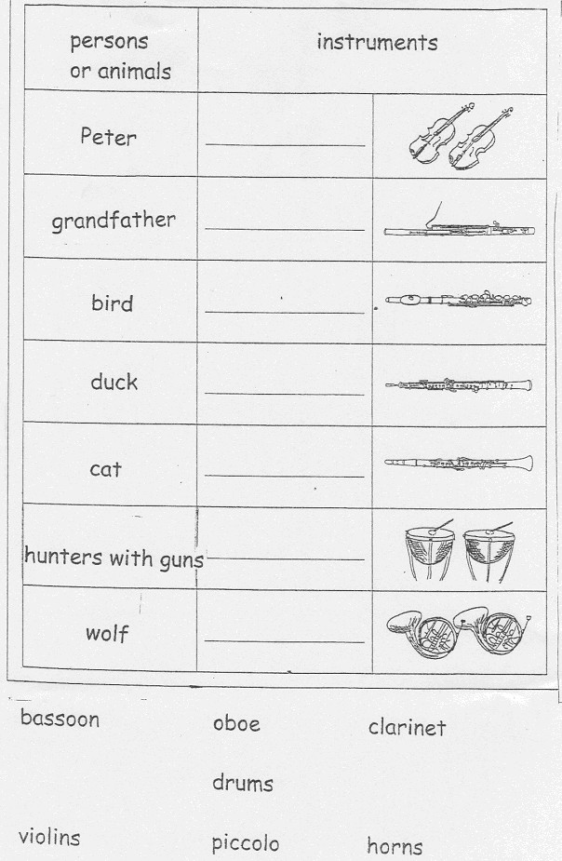

Annex 3

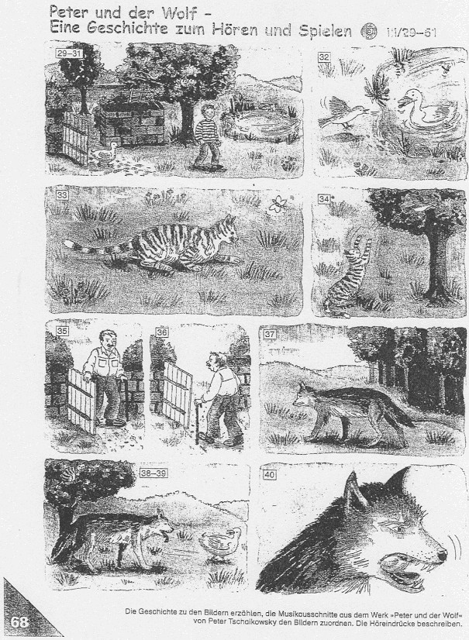

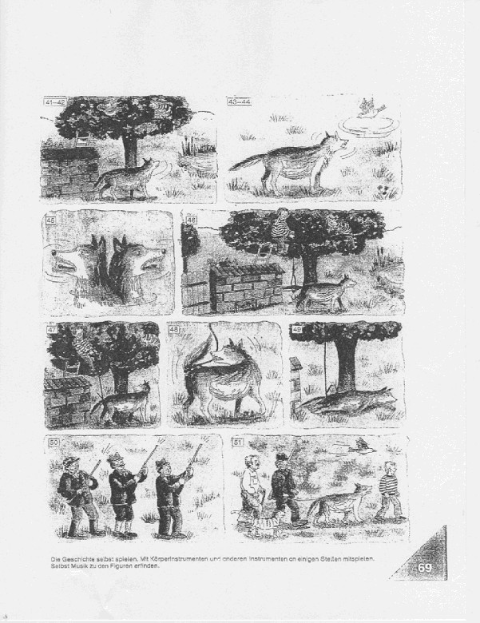

Annex 4

Vocabulary

Substantive | Verbs | Adjectives | Adverbs
meadow | to chirp | angry | happily
pond | to wad | greedy | stealthly
gulp | to shrug | tight | immidiately
rope | to hop |  | angrily
tail | to grab |  | lightly
trail | to swallow |  | discontentedly
 | to stretch out |  | merrily
 | to get loose
 | to wind up

Idioms

To pay attention
To catch attention
By the time
To be upset
No sooner
In the meantime

