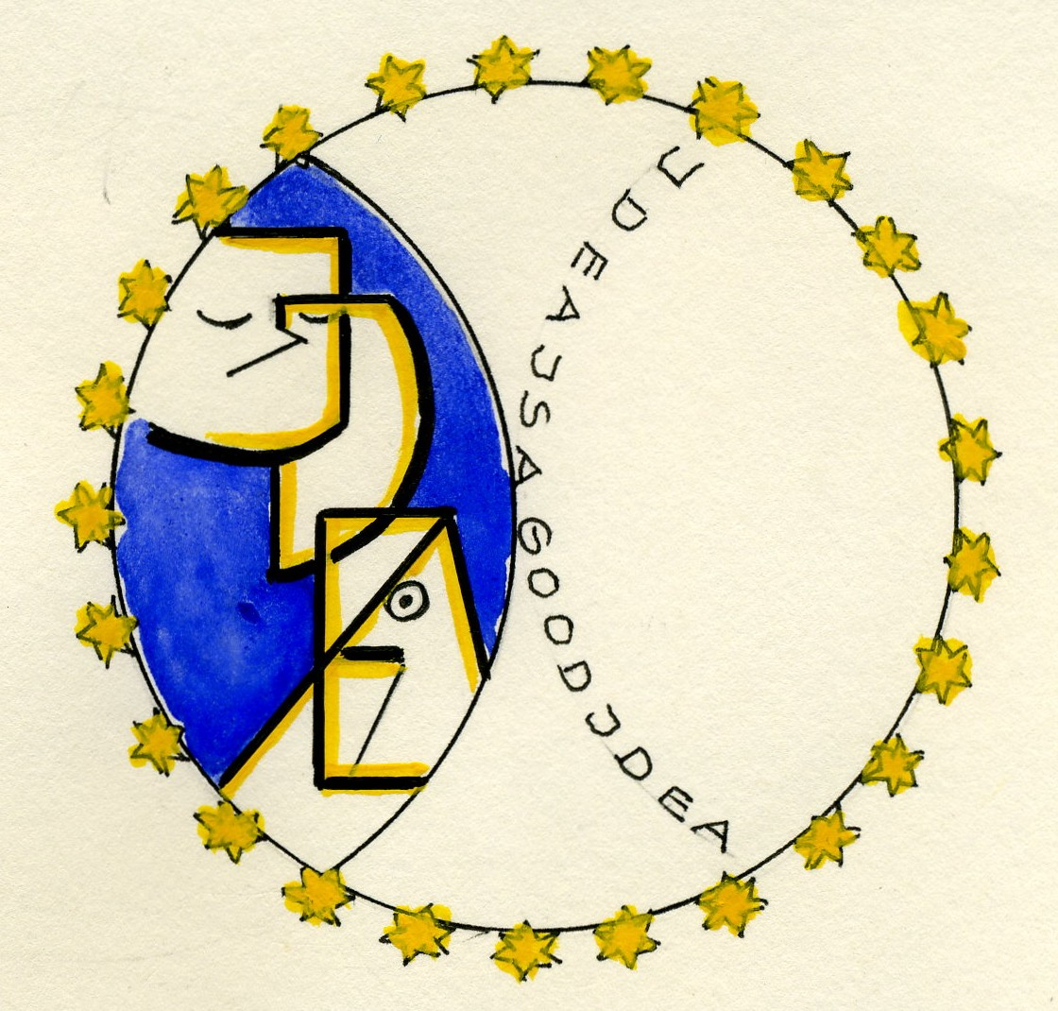

IDEA_______________________________

Plan of the lesson

TITEL: Fairy Tales and Short Stories Level : B1-C2

Iron Hans (Eisenhans) by the Brothers Grimm

Activity Language: English □ L1 X L2

Author : European Team of EU Project “IDEA”
Timing /skills | Preparation/ Material | Procedure
45´  Reading comprehen-sion –  Vocabulary training | Text of the story (see annex 1)  Text cut in stripes.  List of the meaning of the symbols (annex 2) | - Students/learners read altogether the tale and look for unknown words in their dictionaries.  - They are then given the text cut in stripes and have to find the right order of the sentences in the tale.  - They look for the symbols in the tales (e.g. Ball, appel, keys, mirror, finger, hair, sword,…)  - They are asked what is related to these symbols in this tale (e.g. mirror → conscience)  - They are also asked to describe in which other tales similar symbols are to be found. (e.g. mirror / Snow White)  - The result should be that learners/students recognize the significance of symbols in tales
10´- 30´  Vocabulary and associative training | Cards with different colours and colour shades  (see annex 3) | - Learners/students write a list of colour names in small groups and present it to the class.  - They reflect upon the colour names in relation to a language :  1. Each learner/student finds associations  with colour names and compare them  (e.g. white as snow, red like blood,  pitch-black, Red Cross, Red Sea, Red  Square, …)  2. In group of 2 or 3 learners/students find  idioms related to colour names and  eventually to human qualities and  failings  (e.g. The white heat of passion, to see  pink elephants, green with envy, to go  red = to blush, …)  - Learners/students associate colours with persons (character, professions, ….).  - E.g. If the person is red, what  personality will you relate to her/him ?  - If the person is red, she/ he is  passionate, domineering, loud.  - E.g. If the person is dressed in black,  she/he could be a waitress/waiter, a  chimney-sweep, a gravedigger, a judge,  an artist, …  - Colours related to songs: in which songs / lyrics can learners/students spontaneously find colours´ names (e.g. Azurro, Red Roses, Blue Danube, ….)
10´- 20´  Vocabulary and oral expression | Text of the story (see annex 1) | - What metals are named in this tale?  - What other metals do learners/students know?  - What are these metals used for? (e.g. one can build a garden door made of iron, jewels made of gold,…)  - Do these metals represent any human quality or failing? (e.g. nerves of steel, a will of iron, …)  - Do learners/students relate metals to any personalities, events or places? (e.g. the Iron Curtain, Iron Age, Iron Lady, Golden Twenties, copper plate engraving…)
25´  Oral and writing skills -expression | Text of the story (see annex 1)  Pictures of the tale (see annex 4) | - With the help of the pictures, learners /students give a summary of the story  - They rewrite a short form of that tale in the future. What will be different? (e.g. horses are cars, princes are managers, …)

Annex 1 : Iron Hans – The Tale
In English – 2 different translations

(www.pitt.edu/~dash/grimm136.html)

Iron Hans

Jacob and Wilhelm Grimm
Once upon a time there was a king who had a great forest near his castle, full of all kinds of wild animals. One day he sent out a huntsman to shoot a deer, but the huntsman did not come back again.
"Perhaps he has had an accident," said the king, and the following day he sent out two other huntsmen who were to search for him, but they did not return either. Then on the third day, he summoned all his huntsmen, and said, "Search through the whole forest, and do not give up until you have found all three."
But none of these came home again either, nor were any of the hounds from the pack that they had taken with them ever seen again.
From that time on, no one dared to go into these woods, and they lay there in deep quiet and solitude, and all that one saw from there was an occasional eagle or hawk flying overhead.
This lasted for many years, when an unknown huntsman presented himself to the king seeking a position, and he volunteered to go into the dangerous woods.
The king, however, did not want to give his permission, and said, "It is haunted in there. I am afraid that you will do no better than did the others, and that you will never come out again."
The huntsman answered, "Sir, I will proceed at my own risk. I know nothing of fear."
The huntsman therefore set forth with his dog into the woods. It was not long before the dog picked up a scent and wanted to follow it, but the dog had run only a few steps when it came to a deep pool, and could go no further. Then a naked arm reached out of the water, seized the dog, and pulled it under.
When the huntsman saw that, he went back and got three men. They returned with buckets and baled out the water. When they could see to the bottom, there was a wild man lying there. His body was brown like rusty iron, and his hair hung over his face down to his knees. They bound him with cords and led him away to the castle.
Everyone was greatly astonished at the wild man. The king had him put into an iron cage in his courtyard, forbidding, on pain of death, that the cage door be opened. The queen herself was to safeguard the key.
From this time forth everyone could once again go safely into the woods.
The king had a son of eight years. One day he was playing in the courtyard, and during his game his golden ball fell into the cage.
The boy ran to the cage and said, "Give me my ball."
"Not until you have opened the door for me," answered the man.
"No," said the boy, "I will not do that. The king has forbidden it," and he ran away.
The next day he came again and demanded his ball.
The wild man said, "Open my door," but the boy would not do so.
On the third day the king had ridden out hunting, and the boy went once more and said, "Even if I wanted to, I could not open the door. I do not have the key."
Then the wild man said, "It is under your mother's pillow. You can get it there."
The boy, who wanted to have his ball back, threw all caution to the wind, and got the key. The door opened with difficulty, and the boy pinched his finger. When it was open, the wild man stepped out, gave him the golden ball, and hurried away.
The boy became afraid. He cried out and called after him, "Oh, wild man, do not go away, or I shall get a beating."
The wild man turned around, picked him up, set him on his shoulders, and ran into the woods.
When the king came home he noticed the empty cage and asked the queen how it had happened. She knew nothing about it, and looked for the key, but it was gone. She called the boy, but no one answered.
The king sent out people to look for him in the field, but they did not find him. Then he could easily guess what had happened, and great sorrow ruled at the royal court.
After the wild man had once more reached the dark woods, he set the boy down from his shoulders, and said to him, "You will never again see your father and mother, but I will keep you with me, for you have set me free, and I have compassion for you. If you do what I tell you, it will go well with you. I have enough treasures and gold, more than anyone in the world."
He made a bed of moss for the boy, upon which he fell asleep. The next morning the man took him to a spring and said, "Look, this golden spring is as bright and clear as crystal. You shall sit beside it, and take care that nothing falls into it, otherwise it will be polluted. I shall come every evening to see if you have obeyed my order."
The boy sat down at the edge of the spring, and saw how sometimes a golden fish and sometimes a golden snake appeared from within, and took care that nothing fell into it. As he was thus sitting there, his finger hurt him so fiercely that he involuntarily put it into the water. He quickly pulled it out again, but saw that it was completely covered with gold. However hard he tried to wipe the gold off again, it was to no avail.
That evening Iron Hans came back, looked at the boy, and said, "What has happened to the spring?"
"Nothing, nothing," he answered, holding his finger behind his back, so the man would not be able to see it.
But the man said, "You have dipped your finger into the water. This time I will let it go, but be careful that you do not again let anything else fall in."
Very early the next morning the boy was already sitting by the spring and keeping watch. His finger hurt him again, and he rubbed it across his head. Then unfortunately a hair fell down into the spring. He quickly pulled it out, but it was already completely covered with gold.
Iron Hans came, and already knew what had happened. "You have let a hair fall into the spring," he said. "I will overlook this once more, but if it happens a third time then the spring will be polluted, and you will no longer be able to stay with me."
On the third day the boy sat by the spring and did not move his finger, however much it hurt him. But time passed slowly for him, and he looked at the reflection of his face in the water. While doing this he bent down lower and lower, wanting to look straight into his eyes, when his long hair fell from his shoulders down into the water. He quickly straightened himself up, but all the hair on his head was already covered with gold, and glistened like the sun. You can imagine how frightened the poor boy was. He took his handkerchief and tied it around his head, so that the man would not be able to see his hair.
When the man came, he already knew everything, and said, "Untie the handkerchief."
The golden hair streamed forth, and no excuse that the boy could offer was of any use.
"You have failed the test, and you can stay here no longer. Go out into the world. There you will learn what poverty is. But because you are not bad at heart, and because I mean well by you, I will grant you one thing: If you are ever in need, go into the woods and cry out, 'Iron Hans,' and then I will come and help you. My power is great, greater than you think, and I have more than enough gold and silver."
Then the prince left the woods, and walked by beaten and unbeaten paths on and on until at last he reached a great city. There he looked for work, but he was not able to find any, because he had not learned a trade by which he could make a living. Finally he went to the castle and asked if they would take him in.
The people at court did not at all know how they would be able to use him, but they took a liking to him, and told him to stay. Finally the cook took him into service, saying that he could carry wood and water, and rake up the ashes.
Once when no one else was at hand, the cook ordered him to carry the food to the royal table. Because he did not want them to see his golden hair, he kept his cap on. Nothing like this had ever before happened to the king, and he said, "When you approach the royal table you must take your hat off."
"Oh, sir," he answered, "I cannot. I have an ugly scab on my head."
Then the king summoned the cook and scolded him, asking him how he could take such a boy into his service. The cook was to send him away at once. However, the cook had pity on him, and let him trade places with gardener's boy.
Now the boy had to plant and water the garden, hoe and dig, and put up with the wind and bad weather.
Once in summer when he was working alone in the garden, the day was so hot that he took his hat off so that the air would cool him. As the sun shone on his hair it glistened and sparkled. The rays fell into the princess's bedroom, and she jumped up to see what it was.
She saw the boy and called out to him, "Boy, bring me a bouquet of flowers."
He quickly put on his cap, picked some wildflowers, and tied them together.
As he was climbing the steps with them, the gardener met him and said, "How can you take the princess a bouquet of such common flowers? Quick! Go and get some other ones, and choose only the most beautiful and the rarest ones."
"Oh, no," replied the boy, the wild ones have a stronger scent, and she will like them better."
When he got into the room, the princess said, "Take your cap off. It is not polite to keep it on in my presence."
He again responded, "I cannot do that. I have a scabby head."
She, however, took hold of his cap and pulled it off. His golden hair rolled down onto his shoulders, and it was a magnificent sight. He wanted to run away, but she held him by his arm, and gave him a handful of ducats. He went away with them, but he did not care about the gold.
He took the gold pieces to the gardener, saying, "I am giving these things to your children for them to play with."
The next day the princess called to him again, asking him to bring her a bouquet of wildflowers. When he went in with it, she immediately grabbed at his cap, and wanted to take it away from him, but he held it firmly with both hands. She again gave him a handful of ducats. He did not want to keep them, giving them instead to the gardener for his children to play with. On the third day it was no different. She was not able to take his cap away from him, and he did not want her gold.
Not long afterwards, the country was overrun by war. The king gathered together his people, not knowing whether or not fight back against the enemy, who was more powerful and had a large army.
Then the gardener's boy said, "I am grown up, and I want to go to war as well. Just give me a horse."
The others laughed and said, "After we have left, then look for one by yourself. We will leave one behind for you in the stable."
After they had left, he went into the stable, and led the horse out. It had a lame foot, and it limped higgledy-hop, higgledy-hop.
Nevertheless he mounted it, and rode away into the dark woods. When he came to the edge of the woods, he called "Iron Hans" three times so loudly that it sounded through the trees.
The wild man appeared immediately, and said, "What do you need?"
"I need a strong steed, for I am going to war."
"That you shall have, and even more than you are asking for."
Then the wild man went back into the woods, and before long a stable-boy came out of the woods leading a horse. It was snorting with its nostrils, and could hardly be restrained. Behind them followed a large army of warriors, outfitted with iron armor, and with their swords flashing in the sun.
The youth left his three-legged horse with the stable-boy, mounted the other horse, and rode at the head of the army. When he approached the battlefield, a large number of the king's men had already fallen, and before long the others would have to retreat. Then the youth galloped up with his iron army and attacked the enemies like a storm, beating down all who opposed him. They tried to flee, but the youth was right behind them, and did not stop, until not a single man was left.
However, instead of returning to the king, he led his army on a roundabout way back into the woods, and then called for Iron Hans.
"What do you need?" asked the wild man.
"Take back your steed and your army, and give me my three-legged horse again."
It all happened just as he had requested, and he rode home on his three-legged horse.
When the king returned to his castle, his daughter went to meet him, and congratulated him for his victory.
"I am not the one who earned the victory," he said, "but a strange knight who came to my aid with his army."
The daughter wanted to hear who the strange knight was, but the king did not know, and said, "He pursued the enemy, and I did not see him again."
She asked the gardener where his boy was, but he laughed and said, "He has just come home on his three-legged horse. The others have been making fun of him and shouting, 'Here comes our higgledy-hop back again.' They also asked him, 'Under what hedge have you been lying asleep all this time?' But he said, 'I did better than anyone else. Without me it would have gone badly.' And then they laughed at him all the more."
The king said to his daughter, "I will proclaim a great festival. It shall last for three days, and you shall throw a golden apple. Perhaps the unknown knight will come."
When the festival was announced, the youth went out into the woods and called Iron Hans.
"What do you need?" he asked.
"To catch the princess's golden apple."
"It is as good as done," said Iron Hans. "And further, you shall have a suit of red armor and ride on a spirited chestnut horse."
When the day came, the youth galloped up, took his place among the knights, and was recognized by no one. The princess came forward and threw a golden apple to the knights. He was the only one who caught it, and as soon as he had it, he galloped away.
On the second day Iron Hans had outfitted him as a white knight, and had given him a white horse. Again he was the only one who caught the apple. Without lingering an instant, he galloped away with it.
The king grew angry and said, "That is not allowed. He must appear before me and tell me his name."
He gave the order that if the knight who caught the apple, were to go away again, they should pursue him, and if he would not come back willingly, they were to strike and stab at him.
On the third day, he received from Iron Hans a suit of black armor and a black horse, and he caught the apple again. But when he was galloping away with it, the king's men pursued him, and one of them got so close to him that he wounded the youth's leg with the point of his sword. In spite of this he escaped from them, but his horse jumped so violently that his helmet fell from his head, and they could see that he had golden hair. They rode back and reported everything to the king.
The next day the princess asked the gardener about his boy.
"He is at work in the garden. The strange fellow has been at the festival too. He came home only yesterday evening. And furthermore, he showed my children three golden apples that he had won."
The king had him summoned, and he appeared, again with his cap on his head. But the princess went up to him and took it off. His golden hair fell down over his shoulders, and he was so handsome that everyone was amazed.
"Are you the knight who came to the festival every day, each time in a different color, and who caught the three golden apples?" asked the king.
"Yes," he answered, "and here are the apples," taking them out of his pocket, and returning them to the king. "If you need more proof, you can see the wound that your men gave me when they were chasing me. But I am also the knight who helped you to your victory over your enemies."
"If you can perform deeds like these then you are not a gardener's boy. Tell me, who is your father?"
"My father is a powerful king, and I have as much gold as I might need."
"I can see," said the king, "that I owe you thanks. Can I do anything for you?"
"Yes," he answered. "You can indeed. Give me your daughter for my wife."
The maiden laughed and said, "He does not care much for ceremony, but I already had seen from his golden hair that he was not a gardener's boy," and then she went and kissed him.
His father and mother came to the wedding, and were filled with joy, for they had given up all hope of ever seeing their dear son again.
While they sitting at the wedding feast, the music suddenly stopped, the doors opened, and a proud king came in with a great retinue. He walked up to the youth, embraced him, and said, "I am Iron Hans. I had been transformed into a wild man by a magic spell, but you have broken the spell. All the treasures that I possess shall belong to you."

http://www.paralumun.com/grimmironhans.htm
IRON HANS
There was once upon a time a king who had a great forest near his palace, full of all kinds of wild animals. One day he sent out a huntsman to shoot him a roe, but he did not come back. 'Perhaps some accident has befallen him,' said the king, and the next day he sent out two more huntsmen who were to search for him, but they too stayed away. Then on the third day, he sent for all his huntsmen, and said: 'Scour the whole forest through, and do not give up until you have found all three.' But of these also, none came home again, none were seen again. From that time forth, no one would any longer venture into the forest, and it lay there in deep stillness and solitude, and nothing was seen of it, but sometimes an eagle or a hawk flying over it. This lasted for many years, when an unknown huntsman announced himself to the king as seeking a situation, and offered to go into the dangerous forest. The king, however, would not give his consent, and said: 'It is not safe in there; I fear it would fare with you no better than with the others, and you would never come out again.' The huntsman replied: 'Lord, I will venture it at my own risk, of fear I know nothing.'
The huntsman therefore betook himself with his dog to the forest. It was not long before the dog fell in with some game on the way, and wanted to pursue it; but hardly had the dog run two steps when it stood before a deep pool, could go no farther, and a naked arm stretched itself out of the water, seized it, and drew it under. When the huntsman saw that, he went back and fetched three men to come with buckets and bale out the water. When they could see to the bottom there lay a wild man whose body was brown like rusty iron, and whose hair hung over his face down to his knees. They bound him with cords, and led him away to the castle. There was great astonishment over the wild man; the king, however, had him put in an iron cage in his courtyard, and forbade the door to be opened on pain of death, and the queen herself was to take the key into her keeping. And from this time forth everyone could again go into the forest with safety.
The king had a son of eight years, who was once playing in the courtyard, and while he was playing, his golden ball fell into the cage. The boy ran thither and said: 'Give me my ball out.' 'Not till you have opened the door for me,' answered the man. 'No,' said the boy, 'I will not do that; the king has forbidden it,' and ran away. The next day he again went and asked for his ball; the wild man said: 'Open my door,' but the boy would not. On the third day the king had ridden out hunting, and the boy went once more and said: 'I cannot open the door even if I wished, for I have not the key.' Then the wild man said: 'It lies under your mother's pillow, you can get it there.' The boy, who wanted to have his ball back, cast all thought to the winds, and brought the key. The door opened with difficulty, and the boy pinched his fingers. When it was open the wild man stepped out, gave him the golden ball, and hurried away. The boy had become afraid; he called and cried after him: 'Oh, wild man, do not go away, or I shall be beaten!' The wild man turned back, took him up, set him on his shoulder, and went with hasty steps into the forest. When the king came home, he observed the empty cage, and asked the queen how that had happened. She knew nothing about it, and sought the key, but it was gone. She called the boy, but no one answered. The king sent out people to seek for him in the fields, but they did not find him. Then he could easily guess what had happened, and much grief reigned in the royal court.
When the wild man had once more reached the dark forest, he took the boy down from his shoulder, and said to him: 'You will never see your father and mother again, but I will keep you with me, for you have set me free, and I have compassion on you. If you do all I bid you, you shall fare well. Of treasure and gold have I enough, and more than anyone in the world.' He made a bed of moss for the boy on which he slept, and the next morning the man took him to a well, and said: 'Behold, the gold well is as bright and clear as crystal, you shall sit beside it, and take care that nothing falls into it, or it will be polluted. I will come every evening to see if you have obeyed my order.' The boy placed himself by the brink of the well, and often saw a golden fish or a golden snake show itself therein, and took care that nothing fell in. As he was thus sitting, his finger hurt him so violently that he involuntarily put it in the water. He drew it quickly out again, but saw that it was quite gilded, and whatsoever pains he took to wash the gold off again, all was to no purpose. In the evening Iron Hans came back, looked at the boy, and said: 'What has happened to the well?' 'Nothing nothing,' he answered, and held his finger behind his back, that the man might not see it. But he said: 'You have dipped your finger into the water, this time it may pass, but take care you do not again let anything go in.' By daybreak the boy was already sitting by the well and watching it. His finger hurt him again and he passed it over his head, and then unhappily a hair fell down into the well. He took it quickly out, but it was already quite gilded. Iron Hans came, and already knew what had happened. 'You have let a hair fall into the well,' said he. 'I will allow you to watch by it once more, but if this happens for the third time then the well is polluted and you can no longer remain with me.'
On the third day, the boy sat by the well, and did not stir his finger, however much it hurt him. But the time was long to him, and he looked at the reflection of his face on the surface of the water. And as he still bent down more and more while he was doing so, and trying to look straight into the eyes, his long hair fell down from his shoulders into the water. He raised himself up quickly, but the whole of the hair of his head was already golden and shone like the sun. You can imagine how terrified the poor boy was! He took his pocket- handkerchief and tied it round his head, in order that the man might not see it. When he came he already knew everything, and said: 'Take the handkerchief off.' Then the golden hair streamed forth, and let the boy excuse himself as he might, it was of no use. 'You have not stood the trial and can stay here no longer. Go forth into the world, there you will learn what poverty is. But as you have not a bad heart, and as I mean well by you, there is one thing I will grant you; if you fall into any difficulty, come to the forest and cry: "Iron Hans," and then I will come and help you. My power is great, greater than you think, and I have gold and silver in abundance.'
Then the king's son left the forest, and walked by beaten and unbeaten paths ever onwards until at length he reached a great city. There he looked for work, but could find none, and he learnt nothing by which he could help himself. At length he went to the palace, and asked if they would take him in. The people about court did not at all know what use they could make of him, but they liked him, and told him to stay. At length the cook took him into his service, and said he might carry wood and water, and rake the cinders together. Once when it so happened that no one else was at hand, the cook ordered him to carry the food to the royal table, but as he did not like to let his golden hair be seen, he kept his little cap on. Such a thing as that had never yet come under the king's notice, and he said: 'When you come to the royal table you must take your hat off.' He answered: 'Ah, Lord, I cannot; I have a bad sore place on my head.' Then the king had the cook called before him and scolded him, and asked how he could take such a boy as that into his service; and that he was to send him away at once. The cook, however, had pity on him, and exchanged him for the gardener's boy.
And now the boy had to plant and water the garden, hoe and dig, and bear the wind and bad weather. Once in summer when he was working alone in the garden, the day was so warm he took his little cap off that the air might cool him. As the sun shone on his hair it glittered and flashed so that the rays fell into the bedroom of the king's daughter, and up she sprang to see what that could be. Then she saw the boy, and cried to him: 'Boy, bring me a wreath of flowers.' He put his cap on with all haste, and gathered wild field-flowers and bound them together. When he was ascending the stairs with them, the gardener met him, and said: 'How can you take the king's daughter a garland of such common flowers? Go quickly, and get another, and seek out the prettiest and rarest.' 'Oh, no,' replied the boy, 'the wild ones have more scent, and will please her better.' When he got into the room, the king's daughter said: 'Take your cap off, it is not seemly to keep it on in my presence.' He again said: 'I may not, I have a sore head.' She, however, caught at his cap and pulled it off, and then his golden hair rolled down on his shoulders, and it was splendid to behold. He wanted to run out, but she held him by the arm, and gave him a handful of ducats. With these he departed, but he cared nothing for the gold pieces. He took them to the gardener, and said: 'I present them to your children, they can play with them.' The following day the king's daughter again called to him that he was to bring her a wreath of field-flowers, and then he went in with it, she instantly snatched at his cap, and wanted to take it away from him, but he held it fast with both hands. She again gave him a handful of ducats, but he would not keep them, and gave them to the gardener for playthings for his children. On the third day things went just the same; she could not get his cap away from him, and he would not have her money.
Not long afterwards, the country was overrun by war. The king gathered together his people, and did not know whether or not he could offer any opposition to the enemy, who was superior in strength and had a mighty army. Then said the gardener's boy: 'I am grown up, and will go to the wars also, only give me a horse.' The others laughed, and said: 'Seek one for yourself when we are gone, we will leave one behind us in the stable for you.' When they had gone forth, he went into the stable, and led the horse out; it was lame of one foot, and limped hobblety jib, hobblety jib; nevertheless he mounted it, and rode away to the dark forest. When he came to the outskirts, he called 'Iron Hans' three times so loudly that it echoed through the trees. Thereupon the wild man appeared immediately, and said: 'What do you desire?' 'I want a strong steed, for I am going to the wars.' 'That you shall have, and still more than you ask for.' Then the wild man went back into the forest, and it was not long before a stable-boy came out of it, who led a horse that snorted with its nostrils, and could hardly be restrained, and behind them followed a great troop of warriors entirely equipped in iron, and their swords flashed in the sun. The youth made over his three-legged horse to the stable-boy, mounted the other, and rode at the head of the soldiers. When he got near the battlefield a great part of the king's men had already fallen, and little was wanting to make the rest give way. Then the youth galloped thither with his iron soldiers, broke like a hurricane over the enemy, and beat down all who opposed him. They began to flee, but the youth pursued, and never stopped, until there was not a single man left. Instead of returning to the king, however, he conducted his troop by byways back to the forest, and called forth Iron Hans. 'What do you desire?' asked the wild man. 'Take back your horse and your troops, and give me my three-legged horse again.' All that he asked was done, and soon he was riding on his three-legged horse. When the king returned to his palace, his daughter went to meet him, and wished him joy of his victory. 'I am not the one who carried away the victory,' said he, 'but a strange knight who came to my assistance with his soldiers.' The daughter wanted to hear who the strange knight was, but the king did not know, and said: 'He followed the enemy, and I did not see him again.' She inquired of the gardener where his boy was, but he smiled, and said: 'He has just come home on his three- legged horse, and the others have been mocking him, and crying: "Here comes our hobblety jib back again!" They asked, too: "Under what hedge have you been lying sleeping all the time?" So he said: "I did the best of all, and it would have gone badly without me." And then he was still more ridiculed.'
The king said to his daughter: 'I will proclaim a great feast that shall last for three days, and you shall throw a golden apple. Perhaps the unknown man will show himself.' When the feast was announced, the youth went out to the forest, and called Iron Hans. 'What do you desire?' asked he. 'That I may catch the king's daughter's golden apple.' 'It is as safe as if you had it already,' said Iron Hans. 'You shall likewise have a suit of red armour for the occasion, and ride on a spirited chestnut-horse.' When the day came, the youth galloped to the spot, took his place amongst the knights, and was recognized by no one. The king's daughter came forward, and threw a golden apple to the knights, but none of them caught it but he, only as soon as he had it he galloped away.
On the second day Iron Hans equipped him as a white knight, and gave him a white horse. Again he was the only one who caught the apple, and he did not linger an instant, but galloped off with it. The king grew angry, and said: 'That is not allowed; he must appear before me and tell his name.' He gave the order that if the knight who caught the apple, should go away again they should pursue him, and if he would not come back willingly, they were to cut him down and stab him.
On the third day, he received from Iron Hans a suit of black armour and a black horse, and again he caught the apple. But when he was riding off with it, the king's attendants pursued him, and one of them got so near him that he wounded the youth's leg with the point of his sword. The youth nevertheless escaped from them, but his horse leapt so violently that the helmet fell from the youth's head, and they could see that he had golden hair. They rode back and announced this to the king.
The following day the king's daughter asked the gardener about his boy. 'He is at work in the garden; the queer creature has been at the festival too, and only came home yesterday evening; he has likewise shown my children three golden apples which he has won.'
The king had him summoned into his presence, and he came and again had his little cap on his head. But the king's daughter went up to him and took it off, and then his golden hair fell down over his shoulders, and he was so handsome that all were amazed. 'Are you the knight who came every day to the festival, always in different colours, and who caught the three golden apples?' asked the king. 'Yes,' answered he, 'and here the apples are,' and he took them out of his pocket, and returned them to the king. 'If you desire further proof, you may see the wound which your people gave me when they followed me. But I am likewise the knight who helped you to your victory over your enemies.' 'If you can perform such deeds as that, you are no gardener's boy; tell me, who is your father?' 'My father is a mighty king, and gold have I in plenty as great as I require.' 'I well see,' said the king, 'that I owe my thanks to you; can I do anything to please you?' 'Yes,' answered he, 'that indeed you can. Give me your daughter to wife.' The maiden laughed, and said: 'He does not stand much on ceremony, but I have already seen by his golden hair that he was no gardener's boy,' and then she went and kissed him. His father and mother came to the wedding, and were in great delight, for they had given up all hope of ever seeing their dear son again. And as they were sitting at the marriage-feast, the music suddenly stopped, the doors opened, and a stately king came in with a great retinue. He went up to the youth, embraced him and said: 'I am Iron Hans, and was by enchantment a wild man, but you have set me free; all the treasures which I possess, shall be your property.'
http://www.paralumun.com/grimmironhans.htm
www.bcdb.com/cartoon_synopsis/31688-Iron_Hans.html
www.bcdb.com/cartoon/31688-Iron_Hans.html
www.pitt.edu/~dash/grimm136.html

Annex 2 : List of the meaning of symbols in IRON HANS

Colours symbols in Iron Hans

The sequence of the colours
red - white - black
stands for the process of maturing.
In relation with iron : red is iron ore
white is the annealing iron
Black is the steeled iron

Words symbolic

Golden hair = of royal descent
Keys = evolution steps
Fingers = decisive metamorphosis / changes
Golden ball = cosmos, sunny, extraterrestrial
Mirror = look in oneself
Fontaine = life
Poverty = material world
Hair = vitality
Apple = earthy world

Annex 3 : Colours and shapes

Yellow | Red | Blue
Black | White
Pink | Sand | Turquoise | Apple green
Violet | Orange | King Blue | Olive green
Rusty red | Gold | Ultramarine | Light green
Rose | Safran | Sky blue | Trees green
Wine red | Terracotta | Mouse grey | Chocolate brown
Annex 4 : Pictures of the tale (original drawings made by Hanna Häusler-Strahl)

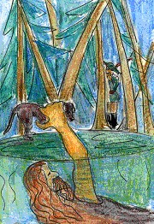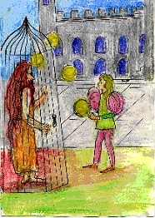
Picture 1 Picture 2

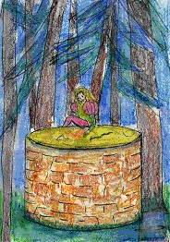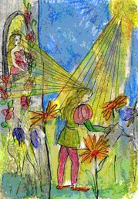
Picture 3 Picture 4

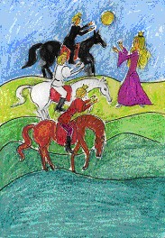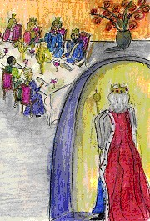
Picture 5 Picture 6

