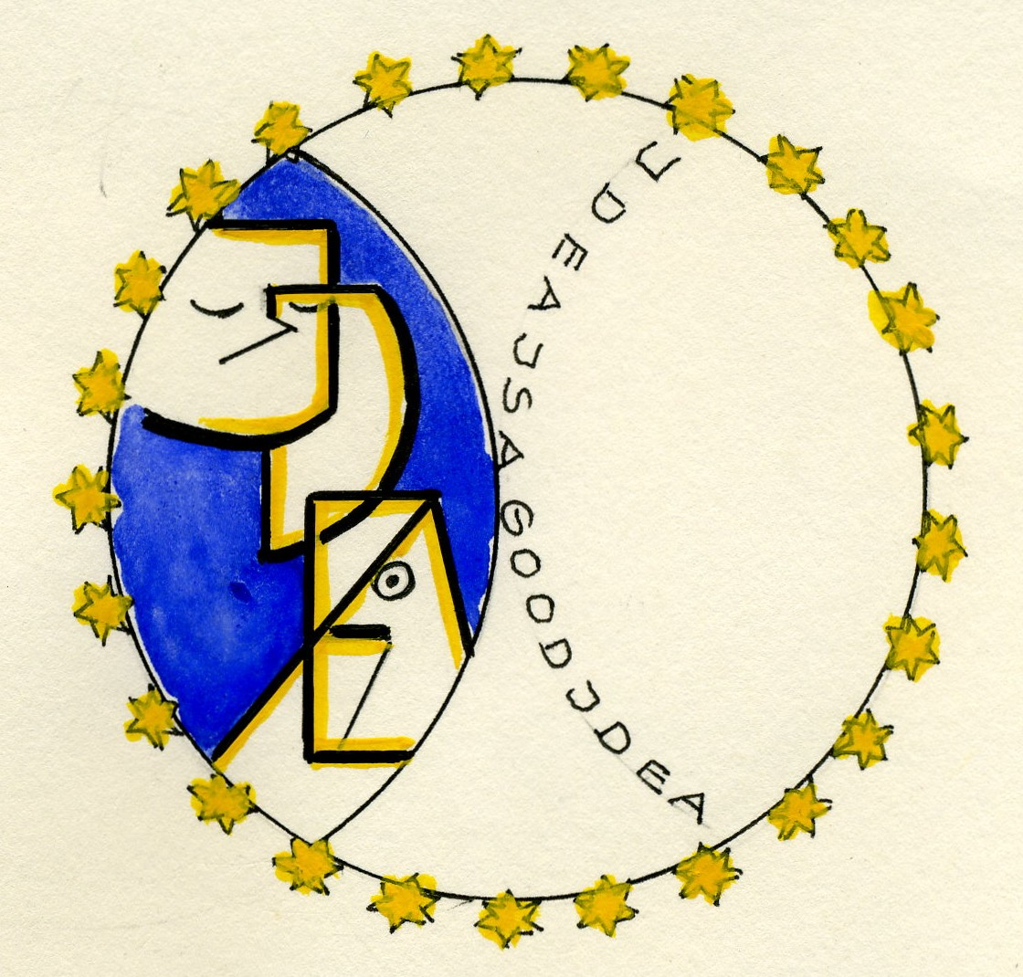

IDEA

Plan of the lesson

TITEL: About Tales and their characters Level : A1

Activity Language: English □ L1 □ L2

Author : European Team of EU Project “IDEA”
Timing /skills | Preparation/ Material | Procedure
15´  Brain-storming –  Vocabulary training,  Association of ideas | List of tales´name and characters or cards  (see example 1 below) | - Students/learners are asked to tell their classmates which tale is/was their favourite one. They write all together on cards words they relate to the tales previously named (e.g. Cinderella → shoes, sisters, mice, cat, horses, dress, ball, ballroom…..)  - Students/learners are asked to tell their classmates which tales´ character is/was their favourite one and to give an adjective describing the person or animal. ( e.g. pretty Cinderella, wooden Pinocchio, smart cat O´Malley in the Aristocats, clumsy bear Baloo in The Jungle Book,…..)
25´  Description –  Written or oral skill training  Grammar: There is/are…  Vocabulary: directions, prepositions | - Pictures / paintings related to some tales or short stories  - (see example 2 )  - a revision sheet with “there is/there are”  - a revision sheet with “directions” words and prepositions (on the right, on the left, in the middle of, next to, etc..)  (well adapted for 3rd age people – memorizing skill ) | - Students/learners can choose a picture /painting out of the supplied examples  - All together they reflect upon the expressions needed to introduce a description or a report (e.g. “This is a picture of Wilhelm Tell and his son. The boy is still young. He is looking at his father. In the right corner of the picture there is/are..). The teacher/tutor writes a list on the blackboard.  - Pair work: Students/learners prepare a short description of their 2 pictures  - Presentation in plenum

Example 1

Main character | Important characters | Less important characters | Others
Snow White | The 7 dwarfs  The Queen  The Prince | The huntsman  The Prince´s servants | The King
Cinderella | The stepmother  The 2 sisters  The godmother in Walt Disney film / a bird in the original story  The Prince | Pigeons  Turtle doves  Birds  Cat  Dog  Mice  Horses | The father  The King
Little Red-Cap | The wolf  The grand´mother | The mother  The huntsman
Mowgli | Bagheera  Baloo  Shere Khan  Kaa | The monkeys  The wolf family | The girl  The birds
http://www.ucs.mun.ca/~wbarker/fairies/grimm/

Example 2
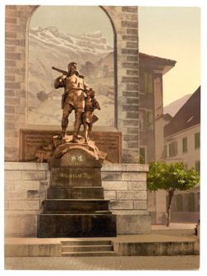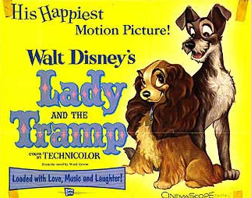

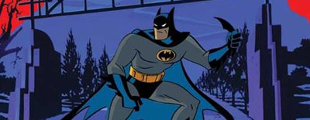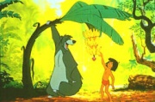

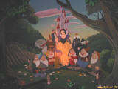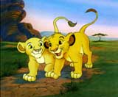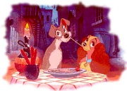

http://www.dlptour.de/disneyland/fantasyland/attraktionen/blancheneige/blancheneige.htm
http://www.duckipedia.de/index.php?title=Walt_Disney_Meisterwerk
http://de.duckipedia.org/index.php/Susi_und_Strolch
http://de.duckipedia.org/index.php/Das_Dschungelbuch
http://www.cs.cmu.edu/~spok/grimmtmp/

with songs and music

Some more

The legend of William Tell
William Tell from Bürglen was known as an expert marksman with the crossbow. At the time, the Habsburg emperors were seeking to dominate Uri. Hermann Gessler, the newly appointed Austrian Vogt of Altdorf raised a pole in the village's central square with his hat on top and demanded that all the local townsfolk bow before it. As Tell passed by without bowing, he was arrested. He received the punishment of being forced to shoot an apple off the head of his son, Walter, or else both would be executed.
Tell had been promised freedom if he shot the apple. On November 18, 1307, Tell split the fruit with a single bolt from his crossbow, without mishap. When Gessler queried him about the purpose of the second arrow in his quiver, Tell answered that if he had ended up killing his son in that trial, he would have turned the crossbow on the reeve. Gessler became enraged at that comment, and had Tell bound and brought to his ship to be taken to his castle at Küssnacht. In a storm on Lake Lucerne, Tell managed to escape. On land, he went to Küssnacht, and when Gessler arrived, he shot him with a crossbow bolt.
This defiance of the Austrian reeve sparked a rebellion, leading to the formation of the Old Swiss Confederacy.
http://en.wikipedia.org/wiki/William_Tell
Guillaume Tell (William Tell) is an opera in four acts by Gioacchino Rossini to a French libretto by Etienne de Jouy and Hippolyte Bis, based on Friedrich Schiller's Wilhelm Tell. It was first performed at the Paris Opéra on August 3, 1829.
It has been performed in Italian under the title Guglielmo Tell. However, today the opera is rarely performed in any language, and it is known mostly for its overture.
William Tell was Rossini's final opera even though the composer lived happily between France and Italy for nearly another 40 years afterwards. There are several recordings of it, but its length (roughly six hours) and casting requirements (the tenor role contains 28 high Cs) contribute to the difficulty in producing the opera. When it is performed, it is often heavily cut
http://www.answers.com

