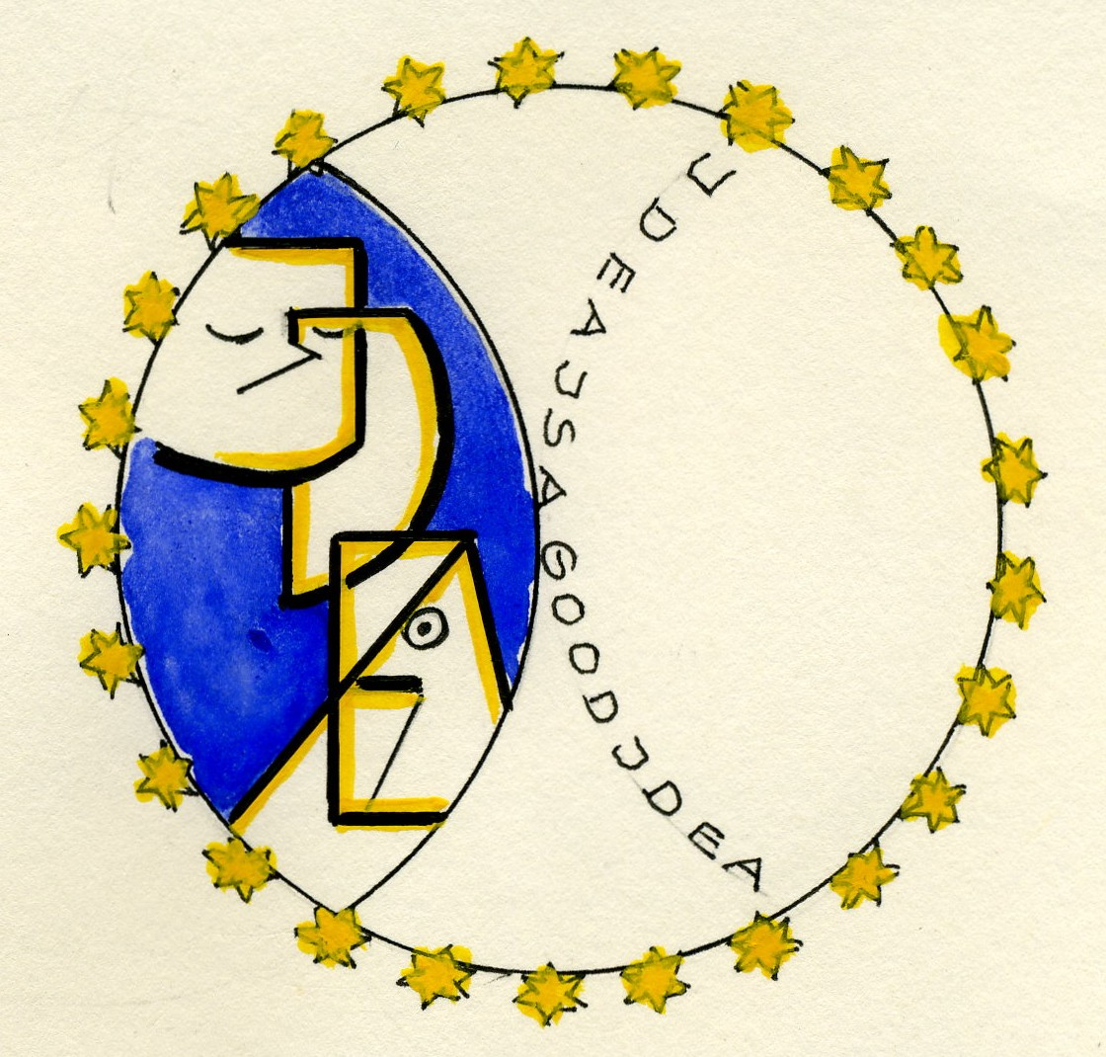

IDEA

Plan of the lesson

TITEL: Fairy tales and short stories : Walt Disney World

Level : B1-B2

Activity Language: English x L1 x L2

Author : European Team of EU Project “IDEA”
Timing /skills | Preparation/ Material | Procedure
4-5 hours for the writing and 4-5 hours for producing the film  Writing/speaking skills | - See example 1 below | - Learners/students write the following of one famous tale as a scenario with dialogs keeping in mind the characters / manners /behaviour of the different persons/animals (e.g. in “Snow White”: “Sleepy” is always tired, Bashful is always shy,…)  - They decide altogether who is going to play each role  - They produce a short picture
35 ´  Listening / comprehen-sion/ oral skills | - A selection of film music (Walt Disney)  (e.g. “The Magic of Disney” -20 Superstar Hits Nr. 09274 52542) | - Walt Disney started very successfully to bring out classic tales as movies. Songs were written for each of them. Lots of them are known all over the world.  - In teams of two persons learners/students listened to very short part of different songs and write on a sheet from which movie they are.  - After listening twice to the tape each team gives his list to the following team (right side).  - The teacher gives the solution during listening a 3rd time to the tape  - Each right answer gets 1 point. The team with the most points is the winner team.
45´  Listening/ vocabulary/ grammar | - Some songs of famous fairy tales movies  - Bring some lyrics (see example 2) | - The learners/students are asked to select two well known songs of fairy tales movies (e.g. The Lion King, Snow White)  - They listen to the song and then they are asked to describe the situations related to the song  - When reading the lyrics they look for adjectives and give the opposites  - When reading they look for verbs and have to give a past and a future form of thess verbs  - After reading they try to find a rime word (phonetically) to each line of the lyric (e.g. From the “Beauty and the Beast”  Tale as old as time -→ mime  True as it can be -→ tea  Barely even friends-→ ….  Then somebody bends -→…..  Unexpectedly -→ …
 | - See example 3 below  - See example 4 below | - Learners/students write a short tale (max. 2 sheets) in group of 2-3 persons.  - Learners/students choose a title and write a song to accompany their tale and if possible the music, too. And record it.

Example 1
Genuine example written in an English course
Note that it is not important that the language and grammar are perfect; the creativity is a better mean to sensibly the learners for a language.

Snow White

and

the seven dwarfs
Snow White and the Seven Dwarfs

Starring. | The reader | = | R
 | Snow White | = | SW
 | The Prince | = | P
 | Doc | = | D
 | Grumpy | = | G
 | Sleepy | = | Sl
 | Sneezy | = | Sn
 | Bashful | = | B
 | Happy | = | H
 | Dopey | = | Dop

R: | 25 years later.  Little Snow White and Prince George are going to celebrate their 25th wedding anniversary.  They have been invited by the Seven Dwarfs.  The little men are busy preparing the table for the event.
Dop: | (with a bunch of flowers in his hands)  No festivity without flowers. Now it looks prettier!
G: | What nonsense! We´ re as mad as a hatter. Why must we invite them? Is it our anniversary? Snow White and the prince celebrate their 25th wedding day, we don´ t. They should invite us.
Sl: | (wakes up and yawns)  Who is invited?
B: | Our Little Snow White and her husband.
Sn: | Ha, ha, ha………..
 | (Dopey and Happy hurry up to Sneezy and put their fingers under his nose: too late!)
Sn: | tschiiiiii………….
 | (cut: vase has fallen down, the flowers are without petals)
D: | (annoyed)  Why can` t you pull yourself together?  We´ re late. Snow White and her Prince will arrive at any moment and you´ re spoiling the whole decoration.  And where is the menu?
H: | (turning away)  We´ re as busy as bees here! I´ll go and fetch the big pudding.
Sl: | (wakes up again)  Pudding? Who has eaten my pudding?
G: | Nobody. But if you keep on sleeping all the time, you won`t get any pudding.
Sn: | (takes a deep breath again)  Ha, ha, ha………….
 | (Dopey and Happy jump up on Sneezy´s feet and put their fingers under his nose, but Grumpy is faster: he hits Sneezy on his head)
Sn: | (soft and coy)  …………………tschiii………………..
 | (Happy comes back to the other. His mouth is smeared with pudding. He licks his fingers.)
D: | (annoyed)  What are you doing, Happy?
H: | (caught in the act, unsure)  Oh!….er….I just tried the pudding a little bit!
D: | (reprimanding)  With your dirty finger?
H: | (smiles)  Don´ t worry. My finger isn´ t dirty any longer.
D: | Come here at once, all together. I want to see your hands:
(cut: close up: dirty hands.
Zoom from the hands to the persons - Sleepy snores.)
(cut: Happy, Sneezy, Bashful, Dopey in a line, hands behind their backs.)
D: | Oh! My goodness! Put immediately your hands in front of you, otherwise I can´ t see whether they are clean or not!
 | (All the dwarfs wipe their hands on their trousers, then they hold their dirty hands in front of them.)
D: | You could drive me to despair! Shame on you! No one has washed his hands.  (Doc shouts)  Grumpy, what´ s up with you? Sleepy, wake up!
Sl: | (frightened, falls down from his chair)  Where is my pudding?
G: | I don´ t wash my hands more then twice a year. Celebration or no celebration!
D: | Don´ t be silly! You know Snow White likes to see clean dwarfs. Go and wash yourselves, all of you!
 | (Grumpy puts demonstratively his hands in his trouser pockets. All the other dwarfs go to a wash tub and wash their hands, then they return to the table and sing)
All: | Hey ho, hey ho, we are happy and go  la, la, la, la, la, la, la, la
H: | (pompously)  I guess it´s important to be sure that the pudding tastes good! We should try it!
(He puts his finger into the pudding bowl.)
(All the dwarfs start to try the pudding, it tastes really good, within a few minutes the bowl is empty)
D: | (realizing the “disaster”)  And now? It´ s terrible! We haven´ t got any dessert! What shall we do? Little Snow White is expecting a festive board.
Dop: | No problem! We´ ll call the pizza service and ask for some tiramisu!
Sn: | (excited, points far away)  Look, look, look………….
 | (Dopey and Happy run to him and put their fingers under his nose)
Sn: | (impatient, points again)  Go away! Look over there! It seems to me Little Snow White is coming!
(cut: Snow White and Prince George have arrived.
All the dwarfs are dancing around them and are singing)
All: | Hey ho, hey ho,  we are happy, she´ s here  la, la, la, la, la, la, la, la  hey ho, hey ho……………….
D: | (Doc tries to stop them)  It´s enough! Be quiet now! Let me say a few words to our guests.
D: | (he looks at Snow White and says warmly)  Nice to see you after such a long time, you look prettier than ever.
P: | We also are glad to see you all and thank you for inviting us.
All: | We are so happy! We missed you very much, dear Snow White!
G: | I´ m not happy, I dislike parties.
 | (Snow White smiles and goes to Grumpy)
SW: | You didn´ t change a bit, Grumpy. Still annoying everyone with your bad temper!
Dop: | But I changed, I learned to speak now.
Sl: | Yes, it ´ s really terrible, he speaks all the time now. No peace anymore!
Dop: | It´ s not true, you lie! I don´ t speak all the time, I only tell you how I feel in your company!
D: | Don´ t argue! Let´ s go to the house and start the party !
SW : | (unfriendly, to the Prince)  And you can help me to go in!
P | (the Prince hurries to Snow White)  Yes, my dear! At once, love! I´ m here, honey!
SW: | (Snow White , cross)  Always too late! You´ re dreaming and never look after me.
(the Prince helps Snow White into the house. She doesn´ t look very glad.)
(Happy and Sneezy standing at the door.)
Sn: | I……..I´ m happy to celebrate with ………….ha………….  ha…………ha…………chi………you.
H: | Come in please, dear Snow White, dear Prince and sit down.  We have prepared an excellent meal.
 | (Snow White and the Prince go into the house followed by the dwarfs. Snow White goes slowly to Bashful.)
SW: | Oh! My dear Bashful! You still look as nice as ever! Have you got a new cap?
 | (Bashful gets red and says:)
B: | Here Snow White, I´ ve got a special present, only for you!  (he takes a diamond out of his pocket and gives it to the princess.)
SW: | Oh! Bashful! It´ s too much really! How wonderful! You know diamonds are a woman´ s best friends!  (she kisses Bashful on the cheek.)
P: | (the Prince who is a few steps away from Snow White looks at Bashful and says:)  Snow White! Snow White! Always and everywhere only Snow White! Why for heaven´ s sake did I kiss her 25 years ago?
G: | For once I agree with you!
Dop: | (to the Prince and to Snow White)  Look what we´ ve prepared for you! Come! I´ m so hungry!
H: | (singing)  I feel happy, I´ m so happy! You ´re here and everything is bright………
D: | Stop it, Happy! We´ re going to eat now. Come Snow White, sit on my right. And you, dear Prince, sit on my left.
SW: | (Snow White decides energetic)  I want Happy to sit next to me and Bashful has to sit on the  other side of the table.
P: | (The Prince remarks)  You´ ve always been great of giving orders!
SW: | (Snow White excited)  You´ d better shut up. You won´ t laugh anymore when we´re at home!
G: | Really, Snow White, I like you better than before because you aren´ t the sweet girl we knew anymore!
Sn: | Why! She is still….…ha……….ha………ha  (Dopey and Sleepy put one finger under Sneezy´ s nose)  quite pretty!
Sl: | Isn´ t it time to go to bed? I´ m soooooo tired!
Dop: | Not yet. We´ re going to eat first.
D: | Everyone sit down. Enjoy your meal, all of you!
All | Thank you, you, too
 | (cut: next shot: after the meal)
D: | Please, dear Snow White and dear Prince, come along with me!
(Both stand up and follow Doc.
Doc gives a short glance at the dwarfs. They leave the room on tiptoe.
Doc escorts Snow White and Prince George to some armchairs.
Shortly after the dwarfs come back with a cake decorated with 25 candles. They are singing:)
All: | Congratulations to you!  Congratulations to you!  Congratulations, dear Snow White!!  Congratulations, dear Prince!
G: | I don´ t like congratulations!
All: | Here is your 25th anniversary cake!
P: | How wonderful!
SW: | How nice of you! It´ s really fantastic!
 | (Snow White turning to the prince, unfriendly again)
SW: | Let´ s blow out the candles and don´ t dare to blow in my face!
P: | God, please, let her fall asleep again!
 | (The prince and Snow White blow out the candles. The dwarfs are joyous, dance and enjoy their party).
 | (Cut: the reader appears again)
R: | Well, time has passed! Snow White has changed, she´ s got a bad temper, she has got and the Prince isn`t so handsome anymore. But the dwarfs are still quite the same and there is no reason why they should change.  They live in a peaceful forest, they work hard every day in the mine but they live for themselves and nobody disturbs them………... till now!
(Last shot:
The dwarfs are happy and dance.
Snow White is quarrelling with Prince George)
 | The End
Video

Example 2

Lyrics of Disney´s Films

Songs Out of The Aristocats soundtrack lyrics -- Thomas O'Malley Cat .. Phil Harris

Words and Music by Terry Gilkyson
I like a cheech-a-cheech-chee-roni
Like they make at home
Or a healthy fish with the big backbone
I'm Abraham deLacy
Giuseppe Casey
Thomas O'Malley
O'Malley, the alley cat!
I've got that wanderlust
Gotta walk the scene
Gotta kick up highway dust
Feel the grass that's green
Gotta strut them city streets
Showin' off my eclat, yeah
Tellin' my friends of the social elite
Or some cute cat I happen to meet
I'm Abraham deLacy
Giuseppe Casey
Thomas O'Malley
O'Malley, the alley cat!
I'm king of the highway
Prince of the boulevard
Duke of avant garde
The world is my backyard
So if you're goin' my way
That's the road you wanna seek
Calcutta to Rome or
Home-sweet-home in Paris
Magnifique, you all
I only got myself
And this big old world
When I sip that cup of life
With my fingers curled
I don't worry what road to take
I don't have to think of that
Whatever I take is the road I make
It's the road of life make no mistake, for me
Yeah, Abraham deLacy
Giuseppe Casey
Thomas O'Malley
O'Malley, the alley cat!
That's right
And I'm very proud of that
Yeah!

Songs From The Aristocats soundtrack lyrics -- Ev'rybody Wants To Be A Cat .. Phil Harris, Scatman Crothers, Thurl Ravenscroft

Music and lyrics by Floyd Huddleston and Al Rinker

http://www.soundtrackslyrics.com/abc/Aristocats.html#03

Beauty And The Beast: Original Motion Picture soundtrack lyrics -- Beauty And The Beast .. Celine Dion

Tale as old as time
True as it can be
Barely even friends
Then somebody bends
Unexpectedly
Just a little change
Small, to say the least
Both a little scared
Neither one prepared
Beauty and the Beast
Ever just the same
Ever a surprise
Ever as before
Ever just as sure
As the sun will rise
Tale as old as time
Tune as old as song
Bittersweet and strange
Finding you can change
Learning you were wrong
Certain as the sun
Rising in the east
Tale as old as time
Song as old as rhyme
Beauty and the Beast

Beauty And The Beast: Original Motion Picture soundtrack lyrics -- Death Of The Beast (Original Early Version)
Instrumental

Beauty And The Beast: Original Motion Picture soundtrack lyrics --
http://www.alram.co.uk/bittersweet/Music/movie.htm
http://www.soundtrackslyrics.com/abc/Beauty-And-The-Beast.html#18

The Jungle Book soundtrack lyrics -- Colonel Hathi's March (Reprise)

Performed by J. Pat O'Malley (Colonel Hathi) and Chorus
Oh, we march from here to there
And it doesn't matter where
You can hear us push
Through the deepest bush
With a military air!
With a military air!
We're a cracker jack brigade
On a pachyderm parade
But we'd rather stroll to a water hole
For a furlough in the shade!
For a furlough in the shade!

The Jungle Book soundtrack lyrics -- Jungle Beat

http://www.soundtrackslyrics.com/ghijkl/Jungle-Book.html#08

Peter Pan soundtrack lyrics -- Never Smile At A Crocodile (Bonus Track) .. Sammy Fain / The Jud Conlon Chorus

Never Smile At A Crocodile
Music: Frank Churchill
Lyrics: J. Lawrence
Never smile at a crocodile
No, you can't get friendly with a crocodile
Don't be taken in by his welcome grin
He's imagining how well you'd fit within his skin
Never smile at a crocodile
Never dip your hat and stop to talk awhile
Never run, walk away, say good-night, not good-day
Clear the aisle but never smile at Mister Crocodile
You may very well be well bred
Lots of etiquette in your head
But there's always some special case, time or place
To forget etiquette
For instance:
Never smile at a crocodile
No, you can't get friendly with a crocodile
Don't be taken in by his welcome grin
He's imagining how well you'd fit within his skin
Never smile at a crocodile
Never dip your hat and stop to talk awhile
Never run, walk away, say good-night, not good-day
Clear the aisle but never smile at Mister Crocodile

Peter Pan soundtrack lyrics -- The Boatswain's Song (Demo Recording) .. Sammy Fain / The Jud Conlon Chorus

http://www.soundtrackslyrics.com/mnopq/Peter-Pan.html#21

Snow White And The Seven Dwarfs soundtrack lyrics -- Heigh-Ho .. The Dwarf Chorus

We dig dig dig dig dig dig dig in our mine the
whole day through
To dig dig dig dig dig dig dig is what we really like to do
It ain't no trick to get rich quick
If you dig dig dig with a shovel or a pick
In a mine! In a mine! In a mine! In a mine!
Where a million diamonds shine!
We dig dig dig dig dig dig dig from early morn till night
We dig dig dig dig dig dig dig up everything in sight
We dig up diamonds by the score
A thousand rubies, sometimes more
But we don't know what we dig 'em for
We dig dig dig a-dig dig
Heigh-ho, Heigh-ho
Heigh-ho, Heigh-ho
Heigh-ho
[Chorus]
Heigh-ho, Heigh-ho
It's home from work we go
[Whistle]
Heigh-ho, Heigh-ho, Heigh-ho
[Chorus]
http://www.soundtrackslyrics.com/rst/Snow-White-And-The-Seven-Dwarfs.html#09

A tip for games: http://www.funtrivia.com/quizzes/movies/kids_and_animated_mixture/disney_lyrics.htm

l
Example 3

Short stories written in one course just before Christmas

Fairy Tales
Marilyn´ s luck

Once upon a time there were a very nice young girl and a sympathetic young man.
He invited her to a candle light dinner in a comfortable restaurant. She was happy but she hadn´t any evening dress.
Two hours before the date she was walking along the street with a despaired face and was
looking at the shop windows.
By passing a lottery stall she bought a ticket and she got the first prize. Marilyn was very happy and went to the next boutique where she bought a wonderful dress.
At 8 o´clock she met her boyfriend for dinner. She ordered an exclusive meal with Champagne, fresh fish, potatoes and mixed salad. Then a spicy beefsteak, vegetables and wine.
Her boyfriend who hadn´t much money, was shocked. Marilyn told him about her good luck. They enjoyed the candle light dinner and the evening. They were happy and smiled full of love.
It was the most memorable day in their life.
Irene and Christa
__________________________________________________________________________
Santa Claus and the animals

Once upon a time at Christmas day, the winter was hard, it was snowing heavily.
It was a hard time for the animals. They can´ t find anything to eat.
But what a surprise , Santa Claus appeared in the wood and saw the great misery .
He decided immediately to help.
He invited all the animals to the restaurant of the hotel "Last Hope". Santa Claus
started to cook a delicious meal in the kitchen of the hotel.
As a starter he offered a fresh soup of fish.
As a main course he presented spicy, hot meat.
First the animals drank a lot of wine.
After the meal Santa Claus served a great Champagne . It was excellent.
The animals enjoyed the relaxed atmosphere. Late in the night they started to go back
to the deep forest.
They were lucky and satisfied.
And if they didn´t die, they are still alive.
Margrit and Friedl
___________________________________________________________________________

A happy fish
Once upon a time there was a fish which was caught
by an old fisher who sold it to a restaurant.
The fish was afraid when he saw the knife and the spoon.
But the chef said to him:
"Don´t worry, I will prepare you in a delicious and spicy , hot meal! You will enjoy being eaten by a nice couple in a good atmosphere"
...And if the fish didn´t die, it is still swimming in the white wine!
Gabi and Adi

A knock at the door

Once upon a time there was a poor young man who lived in an old wooden house. he was alone every day and he felt really lonely.
One evening someone knocked at his door. As he opened it, he saw an old ugly woman, only skin and bones, who was standing at the threshold and who asked him for something to eat.
A bad smell was around her and everyone could see that the woman was not a friend of cleanness.
The young man was afraid of her because she remained him to some fairy tale that his grandma told him a long time ago. But it was cold and snowing outside and he felt the old woman´s life was in danger.
That´s why he lost little time in agreeing and said: "Please, come in, I´m not rich and I have only some spaghettis but I ´ll share then with you. During I´ m cooking, you can have a warm shower!"
The young man felt pity for the woman, he went into the kitchen to prepare a candle light dinner with his best dishes to enjoy the meal in a good atmosphere and in order not to see exactly his guest, too.
After a while, the old woman came back from the bathroom much younger than before.
The young man couldn´t understand her change, didn´t say anything and gave her a big portion of spaghettis.
It tasted deliciously and the sparkling water like Champagne. At the end of the dinner, there was a beautiful young girl sitting on the chair opposite, smiling to the man. She said to him:
" You are a good man with a warm heart. It was important for me to find somebody who accepts me as I am and ask no questions. It was the only way for me to be able to go back to my previous life and to be freed from the magic that was on me so many years.
Take this ring and you will be happy all your life."
Then she disappeared. Every time when he ate spaghettis, he remembered her and hoped she was going to come back one day.
Barbara and Heidi

A fateful night

Once upon a time there was a poor family in Scotland called Mc Arthur. Over the year they used to save money because it was a tradition in the Mac Arthur´s family to celebrate Christmas in a nice atmosphere at home and to invite and meet good friends.
A very important part of the Christmas celebration was to prepare a delicious meal. But the
year 1848 was very bad and the family could not save enough money for the meal.
So it was a big problem to buy the fish they wanted to eat that year. Therefore Mrs. mc Arthur decided that her husband Paul and their son Peter had to go fishing and get a salmon in the river nearby their house.
Early in the morning, on Christmas Day, father and son started and hoped to have luck by fishing. They tried to catch a fish for hours and hours but nothing happened. They got tired, they felt cold and they were afraid of returning home without any fresh fish. The first stars appeared and it was darker and darker. Suddenly they saw a bright light coming over the river. They heard a voice crying for help. Quickly they threw a cord towards the light and pulled it to them. They were watching what was going to happen.
Then they saw a small wizard holding the cord in his hands and standing in a boat filled with water. They helped him to get out of the water. Then they noticed that the water was running out of a big hole in the boat. The wizard jumped out of the boat and showed his life-savers lots of fishes lying on the ground of the boat.
Laughing he said:" That´s all for you".
Then he took his lamp and disappeared.
You can imagine how big the happiness was when they came back in the kitchen of their house.
They never enjoyed any Christmas so much!
Gisela and Robert

Example 4

Song for a tale/story

When Love Opens Your Heart

Look at the night
The stars are bright
The sky offers
Wishes and pictures
Look at the sea
Watch it and see
The shadows so blue
The deepness so true

Refrain (2x): When love opens your heart
You discover
That the world brings smart
Deep feelings
You never expected

Listen to the world
Listen to the words
And open your heart
For a new start
Listen to the music
Sounds so romantic
Give you the feeling
Life has new meaning

Refrain (2x): When love opens your heart
You discover
That the world brings smart
Deep feelings
You never expected

Feel light caress
When loneliness
Has left your heart
Love grows ahead
Feel tender kisses
Exciting kisses
Heavenly moments
Of happiness

Refrain (2 x)

^{E}
Text: Hélène Sajons ©
Music: Matthias Dressel ©
