Plan of the lesson

TITLE: Pinocchio goes to Hamelin in a Snow White Riding Hood with the three little pigs? Level: B1 

Activity Language: English, German, French and Italian □ L1  L2

Author : European Team of EU Project “IDEA”
Timing /skills | Preparation/ Material | Procedure
1) 15’  Speaking & reading | - Short texts of the fairy tales chosen. E.g. Pinocchio (It), Little Red Riding Hood (Fr), Snow White (Ger), Cinderella (Chinese), The Three Little Pigs (En), Sleeping Beauty (Fr) and The Pied Piper of Hamelin (En).  - Cards with titles and/or cover pages of the tales.  - Cards with one of the characters from each of the tales.  - A symbol from each of the tales. E.g. a silver slipper, a red hood, a long wooden nose, etc. | - Warm-up: working in small groups, students are asked to read the texts and try to guess what tale they come from.  - They should also decide where the texts belong in the story.  - They should then try to join the characters and the symbols to the texts.
2) 15´  Speaking & reading | - Same texts as above  - Vocabulary from the tales not present in the texts above. They should be provided with the most significant vocabulary: Once upon a time, wicked stepmother, poisoned apple, “Mirror, Mirror on the wall, who’s the fairest one of all?”, “I’ll huff and I’ll puff and I’ll blooow your house down”, etc | - Students associate the vocabulary to the tales.  - They also try to guess who might say the lines, or where the vocabulary appears in the stories.  - Exercises 1 and 2 are teacher-centred, i.e., students are given the input needed to write a fairy tale.
3) 45’  Speaking & writing | - Cards with titles and/or cover pages of the tales.  - Cards with one of the characters from each of the tales.  - A symbol from each of the tales. E.g. a silver slipper, a red hood, a long wooden nose, etc. | - Students are handed out three cards one with a title, another with character and another with a symbol. They should each belong to different tales.  - Students are told that they have to write a new version of the traditional fairy tale using the cards.  - Exercise 3 is student-centred, i.e., they should try to produce a fairy tale.

Appendix 1

PALABRAS SIMBÓLICAS PARA UNIR A LAS PORTADAS:

Fairy Tale Title | Simbol
Los tres cerditos | Casita de paja
The Three Little Pigs
Les trois petits cochons
Il tre porcellini
La bella durmiente | Rueca
Sleeping Beauty
La Belle au bois dormant
La Bella addormentata nel bosco
El flautista de Hamelín | Flauta
The Pied Piper of Hamelin
Le flûtiste de Hamelin
Il flautista di Hamelin
Cenicienta | Zapato
Cinderella
Cendrillon
Cenerentola
Blancanieves | Manzana roja
Snow White and the Seven Dwarfs
Blanche-Neige
Biancaneve e i sette nani
Caperucita Roja | Cesta de comida
Little Red Riding Hood
Le petit chaperon rouge
Cappuccetto Rosso
Pinocho | Nariz
Pinocchio
Pinocchio
Pinocchio

Frases representativas de los cuentos en inglés:

The Three Little Pigs:

“I’ll huff, and I’ll puff, and I’ll blow your house down!”

Sleeping Beauty:

“I too shall bestow a gift on the child. The Princess shall indeed grow in grace and beauty, beloved by all who know her. But before the sun sets on her sixteenth birthday, she will prick her finger on the spindle of a spinning wheel and −die!”

The Pied Piper of Hamelin:

And to their surprise, there stood a tall thin man dressed in brightly coloured clothes, with a long feather in his hat, and waving a gold pipe at them.
"I've freed other towns of beetles and bats," the stranger announced, "and for a thousand florins, I'll rid you of your rats!"

Cinderella:

“Pick up the laundry and get on with your duties,” her stepmother ordered. “Scrub the large carpet in the main hall, wash the windows, clean the tapestries.”

Snow White and the Seven Dwarfs:

Mirror, mirror on the wall,
Who is the fairest of us all?

Little Red Riding Hood:
“But Grandmother! What big ears you have," said Little Red Riding Hood as she edged closer to the bed.
"The better to hear you with, my dear," replied the wolf.
"But Grandmother! What big eyes you have," said Little Red Riding Hood.
"The better to see you with, my dear," replied the wolf.
"But Grandmother! What big teeth you have," said Little Red Riding Hood her voice quivering slightly.
"The better to eat you with, my dear," roared the wolf and he lept out of the bed and began to chase the little girl.

Pinocchio:
Little puppet made of pine,
Wake! The gift of life is thine!

Appendix 2

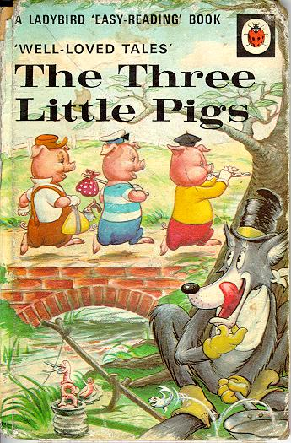

All summer long, they roamed through the woods and over the plains, playing games and having fun. None were happier than the three little pigs, and they easily made friends with everyone. Wherever they went, they were given a warm welcome, but as summer drew to a close, they realized that folk were drifting back to their usual jobs, and preparing for winter. Autumn came and it began to rain. The three little pigs started to feel they needed a real home. Sadly they knew that the fun was over now and they must set to work like the others, or they'd be left in the cold and rain, with no roof over their heads. They talked about what to do, but each decided for himself. The laziest little pig said he'd build a straw hut.

http://live-artist.com/fairytales/pigs.html

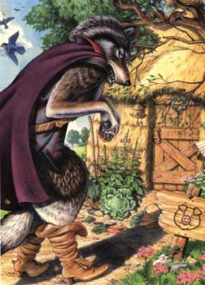

Appendix 3

Symbolos de los cuentos

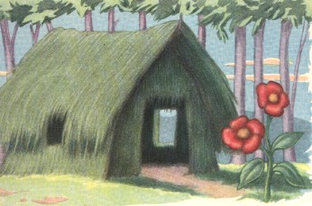

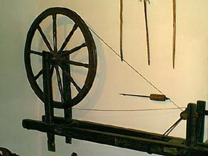

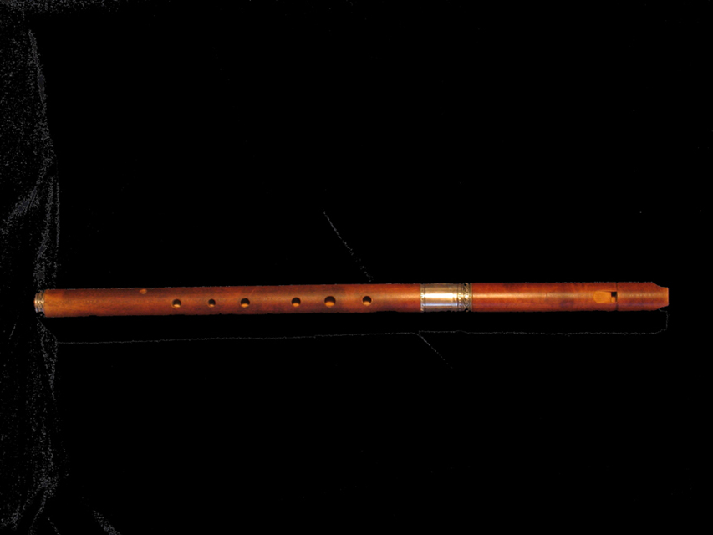

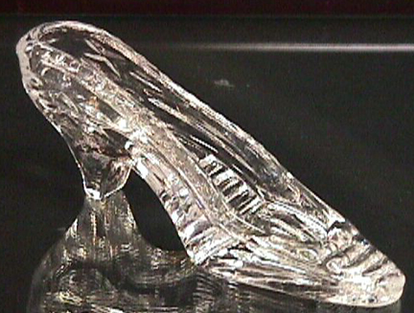
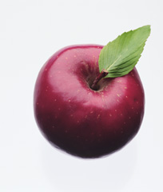

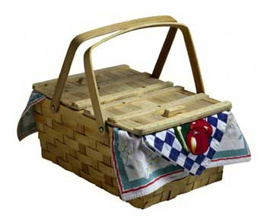

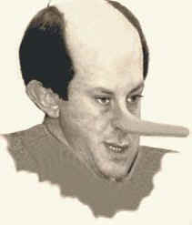

Appendix 4

Fotos de todos los cuentos
