Plan of the lesson

TITEL: Buildings – Art Nouveau Level : C1

Activity Language:English xx L1 □ L2

Author : European Team of EU Project “IDEA”
Timing /skills | Preparation/ Material | Procedure
10´  Warm up  Oral task | - Some questions to check the students/learners knowledge about the topic | - The teacher asks e.g. the following questions and the learners try to answer: 1) What do you know about “Art Nouveau”? 2) When was it in fashion? 3) Do you know cities with famous Art Nouveau buildings? 4) What do you think is typical for the Art Nouveau? 5) Do you like it?
25´  Intercultural task – skills training  Grammar: comparison | - Some pictures of “Art Nouveau” buildings  (see picture box 1) | - The teacher distributes the pictures (1 for 2 persons) and asks each group to look carefully at them.  - Students/learners take notes about the features of the building(s) and about what is different from the actual way of building houses. They should take the decoration of the house into account. (e.g.: Art Nouveau house fronts are more decorated than now. The doors were bigger and often made of iron,….)  - They report in plenum.
25´  Oral skills  Revision of past tenses | - Same pictures | - Students/learners are asked to reflect on the way people were living at that time (end of the 19th century-beginning of the 20th).  - Which kind of persons lived in such houses? What did the men do? What did the women do?  - What about the staff? What jobs did women and men employed in such a house do?  - Are there professions that are quite different or do not exist any more? (e.g. parlour maid, coachman,…)
45´  Written and oral skills  Historical and art knowledge improvement  Intercultural task | - Same pictures but each learner/student has got one picture  - Cards to write the false identity  - Note: Some days before carrying out this role play, it could be useful to ask the learners to investigate through internet about the food and beverage and good manners at this time. | - The teacher suggests to the students/learners to imagine that they are the owners of the house.  - They choose a false identity and profession. Two persons should be foreigners/from another European country.  - Then if the number of students/learners is high, the teacher makes groups of 6-8 people.  - One of the student/learner of each group has now the task to give a dinner party in his/her house.  - The group discusses about the menu and the drinks at that former time. Would one serve the same kind of menus than now?  - What topics would people at that time be likely to discuss?  - Students/learners take their role, sit round a table and talk as if they really were at the dinner party. (They should take care of not introducing expressions, things, food, etc…that do not fit to the situation – and note if someone uses a word, mention an object (TV) that did not exist). The teacher is attentive to control the groups.  - The groups report in plenum about their dinner and eventually about the difficulties they met by talking together.

Plan de la leçon

TITEL: Bâtiments – Art Nouveau Level : C1

Activité en: Français xx L1 □ L2

Author : European Team of EU Project “IDEA”
Durée/ capacités | Préparation/ Matériel | Procédure
10´  Mise en route  Expression orale | - Quelques questions pour évaluer les connaissances sur le sujet | - Le professeur pose par ex. les questions suivantes auxquelles les apprenants essaient de répondre : 1) Que savez-vous de l´“Art Nouveau”? 2) Quand fut-il à la mode? 3) Connaissez-vous des villes avec des bâtiments célèbres en Art Nouveau? 4) Qu´est – ce qui est, à votre avis, typique pour l´ Art Nouveau? 5) Aimez-vous ce style?
25´  Compétences interculturelles  Grammaire: la comparaison | - Quelques photos de bâtiments du style “Art Nouveau”  (voir annexe “box” 1) | - Le professeur distribue les photos (1 pour 2 personnes) et demande à chaque groupe de les examiner attentivement.  - Les apprenants prennent des notes sur l´aspect du /des bâtiment(s) et sur ce qui est différent des constructions actuelles. Ils devraient prendre la décoration du bâtiment en considération (par ex.: les façades des bâtiments de style « Art Nouveau » sont plus décorées que celles de constructions actuelles. Les portes sont plus grandes, souvent en métal forgé,…)  - Ils rapportent leurs impressions en commun.
25´  Expression orale  Révision du passé | - Les mêmes photos | - On demande aux apprenants de réfléchir sur la façon dont vivaient les gens à l´époque. (fin du 19^{ième} siècle - début du 20^{ième}).  - Qui habitaient de telles maisons? Que faisaient les hommes? Que faisaient les femmes?  - Et le personnel? Quels métiers exerçait-il? Que faisaient les femmes et les hommes employés dans de telles maisons?  - Y avaient-ils des professions très différentes de maintenant ou qui n´existent plus? (par ex. bonne, cocher,…)
45´  Expression écrite et orale  Amélioration des connaissances artistiques et historiques  Compétence interculturelle | - Les mêmes photos mais chaque apprenant a une photo  - Carte vierge pour écrire une fausse identité  - Remarque : quelques jours avant ce jeu de rôle, il serait utile de demander aux apprenants de faire des recherches sur internet concernant les habitudes alimentaires de l´époque et l´ art de vivre. | - Le professeur suggère aux apprenants d´imaginer qu´ils sont propriétaires de cette maison.  - Ils choisissent un nom et une profession. Deux personnes devraient être originaires d´un autre pays européen que celui où ils se trouvent.  - Si le nombre d´apprenants est élevé, le professeur divise ceux-ci en groupe de 6 à 8 personnes.  - Un(e) des apprenant(e)s a alors pour tâche d´ organiser un dîner chez elle/lui.  - Le groupe discute du menu et des boissons de l´époque (par ex. : anisette, faisan,…). Servirait-on le même genre de menu maintenant?  - Autour de quels sujets les conversations tourneraient-elles?  - Les apprenants prennent leur rôle, s´ installent autour de la table et se comportent et bavardent comme s´ils étaient vraiment en train de dîner. (Ils devront faire attention de ne pas introduire des expressions, objets, plats, etc… qui ne s´accordent pas avec la situation – et noter si quelqu´un utilise un mot, mentionne un objet (télé) qui n´ existait pas à l´époque). Le professeur est attentif et contrôle les groupes.  - En commun, les groupes se racontent leur dîner et éventuellement expliquent les difficultés qu´ils ont rencontrées en bavardant à table.

Pictures box 1

Private collection (H.S.)
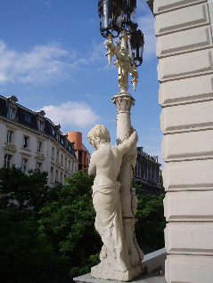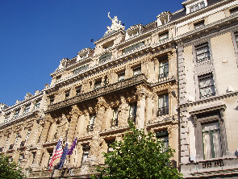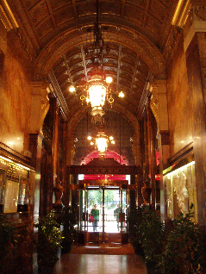

Bruxelles (Belgium) - Metropole Hotel (actually)
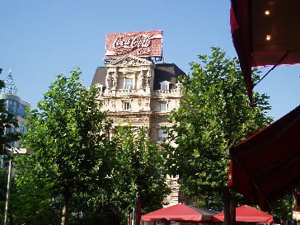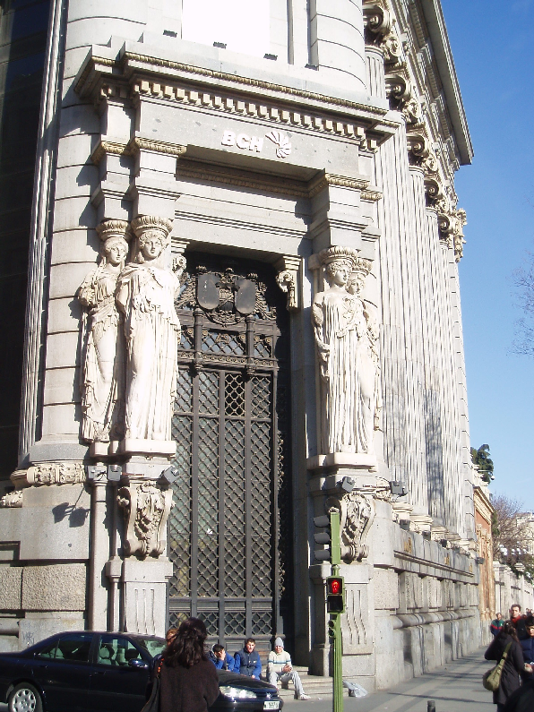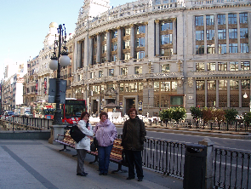

Bruxelles Madrid Madrid

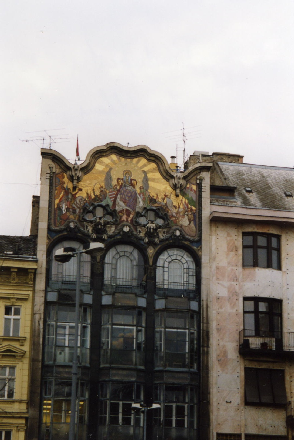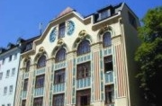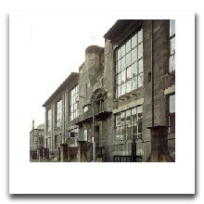

Budapest Munich Glasgow
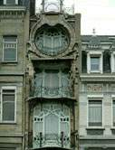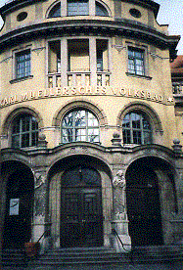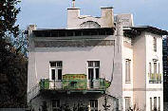
Bruxelles Munich Vienna

Art Nouveau - Information

Definition of „Art Nouveau“

http://en.wikipedia.org/wiki/Art_Nouveau

Character of Art Nouveau
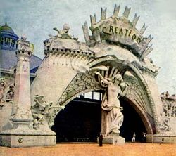

St. Louis World's Fair, (1904). Entrance to the Creation exhibit.
Dynamic, undulating, and flowing, with curved 'whiplash' lines of syncopated rhythm, characterise much of Art Nouveau. Another feature is the use of hyperbolas and parabolas. Conventional mouldings seem to spring to life and 'grow' into plant-derived forms.
As an art movement it has affinities with the Pre-Raphaelites and the Symbolism (arts) movement, and artists like Aubrey Beardsley, Alfons Mucha, Edward Burne-Jones, Gustav Klimt, and Jan Toorop could be classed in more than one of these styles. Unlike Symbolist painting, however, Art Nouveau has a distinctive visual look; and unlike the backward-looking Pre-Raphaelites, Art Nouveau artists quickly used new materials, machined surfaces, and abstraction in the service of pure design.
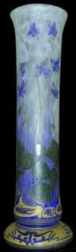

Vase by Daum (c. 1900).
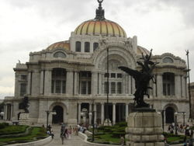

Bellas Artes Palace in Mexico City.
Art Nouveau in architecture and interior design eschewed the eclectic revival styles of the Victorian era. Though Art Nouveau designers selected and 'modernised' some of the more abstract elements of Rococo style, such as flame and shell textures, they also advocated the use of highly stylized organic forms as a source of inspiration, expanding the 'natural' repertoire to embrace seaweed, grasses, and insects.
Japanese wood-block prints, with their curved lines, patterned surfaces, contrasting voids, and flatness of visual plane, also inspired Art Nouveau. Some line and curve patterns became graphic clichés that were later found in works of artists from all parts of the world.
Art Nouveau did not negate the machine as the Arts and Crafts Movement did, but used it to its advantage. For sculpture, the principal materials employed were glass and wrought iron, leading to sculptural qualities even in architecture.
Art Nouveau is considered a 'total' style, meaning that it encompasses a hierarchy of scales in design — architecture; interior design; decorative arts including jewellery, furniture, textiles, household silver and other utensils, and lighting; and the range of visual arts. (See Hierarchy of genres.)

From Wikipedia, the free encyclopedia

http://en.wikipedia.org/wiki/Art_Nouveau

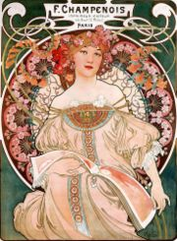

Poster by Alfons Mucha

Art Nouveau (IPA: [art nuvo], anglicised /ˈɑːt nuːvəu/) (French for 'new art') is an international style of art, architecture and design that peaked in popularity at the beginning of the 20th century. Other, more localised terms for the cluster of self-consciously radical, somewhat mannered reformist chic that formed a prelude to 20th-century modernism included Jugendstil in Germany, the Netherlands and Scandinavia, named after the avant-garde periodical Jugend ('Youth'), Młoda Polska ('Young Poland' style) in Poland, and Sezessionsstil ('Secessionism') in Vienna, where forward-looking artists and designers seceded from the mainstream salon exhibitions to exhibit on their own work in more congenial surroundings.
In Russia, the movement revolved around the art magazine Mir iskusstva ('World of Art'), which spawned the revolutionary Ballets Russes. In Italy, Stile Liberty was named for the London shop, Liberty & Co, which distributed modern design emanating from the Arts and Crafts movement, a sign both of the Art Nouveau's commercial aspect and the 'imported' character that it always retained in Italy.
In Catalonia, the movement was centred in Barcelona and was known as modernisme, with the architect Antoni Gaudí as the most noteworthy practitioner. Art Nouveau was also a force in Eastern Europe, with the influence of Alfons Mucha in Prague and Moravia (part of the modern Czech Republic) and Latvian Romanticism (Riga, the capital of Latvia, is home to over 800 Art Nouveau buildings). The entrances to the Paris Metro designed by Hector Guimard in 1899 and 1900 are famous examples of Art Nouveau.

History of Art Nouveau
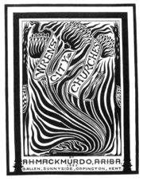
Bookcover of Arthur Mackmurdo, Wren's City Churches, 1883

Though Art Nouveau climaxed in the years 1892 to 1902, the first stirrings of an Art Nouveau movement can be recognised in the 1880s, in a handful of progressive designs such as the architect-designer Arthur Mackmurdo's book cover design for his essay on the city churches of Sir Christopher Wren, published in 1883. Some free-flowing wrought iron from the 1880s could also be adduced, or some flat floral textile designs, most of which owed some impetus to patterns of High Victorian design.
The name 'Art Nouveau' derived from the name of a shop in Paris, Maison de l'Art Nouveau, at the time run by Siegfried Bing, that showcased objects that followed this approach to design.
A high point in the evolution of Art Nouveau was the Exposition Universelle of 1900 in Paris, in which the 'modern style' triumphed in every medium. It probably reached its apogee, however, at the Esposizione Internazionale d'Arte Decorativa Moderna of 1902 in Turin, Italy, where designers exhibited from almost every European country where Art Nouveau flourished. Art Nouveau made use of many technological innovations of the late 19th century, especially the broad use of exposed iron and large, irregularly shaped pieces of glass in architecture. By the start of the First World War, however, the highly stylised nature of Art Nouveau design — which itself was expensive to produce — began to be dropped in favour of more streamlined, rectilinear modernism that was cheaper and thought to be more faithful to the rough, plain, industrial aesthetic that became Art Deco.

Art Nouveau media
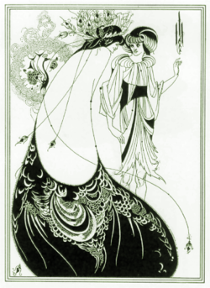
The Peacock Skirt, by Aubrey Beardsley, (1892).
Two-dimensional Art Nouveau pieces were painted, drawn, and printed in popular forms such as advertisements, posters, labels, magazines, and the like.
Glass making was an area in which the style found tremendous expression — for example, the works of Louis Comfort Tiffany in New York and Émile Gallé and the Daum brothers in Nancy, France.
Jewellery of the Art Nouveau period revitalised the jeweller's art, with nature as the principal source of inspiration, complemented by new levels of virtuosity in enamelling and the introduction of new materials, such as opals and semi-precious stones. The widespread interest in Japanese art, and the more specialised enthusiasm for Japanese metalworking skills, fostered new themes and approaches to ornament.
For the previous two centuries, the emphasis in fine jewellery had been on gemstones, particularly on the diamond, and the jeweller or goldsmith had been principally concerned with providing settings for their advantage. With Art Nouveau, a different type of jewellery emerged, motivated by the artist-designer rather than the jeweller as setter of precious stones.
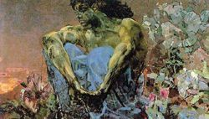
Mikhail Vrubel. Demon Seated in a Garden, 1890
The jewellers of Paris and Brussels defined Art Nouveau in jewellery, and in these cities it achieved the most renown. Contemporary French critics were united in acknowledging that jewellery was undergoing a radical transformation, and that the French designer-jeweller-glassmaker René Lalique was at its heart. Lalique glorified nature in jewellery, extending the repertoire to include new aspects of nature — dragonflies or grasses — inspired by his encounter with Japanese art.
The jewellers were keen to establish the new style in a noble tradition, and for this they looked back to the Renaissance, with its jewels of sculpted and enamelled gold, and its acceptance of jewellers as artists rather than craftsmen. In most of the enamelled work of the period precious stones receded. Diamonds were usually given subsidiary roles, used alongside less familiar materials such as moulded glass, horn and ivory.

Art Nouveau 1890-1914
History and exhibitions
Art Nouveau 1890-1914, Victoria & Albert Museum, London, until July 30, 2000
What is Art Nouveau? A consciously mystical and illogical continuation of the Romantic tradition? "A logical opposition with a rationalist foundation", firmly rooted in the scientific achievements of the nineteenth century? A concrete expression of social science? A turning inward - materially and psychologically - of a decadent and capital driven bourgeoisie? A style centrally concerned with public life? A government-based, pragmatic money making strategy? A non-conformist artistic revolt intent on "defeating the establishment order"? An idealistic crusade, composed of a number of international styles? A movement by artists and their institutional sponsors who shared a contemporary nationalist ideal? There are a lot of often contradictory definitions of Art Nouveau, which are reflections of its multiple facets.
In a major exhibition, the Victoria and Albert Museum in London (V&A) celebrates Art Nouveau and, therefore, unites many disparate objects from museums and private collections from Europe and the USA, which at their time cohered into a style which became, despite contemporary rivals, the style of the age. At the V&A exhibition, Art Nouveau stands for: "a style in the visual arts that was a powerful presence in Europe and North America from the early 1890s until the First World War. The style emerged from the intense activity of a collection of movements, manufacturers, public institutions, publishing houses, individual artists, entrepreneurs and patrons, located all over the urban, industrial world. It existed in all genres, but the decorative arts were centrally responsible for its inventions and its fullest expression." The key motivation was modernity in the arts as a recognition and expression of a technically, economically and politically changing world. The German Art Nouveau intellectual Julius Meier-Graefe stated that "if the uses of art change, art itself must change." One aspect was the equality among the arts and their orchestration into unified ensembles: Gesamtkunstwerk was the keyword (a term first applied in the fin-de-siècle context to the music of Richard Wagner).
One of the first representatives of the Art Nouveau style was German-born French entrepreneur Siegfried Bing who opened a gallery and shop in Paris in 1895. The gallery L'Art Nouveau subsequently expanded to include workshops and ateliers. Hermann Obrist in Germany, Charles Rennie Mackintosh in Scotland, Emile Gallé in France and Louis Comfort Tiffany in the United States are a few other early names of the style, which, in its second phase from 1895 to 1900, spread to many urban centers in Europe and North America.
The V&A exhibition and its catalogue not only deals with the creation and meaning of Art Nouveau (e.g. the cult of nature and the relation between Orient and Occident), but also the materials of invention (e.g. new textiles and ceramics) and the different centers and their designers (e.g. Victor Horta and Brussels, Secession and Jugendstil in Munich). An exhibition not to miss, which includes painting, sculpture, jewelry, furniture, vases and other decorative objects as well as a look at architecture.
1900: Art at the crossroad. Royal Academy of Art, London, until April 2000. Catalogue edited by Robert Rosenblum, Mary-Anne Stevens and Ann Dumas, Royal Academy of Arts editions, 448 p.
The exhibition was centered on painting and sculpture. Objects from all styles, schools and nationalities of the year 1900 were represented (Europe, Russia, USA and Australia). At the same time a limited topic since nothing from 1890 or 1910 was included and a large show since not only Art Nouveau was on display. The show was divided in topical parts such as historical paintings, nudes, portraits, landscapes, etc. Within these categories, a large variety of schools were presented, such as the post-impressionists and the realists, Munch and Klimt, Maillol and Cézanne, Gauguin and Matisse, Liebermann and Von Stuck, Hodler and Nolde, young artists at the beginning of their career such as Kandinsky and Mondrian. The industrial society and the birth of the culture of the masses was one of their central subjects.
Grand Palais, Paris. Exhibition: 1900, until June 26, 2000. Catalogue: 1900, ouvrage collectif sous la direction de Philippe Thiébaut, avec des contributions sur l'histoire, la science, l'architecture, la sculpture et la photographie, Editions RMN, 400 p.
Built for the Universal Exhibition of 1900, the stone, glass and steel architecture of the Grand Palais is the natural place to show the exhibition centered on Art Nouveau. All other artistic movements of 1900 are excluded from the show which presents, in contrast to the Royal Academy of Art, not only painting and sculpture, but also the applied arts, jewelery, illustrated books and, as an important part, architecture. Grouped around themes such as "modernity and tradition" and "the unity of the arts", the organizers tried to show a coherent image of Art Nouveau, excluding everything that does not fit into their definition. Important foreign Art Nouveau centers and nations are neglected or even ignored completely.
In 1900, Paris wanted to blend the world and the Art Nouveau building of the Grand Palais was one of the means to do so. At the turn of the century, architects, decorators, painters, sculptors and others were in search of a new art. Based on national, re-actualized and often rural traditions of arts and crafts, a new vision of art, architecture and design was to be born. A return to nature and its bio-morphological forms was one of the results. That's the essence of the Art Nouveau-definition at the Paris exhibition.

http://www.cosmopolis.ch/english/cosmo7/artnouveau.htm

