Plan of the lesson

TITEL: Cooking and Drinking Level : A2 – C1 Events and Tables

Activity Language: English x L1 □ L2

Author : European Team of EU Project “IDEA”
Timing /skills | Preparation/ Material | Procedure
20´ A2  Vocabulary improvement and writing skills | - Pictures of tables laid for dinner  (see Pictures box 1) | - The learners/students first guess for which occasion the table is laid.(e.g. wedding, party, ….)  - They write an invitation for the event.  - They make proposals who should be invited (Mary´s mother-in-law, Ann´s sister,….)
10´ A2  Vocabulary improvement | - The same pictures of tables laid for dinner | - In pair learners/students write a collection of words with all items/things on the table (e.g. a fork, a plate, a napkin, …). Then all words are written on cards. New vocabulary will be given by the teacher or look up in a dictionary.
20´ A 2  Oral fluency | - Cards with words related to the decoration and items used to lay a table | - The cards are laid on a desk/table. Each learner/student takes 3 of them. They should explain for what the item is used. (e.g. a tablecloth is used to protect or decorate a table; place cards are used to indicate where a person is sitting,…)
20 ´ A 2  Reading and speaking skills | - Domino game with objects and verbs for each pair of learners (see example below)  - (Well adapted for 3rd age learners) | - In pair the learners/students are asked to put the domino cards together so that the explanation of the use of an object fits with the verb (e.g. a fork → to pick something to eat; a napkin → to fold to decorate a table or to clean one´s mouth,….).  - When laying a domino card on the table the learners/students should built a sentence with the substantive and the verb matching to it (e.g. With my napkin, I can clean my mouth or I can fold it to decorate a table)
60 ´ C 1  oral and written skills | - Pictures of the steps when laying a table (see pictures box 2 below) | - Learners are asked to put the pictures in the right order.  - They guess or make proposals about what could be served / eaten taking into consideration the things on the photos.  - In small groups they compose a menu for a dinner and select the drinks.

Picture box 1

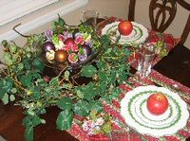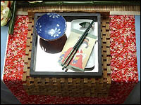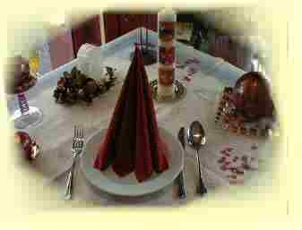

Christmas table Chinese party table Communion table

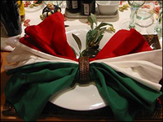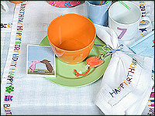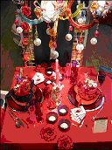

Italian party table Kids´ birthday table New Year table

“Moulin Rouge”

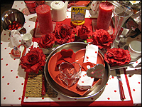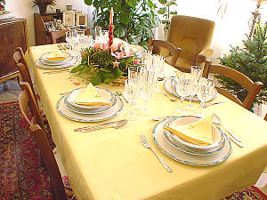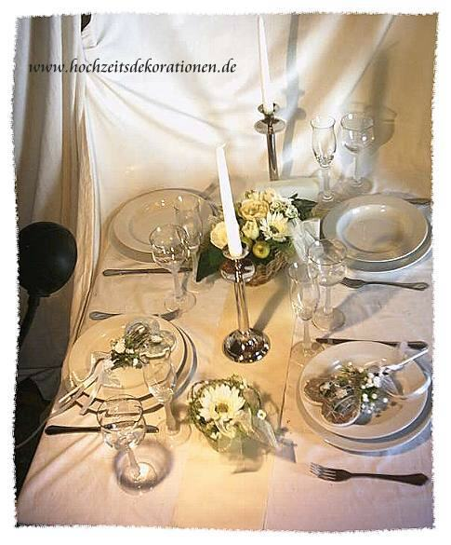

Mother day / St.Valentine Wedding anniversary Wedding table
table table
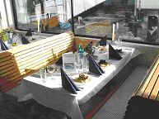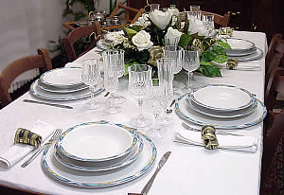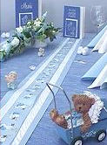

River boat party table Festive table Christening table

Example for a domino game (cut the cards when the colour changes)

to pick sth to eat | a napkin | to clean one´s mouth | a glass
to drink  sth | a spoon | to eat soups or  desserts | a ladle
to poor  the  soup or  sauces | a plate | to serve a dish | a knife
a help to eat/to cut e.g. meat | a saucepan | a pot to cook warm dishes | a jar  or  a mug
to put water or wine in it | a place card | to show where s.o. will sit | a soupe plate
to contain  the soup | a decanter | to allow the wine to get its best aroma | a candle
to spend some smooth light | a saucer | to put a cup or a bottle on it | a fork
Picture box 2 – Laying the table ( original range of pictures – can be cut and mixed)

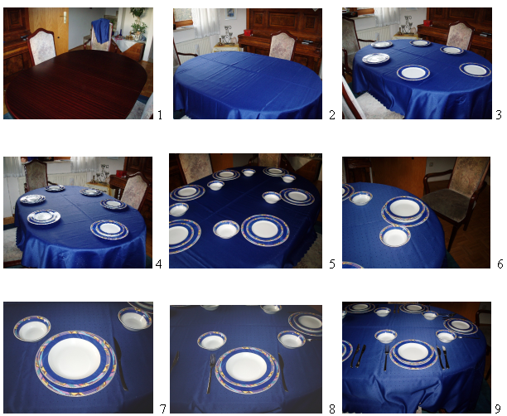

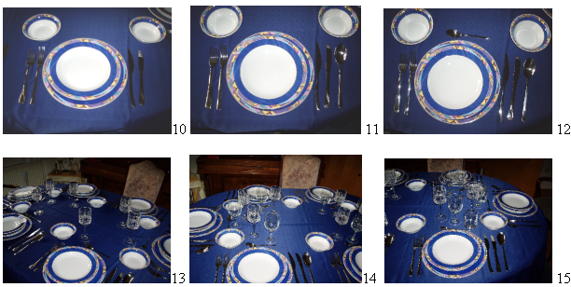

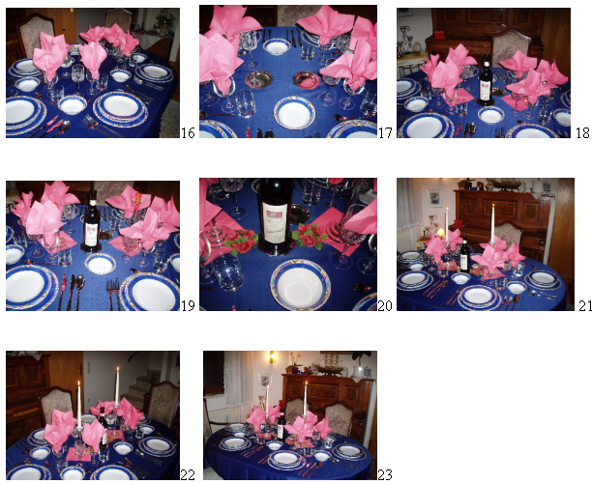

This table was laid for a dinner party with friends.

The French way of laying a table: how to do it

e

