Plan of the lesson

TITLE: “Winter Cooking Traditions in Asturias.”

Level : B1

Activity Language: English (although the activity and the topic can be easily adapted to the French, German and Italian cultures and languages).

□ L1  L2

Author : European Team of EU Project “IDEA”
Timing /skills | Preparation/ Material | Procedure
1) Warm-up activity: 20’.  Or  2) Follow-up activity: 60’.  Speaking and Reading:  “Winter Cooking Traditions in Asturias” | - Photocopies of the sheets with the questions, without the answers. | You can use this activity as a warm-up if you’re dealing with topics that have something to do with cooking or traditions.  Students, in small groups, will have to read the questions and choose the right answers. Allow some time for discussion and then, some time for idea-sharing. Help them with the answers in case they find it difficult to guess.  As well as a warm-up activity, it can be used as a model follow-up activity. Thus, if your students are familiar with any of these topics, they can create their own country quizzes, so that other European students can find out more about them. Obviously, the follow-up activity will take more time, as your students will need to think about the questions, the multiple choice answers and surf the Net to include some photographs.

How well do you know them? Here is a quiz for you, so that you can learn something else about this part of the country:

1) We still follow the custom known as the “Amagüestu”, a sort of feast that villagers and farmers used to hold at the end of the maize harvest time. Moreover, it was an excuse to celebrate the arrival of a new season. We hope these clues are useful for you to answer the following questions. What does the “Amagüestu” consist of?

  - Baking a kind of dry fruit.
  - Frying a kind of meat.
  - Grilling a kind of fish.
  - Boiling a kind of vegetable.

2) The “Amagüestu” takes place in ...

  - September and October.
  - October and November.
  - November and December.
  - December and January.

3) This is due to the fact that we can only pick up its basic ingredient at this time of the year. Which ingredient are we talking about?

  - Lettuce.
  - Sea urchins.
  - Chestnuts.
  - Ribs.

4) We normally wash this tasty meal down with some ...

  - ... orange juice and vodka.
  - ... milk or sweet cider.
  - ... Coke and rum.
  - ... coco loco.

5) “El Desarme” (The Disarmament) is the name of a local public holiday which started to be celebrated in Oviedo, but nowadays it has spread throughout the whole wide region. It is based on a legend that dates from the 19th century, during the First Carlist War (1833-1839). The controversial change which Ferdinand VII of Spain made to the law in order to allow his daughter Isabella to succeed him instead of his brother, gave rise to Carlism, a movement supporting Isabella’s uncle’s claim to the throne. What was that pretender’s name ?

  - Carlinhos Brown.
  - Juan Carlos II.
  - Carlos María Isidro de Borbón.
  - Carlos V.

6) At that time, Oviedo didn’t want to back the Carlist cause, so a plan was carefully thought out to offer resistance to the Carlists. However, instead of fighting against the enemy, the “Ovetenses” decided to give them a “delicious” welcome and invited them for lunch. What was the main dish based on?

- Chickpeas, cod and spinach.
- Spaghetti, pizza and a salad.
- A steak, bacon and eggs.
- A happy meal: a cheeseburger, chips and chicken fingers.

7) The Carlist soldiers were not used to eating so much, therefore, as the legend says, they were immediately overcome by sleep . The “Ovetenses” then, took advantage of the situation and managed to ...

a)... steal their money.
b)... sing a lullaby to put them to bed.
c)... requisition their armament.
d)... take off their uniforms.

When the Carlist soldiers woke up, they realised they were quite defenceless against the witty “Ovetenses”. Consequently, they had no choice but to retreat from the town.

8) The killing of animals for meat in winter, “slaughter”, is a long-established tradition, handed down from generation to generation. Families get together every year in the months the local government allows them to do it at home. Can you guess which months?

- October and November.
- December and January.
- February and March.
- April and May.

9) Each member of the family helps in this sort of ritual: the bravest ones kill the animal; others cut it up ... well, you don’t need full details, do you? Anyway, which is the animal we are talking about?

- A bull.
- A canary .
- A pig.
- An octopus.

10) Which is the most appreciated and, therefore, the most expensive part of this animal? It is well-known all over the world.

- Its ham.
- Its snout.
- Its tail.
- Its ear.

KEY

1) a 2) b 3) c 4) b 5) c 6) a 7) c 8) b 9) c 10) a.

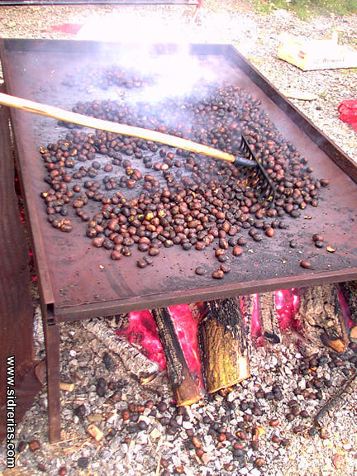
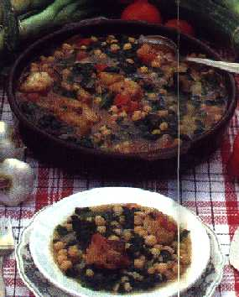
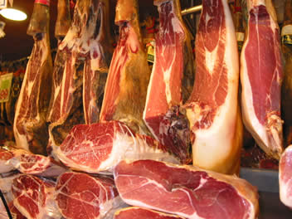
AMAGÜESTU DESARME JAMÓN

