Plan of the lesson

TITLE: Rooms Level : A2

Activity Language: English □ L1 □ L2

Author : European Team of EU Project “IDEA”, Italy
Timing /skills | Preparation/ Material | Procedure
1)5’  2)25’ speaking and writing  3) 10’ speaking  4) 35´  speaking | - Pictures of a friend or a relative and another picture of that person’s favourite room - in different envelopes (with the name of the student who brought them on)  - Pictures of rooms  - Pictures of people  Pictures of rooms and people | - Teacher collects the envelopes and gives instructions for the first activity.  - Teacher divides the class into pairs/small groups and gives an envelope with a picture representing a room to each pair of students (not their own picture of course). Students write a short description of the person (personality/likes and dislikes/job) who lives in the room inferring ideas from the details the picture. (See appendix 1 for a guided description)  - Teacher shows Students all the pictures representing people and asks them to choose the person they think lives in the room they have analysed (eventually also explain why).  - A pair/group briefly reports to the class their deductions about the person who lives in the room they have analysed. Then the student who brought the picture shows the class the picture of the person who actually lives in the room and confirms or rejects his/her classmates deductions. This activity is then carried on in the same way with the other groups.

Previous homework
- Students agree to take 2 pictures one of a friend or a relative and another one of their friend/relative’s favourite room. If this is not possible the teacher can provide these pictures asking for his/her own friends’, relatives’ or colleagues’ collaboration. In this case the teacher will confirm or reject the students’ deductions.
- This activity can be proposed to A2 level students but in this case Students should write a short description of the personality and likes and dislikes of the person in the picture they bring o class so as to feel more comfortable in the speaking activity in class.
- If the pictures are taken with a digital camera they can be printed in a large format.
- Pictures are more interesting if the rooms are a bit untidy.

APPENDIX 1
Is the person who lives in this room a woman or a man?
How old is he/she? (or Is he/she old or young)
What’s his/her job?
What are his/her hobbies?/What does he/she like doing in her free time?
Is he/she married?
Has he/she got any children?
Does he/she like travelling?
Does he/she like sport?
Does he/she enjoy reading?
Does he/she like listening to music?
…….

APPENDIX 2:
Pictures of rooms

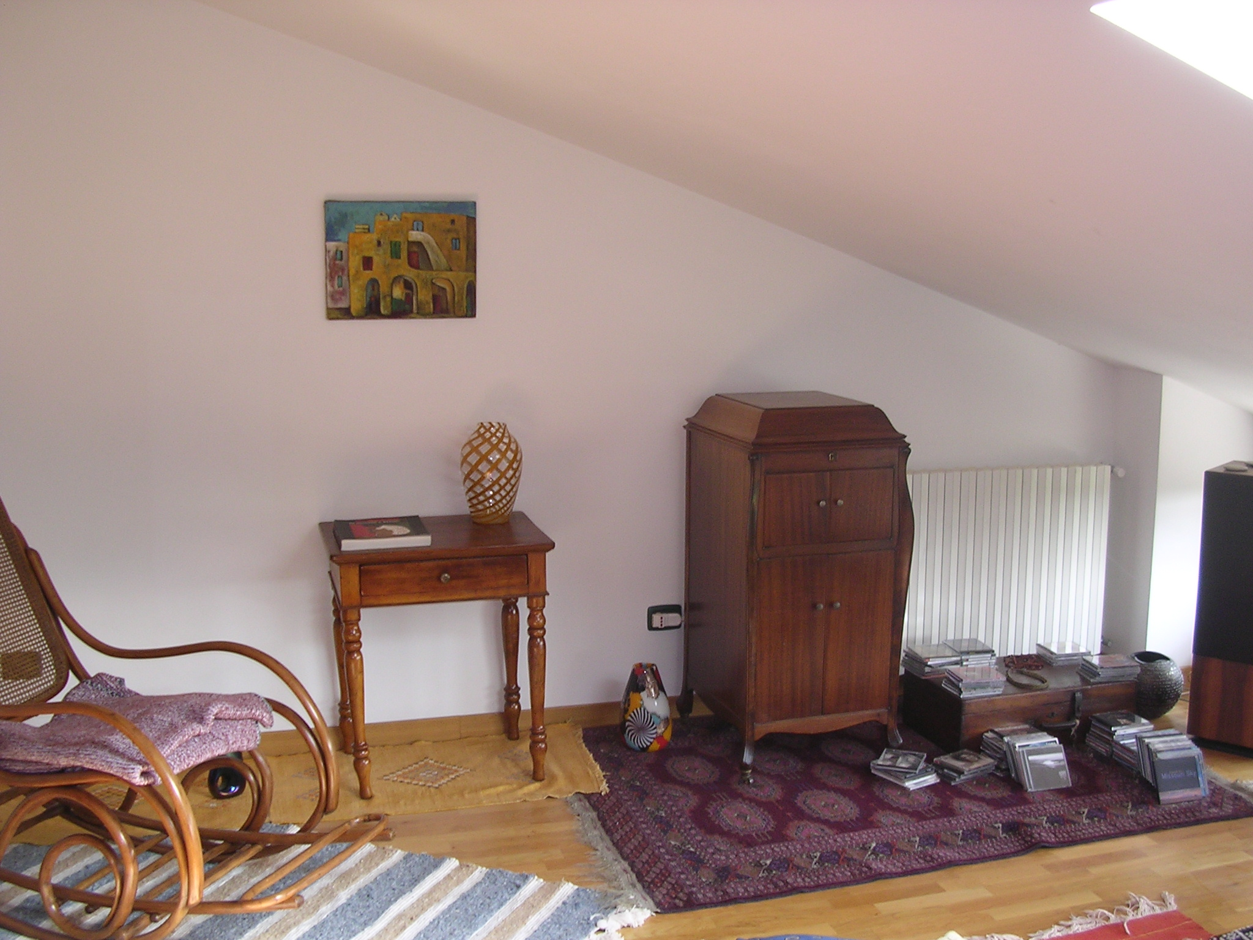

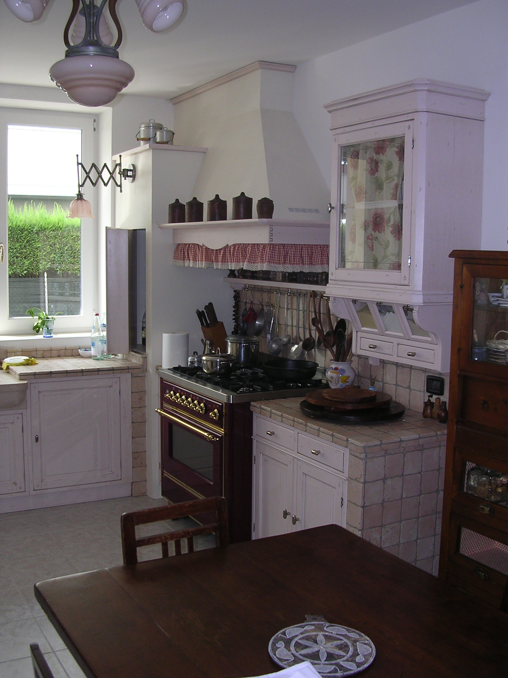

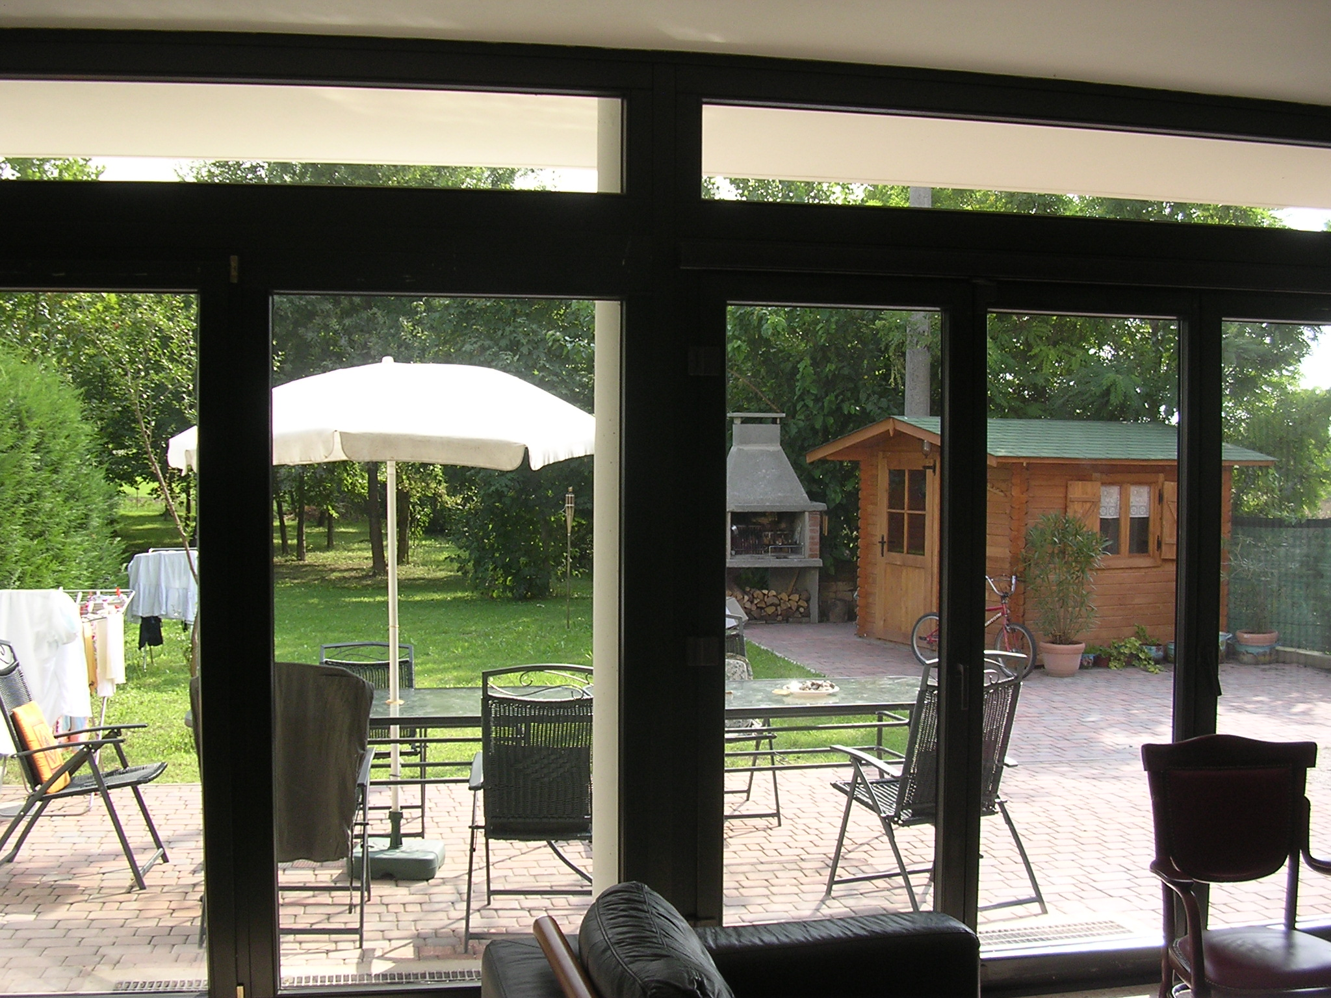

APPENDIX 2:
Pictures of people

